African Djembe Drum Craft
The finished project measures approximately 9 inches in height.

Materials:
two drinking cups (styrofoam, plastic or paper) or yogurt containers
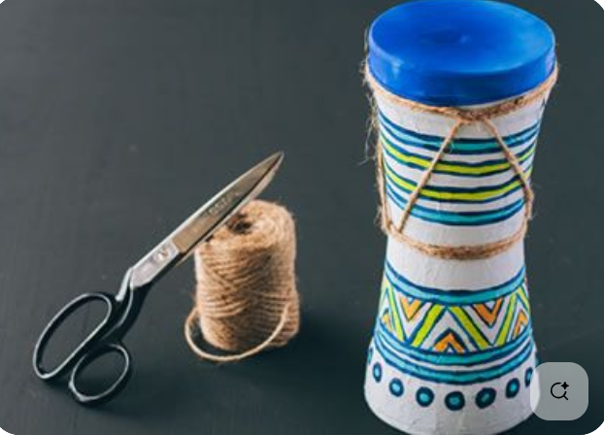
glue
masking tape
rags or paper or paper mache
permanent markers or paint
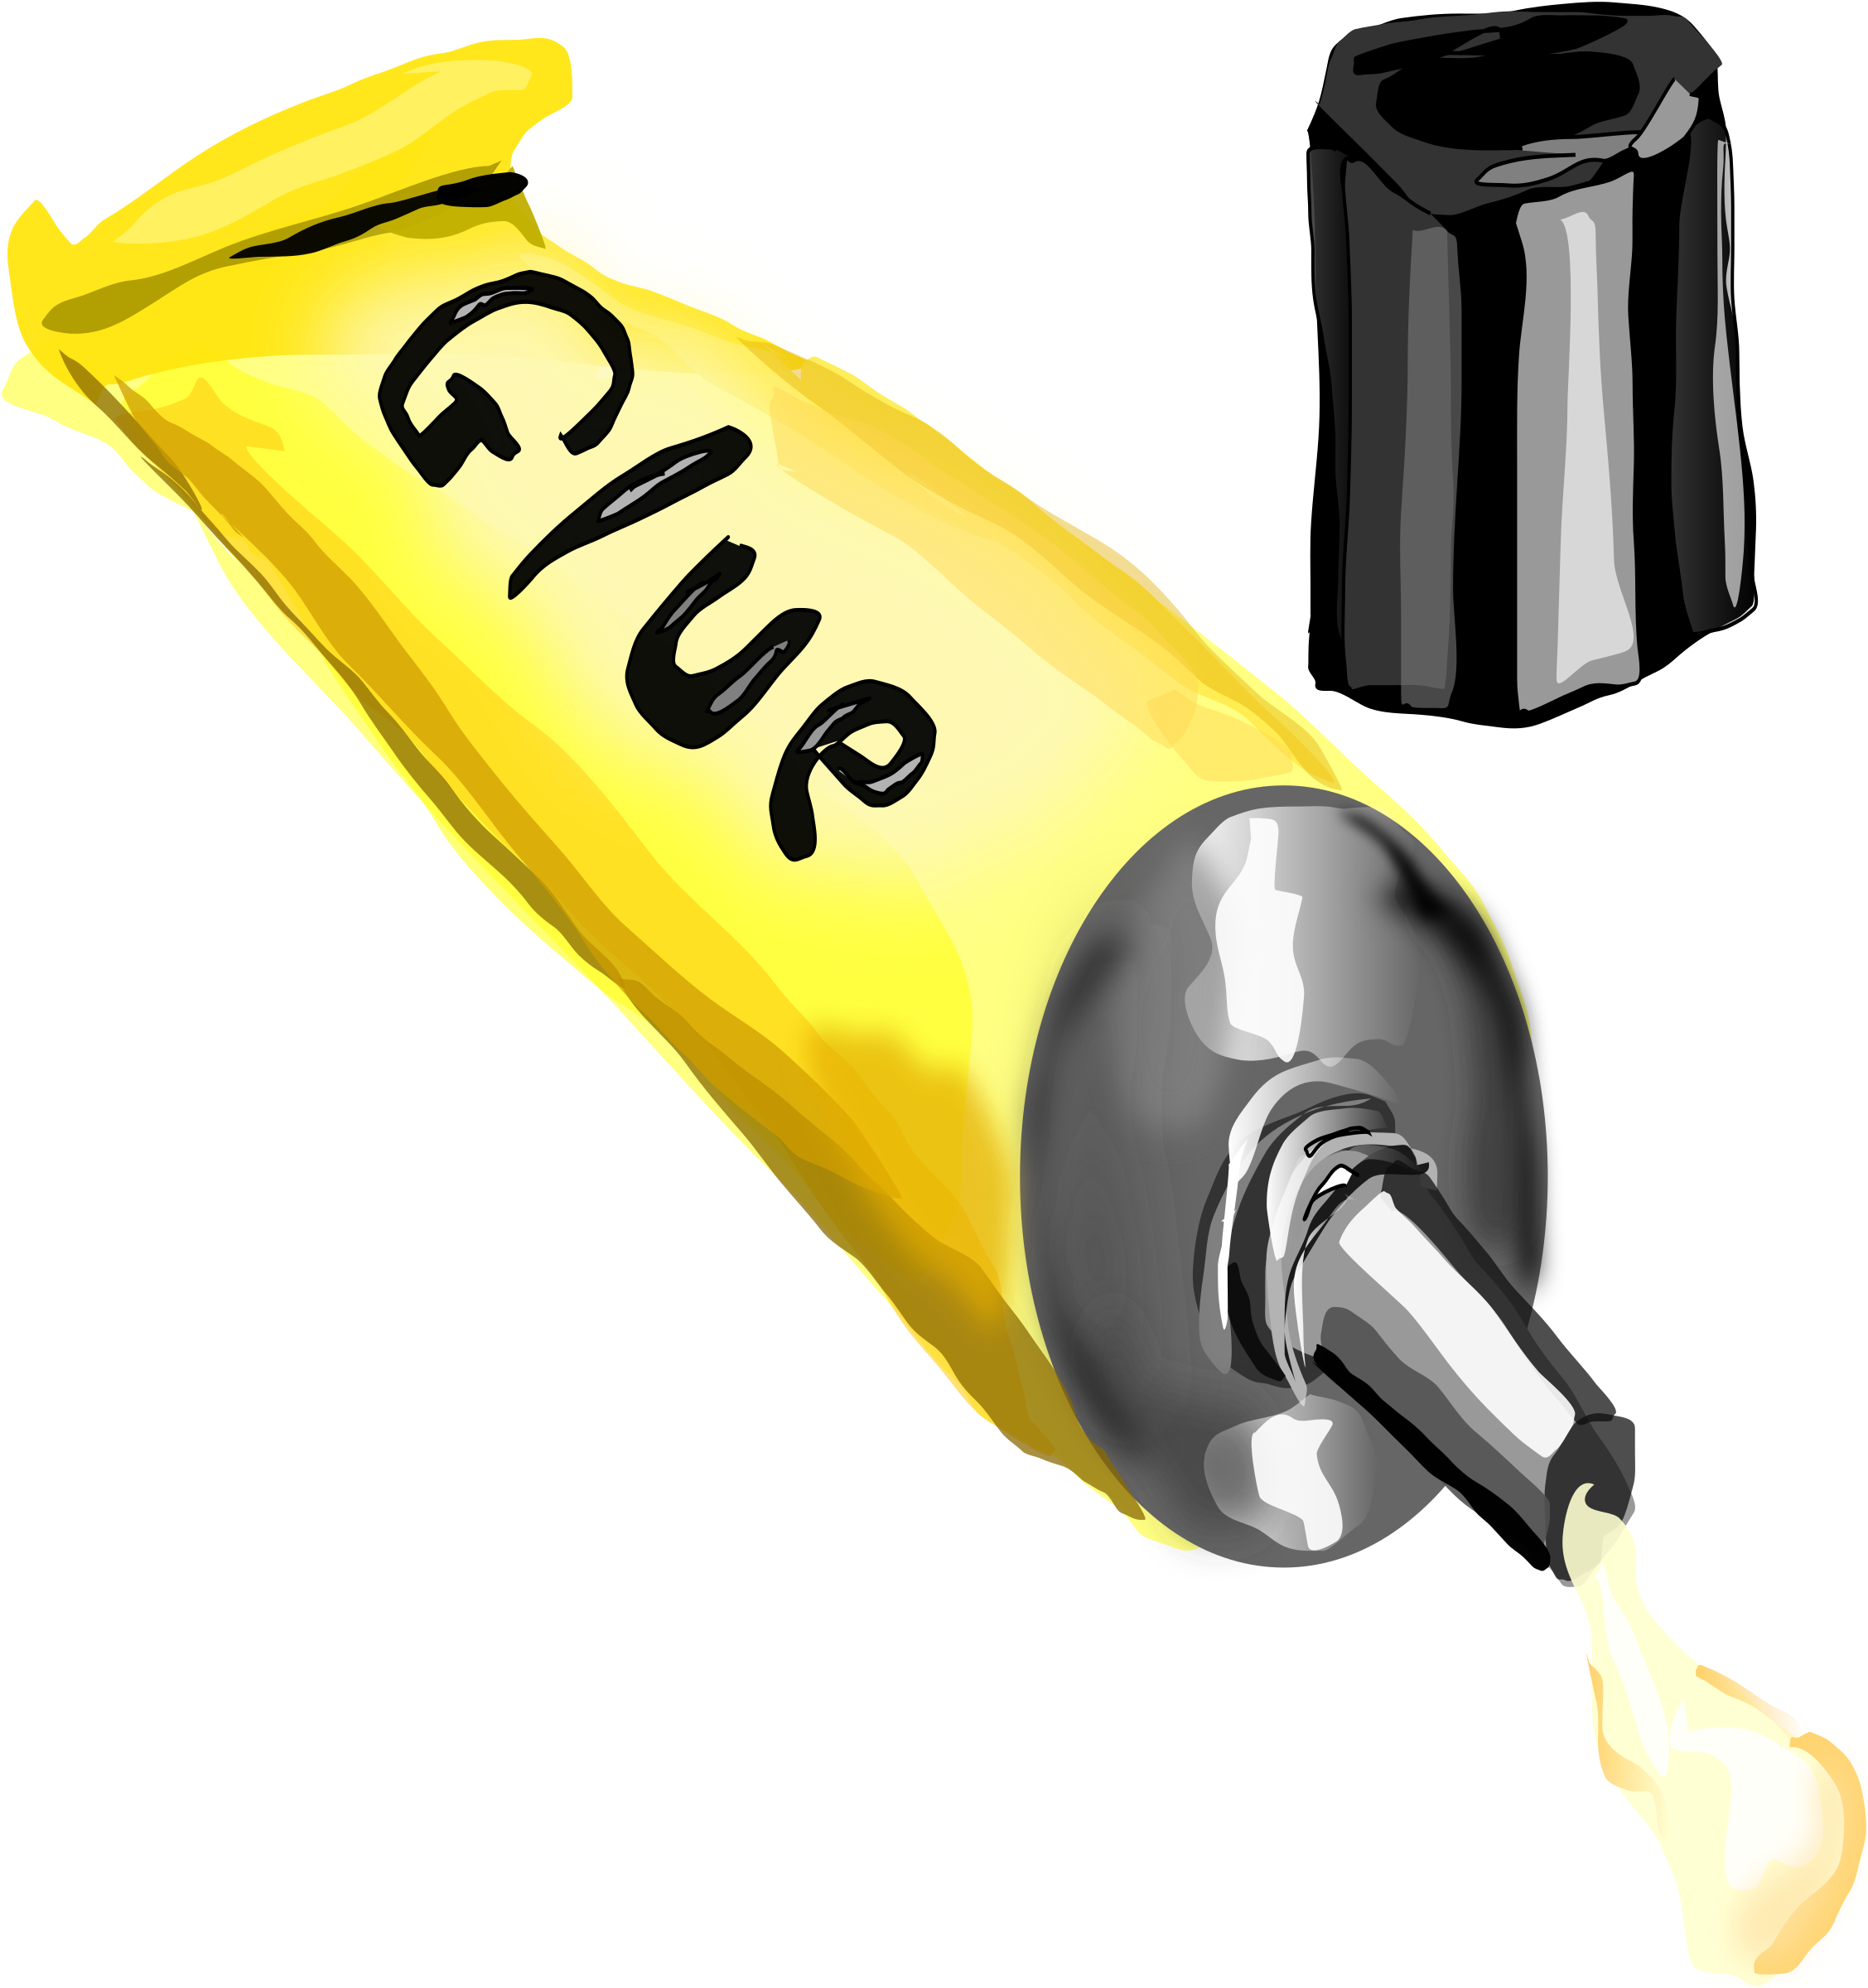
elastic bands
2 balloons
string
Paper Mache -- visit "How to Paper Mache" for the recipe

Instructions:
- glue two cups together, bottom to bottom and let dry
- if doing the project with a large group of children, prep the first step using hot glue to make things flow a bit more smoothly during craft time (most "low temp" craft hot glue guns work on styrofoam cups... carpentry ones will melt them though).
- have the children tear off 4-to-5-inch lengths of masking tape and completely cover the opening at the top and bottom of the cups OR stretch a balloon over the openings and secure to the cups with an elastic band
- using 3-to-4-inch lengths of masking tape, completely cover the outside of the cups OR cover with paper mache
- paint the outside of the drum in a neutral colour. Let the paint dry.
- draw geometric or other designs around the top, middle and bottom of the drums with permanent markers.
- string can be wound around the drum for more effect

