Grant Recipients 2024-25

Location | Organization | Project | Amount
CANADA
British Columbia | A Way Home Kamloops Society  A Way Home Kamloops Society was given a $5,000 World Day of Prayer grant to host special events for young women ages 16- 26 who live in their housing programs. 8-10 women were given opportunities on 7 different dates to come and connect with special supports and materials, through meals, and by grocery gift card distribution. | Young Women’s Housing Support Project  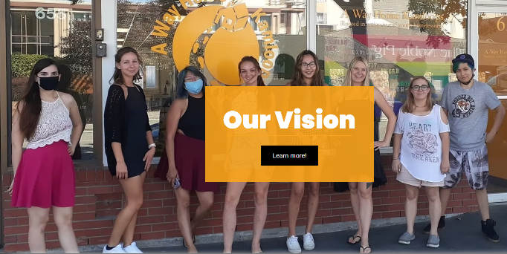 | $5,000
British Columbia | Salvation Army – Cariboo Tree Temple  A $4,000 World Day of Prayer grant enabled weekly meetings of 40 to 50 girls who were at risk for human trafficking. Backgrounds deemed to be at-risk included families of divorce, those in foster care, victims of sexual abuse and girls new to Canada. Weekly programming topics included mental health, mentorship, life skills and providing a safe place for personal growth.  Testimony from Sonia, aged 14:  Brave is a safe place where you feel like you belong. You’re not judged and you can talk about anything. Brave has helped me in so many ways emotionally and mentally but it’s also helped me make great friends. In my opinion, any girl would be very lucky to join Brave. | BRAVE Counselling Program  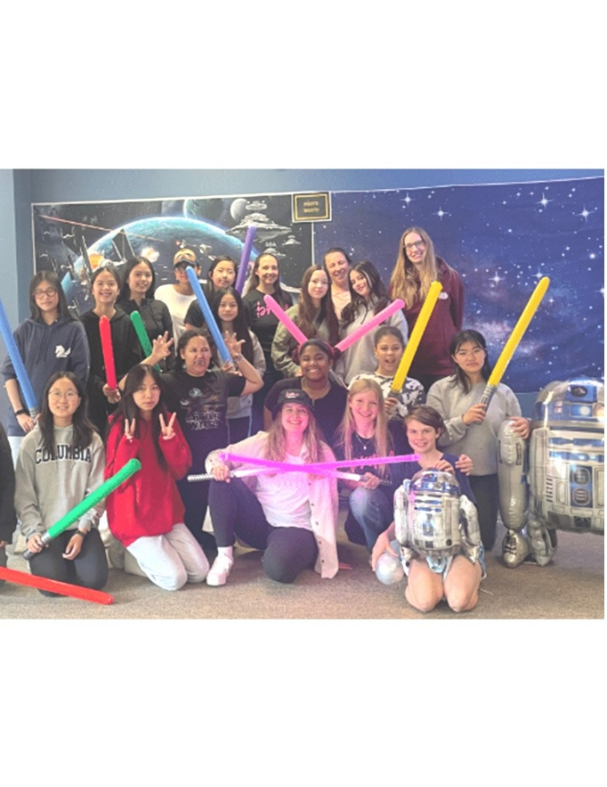 | $4,000
British Columbia | Kamloops United Church  Kamloops United Church supports community members who are struggling. A World Day of Prayer grant of $5,000 funded SPOT, a program which offers free menstrual supplies to 75 women per month. These were to be distributed in three ways: the PIT Stop, which is the church’s weekly free meal serving people with food insecurity, the front office, and the Thrift Shop. Depending on living situations and storage availability, the women can pick supplies for a month or longer. | SPOT – Menstruation Supplies; August 2024 FIRE has delayed the final report | $5,000
British Columbia | Central Okanagan United Church  By December 2024, meals and groceries were provided to 150 people in need in Okanagan, including special meals at Thanksgiving and Christmas. One week, the Food Pantry used seven different languages to communicate. An Arabic interpreter was hired for seven Tuesdays to assist with translation. 11 people participated in the Food Safe Level 1 training while 17 completed a Basic First Aid course. Both were offered free to those interested in improving their skill base. Most participants were women.  Testimonial: Taking the food safety course meant a lot to me because now I have a credential in something that will be useful for finding jobs in the food industry. It also gave me more confidence in my own cooking skills. The first aid course taught me valuable lessons that could be potentially life saving for someone. I appreciated having so much hands on activities, it really helped to put those words on paper to something actually physical and real. A lot of effort was put into this course. Overall, I had a positive experience with these courses. The skills I learned along the way will be a valuable asset to my life. Amina | Beyond Tuesday Morning Fellowship  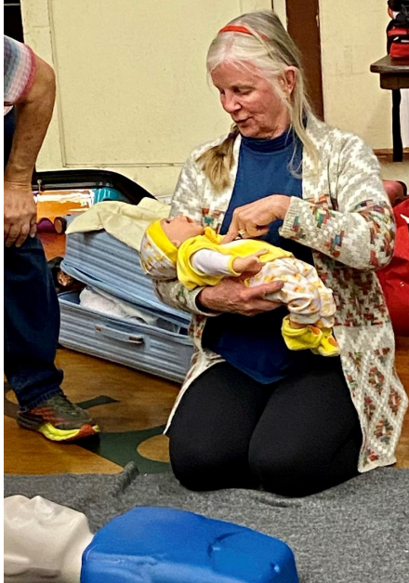 | $5,000
Ontario | Salvation Army – North York  Woven is a weekly empowerment program designed to prevent human trafficking among at-risk teenage girls in Grades 7-12. The focus is on youth from low-income, refugee, and ethnic minority communities—groups often targeted by traffickers—Woven provides a safe space where girls can develop resilience and thrive. As a key initiative of The Salvation Army North York Temple, the program works closely with families and young girls in the North York community.  A World Day of Prayer grant of $3,500 funded weekly programming, including workshops on self-esteem, healthy relationships, online safety, and recognizing grooming methods used by traffickers. Participants also gain leadership experience through roles at The Salvation Army’s children's camps.  Staff testimonial: Woven has not only provided mentorship and support to our girls but has also empowered them to give back to their community. Many participants who initially joined seeking guidance have grown into confident leaders, volunteering and working as camp counsellors and mentors for younger girls. Along the way, they have built deep friendships, supporting each other in their studies, spending time together outside of the program, and staying in constant communication. Seeing them step into these roles while forming such strong bonds is a testament to Woven’s impact—helping them build resilience, leadership skills, and a lasting sense of community. | Woven – Empowerment for Girls and Human Trafficking Prevention  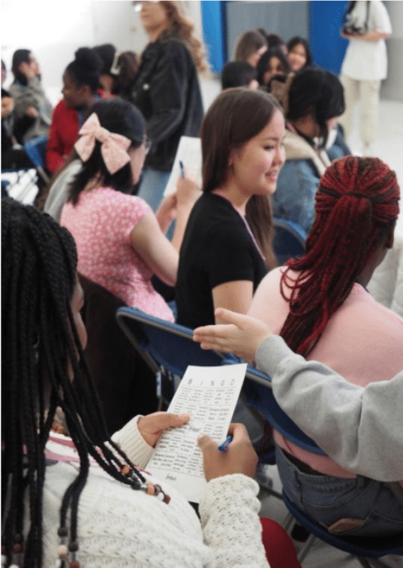 | $3,500
Ontario | Elora House  A World Day of Prayer grant of $1,000 helped fund therapeutic and holistic care activities for 20 survivors of human trafficking through Elora House.  Key goals include the building of enhanced emotional resilience through art therapy, improved mental and physical health via nutritional support workshops and strengthened peer connections through coping strategies examined in group therapy.  Impact story: “I am so thankful for everything Elora House has done for me. I honestly think I would have either been dead or in jail if it wasn’t for them. They saved my life and gave me a chance to break free from the cycle that seemed impossible to escape. I’ve learned what real support and family should look like, and unconditional love is what I found here. Elora House gave me the kind of love and care I never knew existed.” | Building Hope and Healing Program  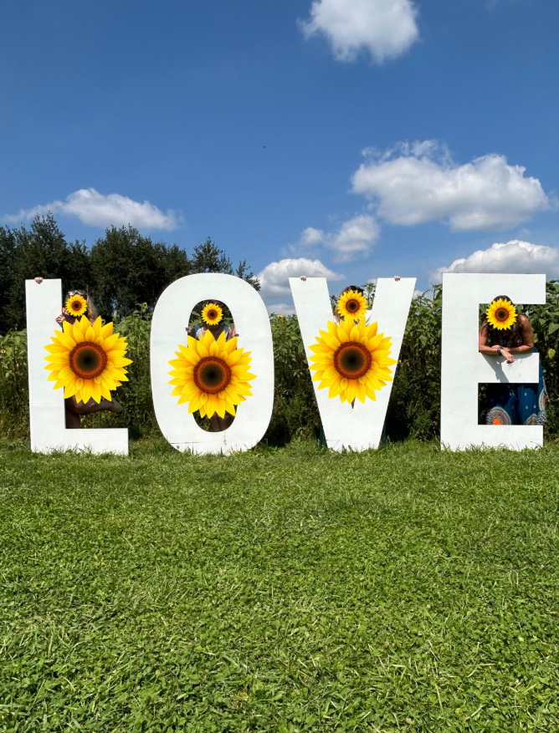 | $1,000
Ontario | Salvation Army – Belleville  A $2,900 World Day of Prayer grant funded Brave Day for twenty girls aged 12 to 18 years, as well as several Brave Circle events. Brave is an international movement that organizes experiences for vulnerable youth in order to give them positive and uplifting messages from speakers, artists and community leaders.  At the 2024 Brave Day, the girls listened to a human trafficking expert/Salvation Army officer, a police officer/lawyer and a local entrepreneur. There were breakout sessions of yoga, vision boards, crafts and self care techniques. All took home a gift bag with a tee-shirt and book.  Testimonial: Janey King, a 16 yr old Brave attendee said "The Brave event was truly a wonderful day! My favourite part was the Women's Panel. It was very inspiring to hear from a local lawyer who managed to go back to school and be called to the Bar in her 40's. She really reminded me that anything is possible! The food was great too. | BRAVE Event  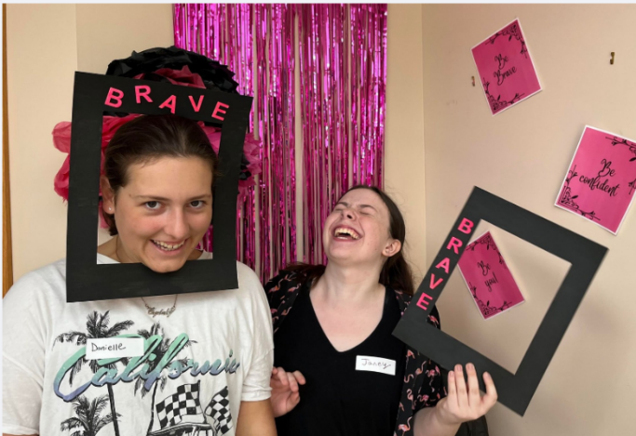 | $2,900
Ontario | FCJ Refugee Centre  The FCJ Refugee Centre provided transitional housing for 39 women and children in 2024. 18 women secured permanent housing. A $5,000 World Day of Prayer grant funded 16 workshops for these women to foster resilience, creativity and cultural understanding. Topics included sewing, domestic violence, anxiety management, dancing and painting.  By providing spaces for learning, creativity, and connection, FCJ empowered participants to express themselves, build supportive relationships, and thrive in their new Canadian context. | Empowering Refugee Women through Art and Recreation Activities  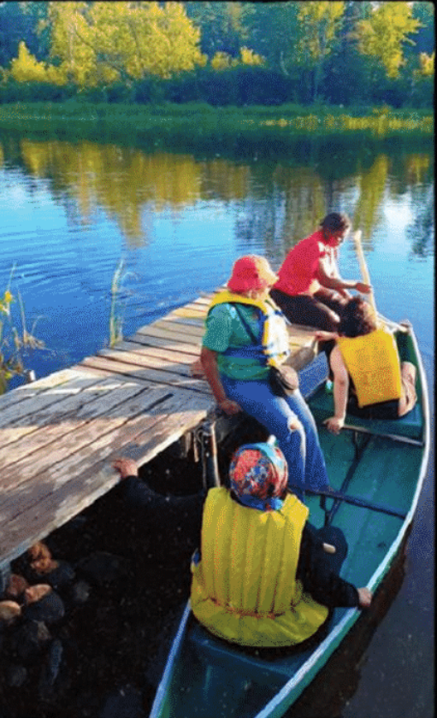 | $5,000
Ontario | Tyndale University  Tyndale University received a $3,600 World Day of Prayer grant to create a website that supports women in academia and amplifies their voices while developing an understanding of the work in connection with their Christian faith. Currently, 24 researchers from Tyndale, Redeemer, and the Institute for Christian Studies are sharing their studies on this wired impact portal. Through them, the stories of 1000 to 3000 women, research participants, will be shared.  Testimonial: One WIRED woman, upon seeing the new site at www.wiredamplified.com, wrote, “How delightful! It makes me want to invite every female scholar I know out there!! How big do we want WIRED to get? | WIRED Impact Portal   | $3,600
Nova Scotia | TREY (Trauma Recovery for Exploited Youth)  TREY (Trauma Recovery for Exploited Youth) is a non-profit organization that runs a small, safe, restorative home for young women who have escaped commercial sexual exploitation. Upon reaching a point where the residents feel prepared to transition from TREY, staff recognize the importance of ongoing support in rebuilding lives. Thanks to the World Day of Prayer grant of $5,000, two graduates received supplies, including Chromebooks, to help with their transition to independent living. Remaining grant funds enabled TREY to print and distribute materials for both schools and the public on the prevention of human trafficking. The students have welcomed the opportunity to discuss this important and very relevant topic. In June, one school invited TREY staff back to see projects many students chose to do for their Advocacy Fair after hearing the presentation from TREY.  Testimony from a school administrator - “I was contacted that (presentation) day by teachers to say how great it was! The students were very impacted by it. Each year, our Grade 8 students participate in an Advocacy Fair, which resembles a science fair project on a trifold board, but with a focus on researching social issues. Today is the fair, and there are at least a dozen projects on Human Trafficking. I asked one teacher about it and she said they started working on their projects the day after you were in, and in her two classes alone, there are 7 projects on the topic. That speaks volumes! Thank you for coming in:) We'd love to have to back again next year. | Prevention of Sexual Exploitation and Aftercare for Exploited Youths  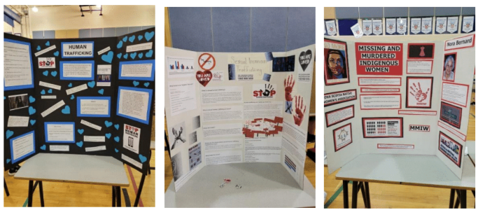 | $5,000
INTERNATIONAL
Angola | Africa Inter-Mennonite Mission Canada  A $5,000 World Day of Prayer grant helped thirteen widows in Angola to become less dependent on charity. These women were given either $200 USD to augment their current earning power or $300 USD to start new market projects, including the selling of vegetables, prepared food, spices and charcoal, either in markets or by peddling goods from door to door.  Testimony: I am Maria Luisa, a widow for over 15 years since I lost my husband. I lost all my possessions and the house that we had acquired with my late husband. His family confiscated everything. I was left with nothing, and I always tried to provide for my family, my children's health, and their schools. God answered my prayer when I received a donation from our Church (IEIMA),which has now helped me to sell coal again, as well as other things. This way, I am able to buy food and pay school fees for my orphaned children who were left in my care. I am very grateful for the support provided by the ecumenical women, for thinking of us in order to continue changing the lives of more women like me. May God bless you. | Economic Empowerment for Widowed Women and their Children  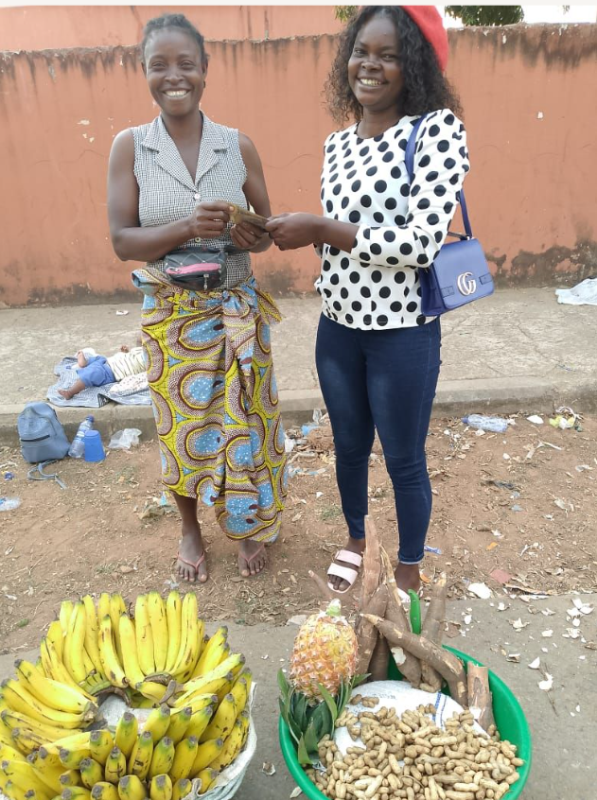 | $5,000
DR Congo | Canada Africa Community Health Alliance  A $5,000 food emergency grant was given to the Tchukudu Women’s Training Centre which exists in an active war zone. Eighty-five women, who were either trainees or graduates, and their families (over 500 individuals), were provided with the best-sourced food that could be safely transported to the Centre for distribution on a monthly basis for over half a year.  Testimony from Cathy Cleary (administrator): The current situation is a localized war that is expanding daily with countries like Rwanda, Uganda, and Burundi becoming involved in the fighting. M23 is demanding that schools open and children return. They want the appearance that everything is normal while at the same time demanding payment as well as kidnapping children to become soldiers. The women continue to pray for a future lived in a peaceful state with enough food for everyone and easy, affordable access to education for their children. I understand that you would like a personal story from one of the women, and usually, they would be so happy to provide that. At this time, I cannot ask that of anyone. The women are living minute to minute without any guarantee for the future. I hope you understand. | Tchukudu Women’s Emergency Food Initiative  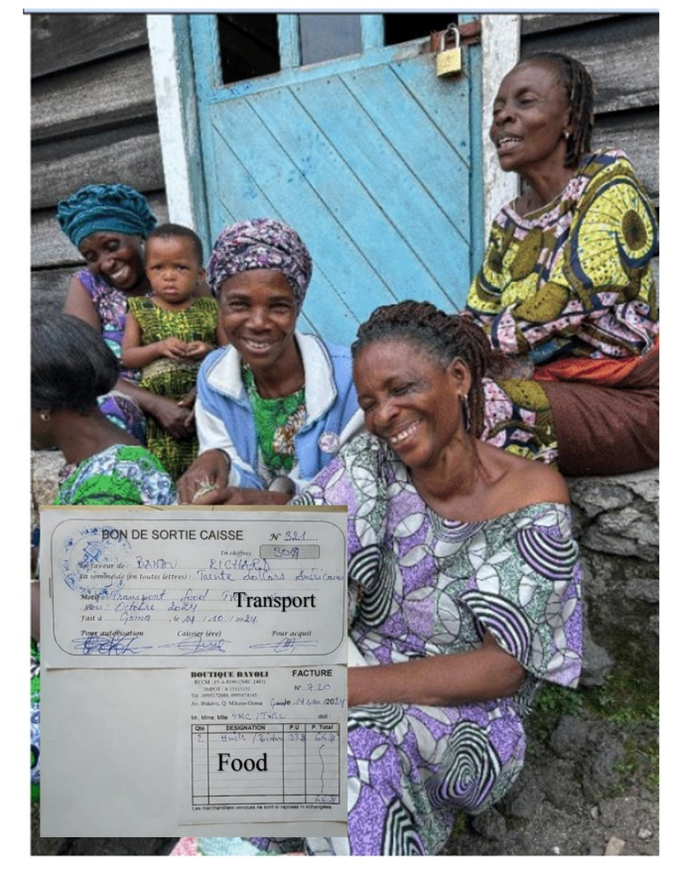 | $5,000
DR Congo | Canadian Baptist Ministries Eastern Congo  The Community of Baptist Churches in the Eastern DR Congo were given a WDP grant of $5,000 to continue peace and capacity-building training for female leaders in the Goma and Kalehe regions. 45 women reviewed training from 2023, before continuing training on reconciliation, mediation, trauma healing, restorative justice, servant leadership and caring for creation over three days. Funds were used for supplies, refreshments and transportation. | Peace & Capacity Building Training for Women Leaders  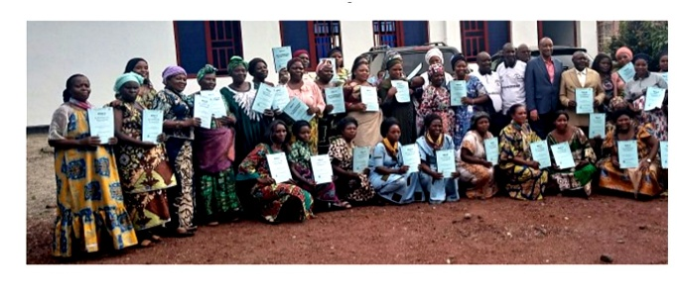  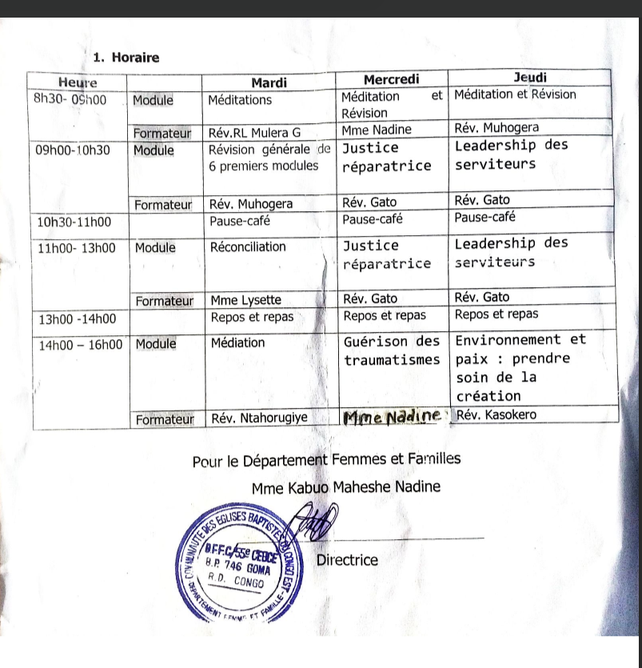 | $5,000
Kenya | Canadian Baptist Ministries/ACC&S Women’s Action  A $5,000 World Day of Prayer grant paid for hygiene supplies for 125 girls and 122 boys aged 11 to 13 years in Kenya. Each child received toothpaste, soap and underwear. Two sanitary towels were given to each girl, as well. The overall goal was to prevent school absenteeism related to hygiene concerns.  Testimony: One of the boys from Ikumbi primary school excitedly said “oh my, for the  first time a boy child has been remembered” I (mentor) asked him why and he had this to say “any time a group of people comes to our school either to speak to us and motivate us they end up giving our girls who are our classmates sanitary towels but nobody has ever bothered to know what  boy child go through. Today was a unique day both boys and girls have been considered. God  bless whoever did this to us” | Health and Mentoring for Girls  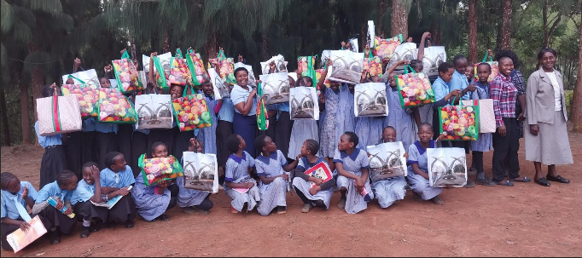 | $5,000
Philippines | Luzon Convention Baptist Fellowship  A $5,000 World Day of Prayer grant to Luzon Convention Baptist Fellowship in the Philippines supported a number of Waste Management training events. 52 women and men attended a Zero Waste Forum while 20 women from Luzon and BOT joined together for similar discussions. Materials for Sunday Schools on “waste to energy” are going to be developed and distributed while older youth were invited to a Youth Leadership Event on waste management in January 2025.  Testimony from Prima S. Formilleza (organizer): One of our objectives is “to let the neighborhood know that the church is present and has something to contribute.  That the church is not an ivory tower, looking down at what is happening below.” | Climate Change Adaptation – Waste Management  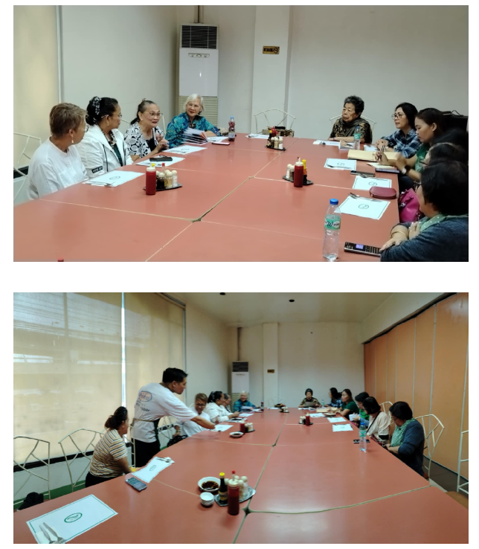 | $5,000
Guatemala | Horizons of Friendship  A $5,000 WDP grant contributed to a three-year training program by Horizons of Friendship for 175 traditional midwives. New medical equipment, education and other supplies helped improve the safe and hygienic delivery of babies and prenatal healthcare.  Testimony: This training has helped to complement my traditional knowledge with conventional medicine and science. I am grateful for the transportation support provided to me, which allows me to participate in these important training sessions.”-Magdalena, a Comadrona with over 36 years of experience delivering babies. | Maternal Health – Re-equipping Traditional Midwives  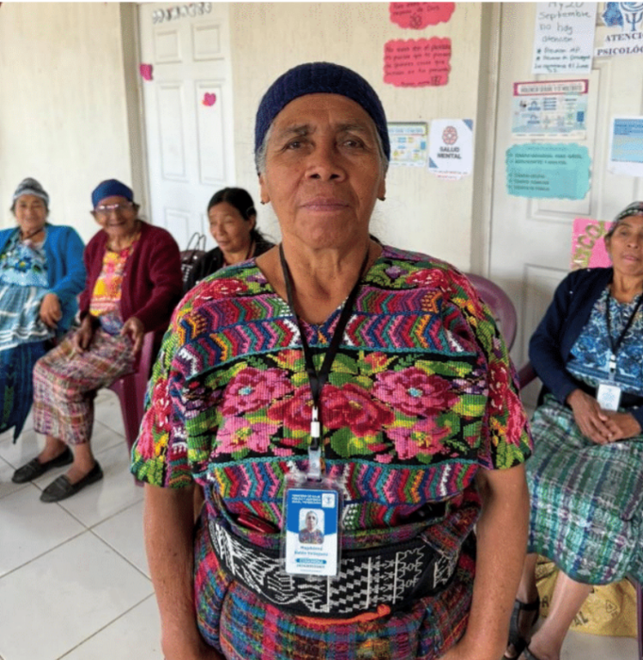 | $5,000
Cuba | The organization that received this grant requested that no information or pictures be posted on the internet or in newsletters for the safety of these organizations in Cuba, due to the regulations of the Cuban government. In general, food was distributed to 34 families over 6 months, children were invited to be part of safe programming, and supplies were distributed to an orphanage. |  | $5,000
Kenya | Village of Love  An emergency grant of $2,000 was given to Village of Love to fund meals to families in Kiberia affected by floods. In 2024, 7.2 million people in west and central Africa were affected by floods. | 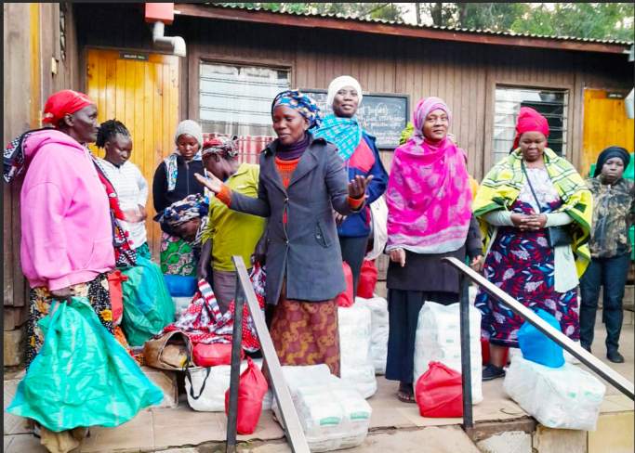 | $2,000
Total |  |  | $77,000

