World Day of Prayer 2027 – 100th Anniversary
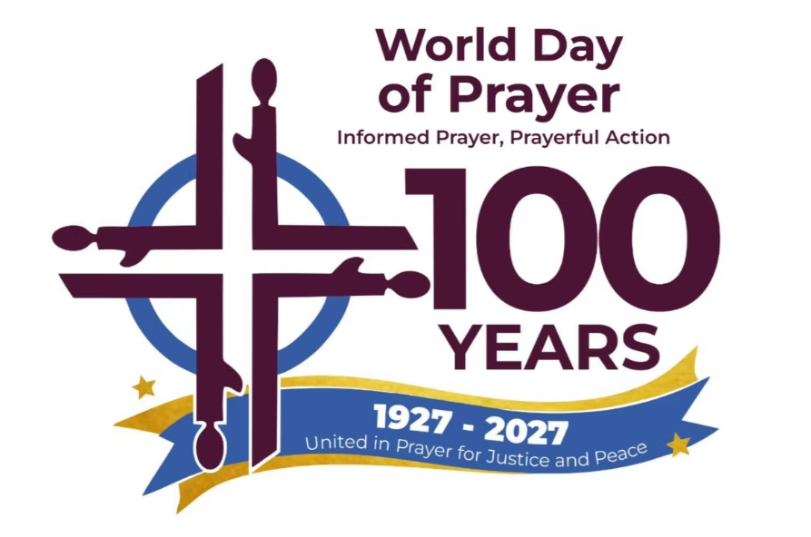
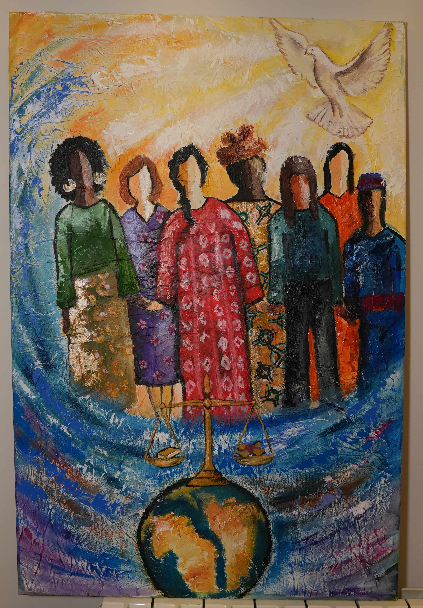

“United in Prayer for Justice and Peace”
Written by the World Day of Prayer International Committee
1 Samuel 2:1–10 • Luke 1:39–55
March 5, 2027

WELCOME
Leader 1: A hundred years ago, a small stream began to flow when a handful of women decided to pray together, on the same day, across every border they knew. That stream became a river. That river became a flood of prayers and actions that have touched every continent on earth.

Today, we gather as inheritors of and contributors to that river. We carry the prayers of Hannah, who cried out to God in a temple when no one believed in her. We carry the song of Mary, who sang of a world turned upside down before her child drew his first breath. We carry the faith of the women between 1887 and 1927, and the courage of the millions who have prayed and acted in the century since.

This service is a celebration - of one hundred years of informed prayer and prayerful action. It is also a recommitment. As we enter our second century, we lift our voices together for justice, for peace, for every woman and child whose lives this movement exists to transform.
WE GATHER
Leader 2: Let us stand, as we are able, and sing a hymn based on Psalm 133 created for this service.

All: How good, how good to live as one!
How good, how good — God’s blessings come!
How good to live as one – God’s blessings come - God’s blessings come.

Leader 1: Please repeat after me.

Leader 1: Behold!
All: Behold!

Leader 1: How good and pleasant it is
All: How good and pleasant it is

Leader 1: When God’s people live together in unity
All: When God’s people live together in unity

Leader 1: For when we live in unity
All: For when we live in unity

Leader 1: God’s blessings overflow
All: God’s blessings overflow

Leader 1: God’s justice overflows
All: God’s justice overflows

Leader 1: God’s peace overflows
All: God’s peace overflows

Leader 1: Amen
All: Amen
ONE HUNDRED YEARS: A LITANY OF CELEBRATION

Leader 1: The women of Europe shout out, “For one hundred years, Christian women have gathered to pray — crossing oceans, borders, and languages to stand before God together.” Let us all say together …
All: Thanks be to God!

Leader 2: The women of Asia shout out, “For one hundred years, we have listened to women’s voices — voices of hope from the margins, voices of sorrow from places of suffering, voices of courage that refused to be silent.” Let us say together …
All: Thanks be to God!

Leader 3: The women of North America and the Caribbean shout out, “For one hundred years, our prayers have not stayed on our lips. They have moved our feet and opened our hands — to feed the hungry, to shelter the vulnerable, and to stand beside those whom the world has abandoned. Let us respond together …
All: Thanks be to God!

Leader 4: The women of Africa shout out, “For one hundred years, we have confronted injustice with love — calling for equal dignity, fair wages, access to education and healthcare for every woman and child.” Let us respond together …
All: Thanks be to God!

Leader 5: The women of the Pacific shout out, “For one hundred years, we have prayed through world wars and pandemics, through violence and grief — and the river of our faith has never stopped flowing.” Let us respond together …
All: Thanks be to God!

Leader 6: The women of the Middle East shout out, “For one hundred years, we have shared our music, our art, our stories, our cultures — weaving a tapestry of faith that is richer for every thread.” Let us say together …
All: Thanks be to God!

Leader 7: The women of Latin America shout out, “For one hundred years, a small stream has become a mighty river. Today, in over 135 countries, women are gathering to pray. Today, we are that river.” Let us respond together …
All: Thanks be to God!

Leader 7: Let us say together ….
All: For one hundred years — and for one hundred years to come — we walk together! We work together! We pray together!

Leader 1: Please stand, as you are able, to sing We Are One in the Spirit. We are encouraged to wave our arms during the final verse to symbolize the flowing of a river.

We are one in the Spirit, we are one in the Lord,
we are one in the Spirit, we are one in the Lord,
and we pray that all unity will one day be restored,
and they’ll know we are Christians by our love, by our love,
and they’ll know we are Christians by our love.

We will walk with each other, we will walk hand in hand,
we will walk with each other, we will walk hand in hand,
and together we’ll spread the news that God is in our land,
and they’ll know we are Christians by our love, by our love,
and they’ll know we are Christians by our love.

We will work with each other, we will work side by side,
we will work with each other, we will work side by side,
and we’ll guard each one’s dignity and save each one’s pride,
and they’ll know we are Christians by our love, by our love,
and they’ll know we are Christians by our love.

All praise to Creator, from whom all things come,
and all praise to Christ Jesus, who is God’s only Son,
and all praise to the Spirit, who makes us one,
and they’ll know we are Christians by our love, by our love,
and they’ll know we are Christians by our love.

THE STORY OF WORLD DAY OF PRAYER
(a 10-minute WDP history video is available)
Leader 2: Today, we step into a river of women whose prayers, courage and actions sustained us. When we worship today, we remember 100 years of faithful women who made it possible for our generations to gather for a global movement of prayer and action. We will now share some of the historical highlights.
World Day of Prayer grew from 19th-century world missionary movements. These societies had developed annual denominational days of prayer to unite women in their work at home and abroad, and offerings funded missions.
In 1887, the Presbyterian women in the U.S. called for a National Day of Prayer, while the Anglican women in Canada established a national day of corporate intercession for mission in 1895.
Then came World War I, and the horror of nations at war with one another. The women realized: Christians must work for peace. And to work for peace, they must work together.
On October 19, 1918, Presbyterian women in Canada called together representatives of the five Women’s Missionary Boards – Anglican, Baptist, Congregational, Methodist and Presbyterian to “promote the spreading of Christ’s kingdom through united prayer and action.” This led to a national and inter-denominational day of prayer on January 9, 1920.
Leader 3: In 1922, the Canadian and U.S. committees agreed to use the same theme and day for prayer. For the 1927 Women’s Day of Prayer, a small committee of 6 women had the inspiration to send out the program to their missionary contacts around the world, which led to the words “World Day of Prayer for Missions” being on the cover. On the first Friday in Lent of 1927, women around the world prayed together for the first time.
They prayed for hearts “dominated by Christ’s passion for justice, goodwill and equal opportunity for all races and nations, industrial justice and world peace, and farm and cannery migrants.” They asked for forgiveness for their “slowness to respond to the needs of a suffering world.” They asked the Spirit to guide them “into the lives of those in need.”

A year later, in 1928, a World Missionary Conference was held in Jerusalem. Forty-two women from Asia, Africa, Latin America, Europe, and North America gathered to talk about this new World Day of Prayer.
Realizing that writers were needed from different parts of the world, other than North America, they asked Helen Kim from Korea to write the 1930 service.
Prayers confessed failures in national life, naming "class and race discrimination" and "lack of courage on moral questions." They confessed failures in church life, for being "institution-centered instead of Christ-centered." They confessed failures in international life, acknowledging "injustice and lack of brotherliness in international and interracial relations."
Leader 4: In 1938, as nations prepared for another war … women prayed a liturgy written by Alice Henderson from New Zealand entitled “The Church—A World Community.”
The women prayed: "As members of this great fellowship in the Church of the Living God, may we unite in prayer for a sense of real-world brotherhood…may we be banded together in love and understanding."
Then the bombs fell in Germany, Japan, Italy, the UK, China, France, Poland and the Soviet Union. Towns, cities, and lives were torn apart. The raging war could not stop the World Day of Prayer. The liturgies of World War II years named the horrors without flinching: concentration camps, persecution, and war. Over 40,000 Canadian military personnel were killed.
Prayers were not abstract. In Japanese-ruled Korea, Korean women and American missionaries distributed the 1941 prayer service to churches across the country to pray for peace. The authorities called the prayers anti-war and anti-national. American missionaries and Korean women were arrested, and churches were investigated.
Leader 5: The 1944 service had a stirring theme, ‘God Wondered That There Was No Intercessor.’ It was based on statements of 150 people from over 100 countries, many from nations at war with each other. They remembered the “sorrows of all the world,” praying for "stricken people, … destroyed cities, and the unprivileged masses. They prayed for their enemies and confessed their own complicity.”
The world was remade after the war. In 1945, the United Nations was founded, pledging to save future generations from the devastation of war. In 1948, the World Council of Churches was founded to work for Christian unity, stating that the “war is contrary to the will of God.”
The World Day of Prayer continued amid turmoil as oppressed and colonized people who had fought in the war to free Europe from fascism fought to be free at home. The 1953 service centered on African voices, including prayers by a South African student and a teacher in Mayamba, Belgian Congo. A prayer of forgiveness was raised “for our blindness and for the inequalities we tolerate in the family of Thy children.”
Leader 6: In the 1960s, the Second Vatican Council gave the ecumenical movement unprecedented momentum. Catholic women were officially encouraged to join the World Day of Prayer in 1967. The World Day of Prayer was also moved from the first Friday in Lent to the first Friday in March, signaling an accommodation to Orthodox women.
In 1968, 33 women from 23 countries gathered in Sweden to form the International Committee for the World Day of Prayer. Local communities, though, would continue to be the beating hearts of the movement.

The newly formed International Committee began meeting every 4 to 5 years. The 1974 location was Mexico City, where the United Nations was organizing its first conference focused solely on women in 1975.
In 1976, as the United Nations launched the UN Decade for Women, our World Day of Prayer movement prayed a liturgy written by WDP Mexico, with the theme "Education for All of Life."
Opening words included “Everything that we know must be used as an instrument to make life more human in the place where we live."
Scenes featuring social injustice for women were shared: the reality of poverty, unbalanced domestic relationships and repression of governments.
The service ended by asking: "Is it true that as Christians we have social and political responsibility?"
The 1994 liturgy by WDP Palestine was shaped by the theme "Go, See and Act," and centered on women who were “moved and affected,” and “crying and lamenting,” as they accompanied Jesus to the cross.
They prayed: "Let us pray that we can see and act like...the women of Galilee. It is the duty of all God's people to protect human life and to protest against every form of discrimination—racial, religious, political, social.”
A Palestinian woman named Amal, whose name means Hope, told her story. She spoke about still being haunted by memories of 1948 and 1967 when family members were displaced, targets, killed or injured.
Leader 7: A few years later, World Day of Prayer women named and faced another difficult reality: the AIDS crisis. African women put together a series of workshops from 2000-2002, focused on reconciliation and response to the HIV/AIDS epidemic.
In contrast to many churches and governments remaining silent about the devastation of AIDs, World Day of Prayer workshops became spaces where African women broke the silence and educated.
As the 21st century unfolded, the river of prayer met new urgencies facing the world: climate change, human trafficking and domestic violence.
In response, women were organizing — building networks across borders, demanding justice, and creating sanctuaries for the displaced and exploited.
In 2001, WDP Samoa focused the movement on its core motto: Informed Prayer, Prayerful Action. Through the traditional kava ceremony that transforms strangers into family, Samoan women spoke: "We need to be informed when we pray, and we need to be practical after our prayer. It is not prayer if we do not act."
WDP France built the 2013 service around the theme "I Was a Stranger and You Welcomed Me." Five immigrant women told their stories—of trafficking, discrimination, welcoming, and new life. The service prayed "for the courage to face the reasons why people are driven from their homes: war, natural disaster, the damage caused by climate change, and a failed economy."
The COVID-19 pandemic forced a sudden, massive shift in how World Day of Prayer services took place, accelerating reliance on digital communications. In March of 2021, many locations in Canada had restrictions that prohibited large-group gatherings involving singing and multiple leaders at a microphone. In response, WICC produced its first WDP service video, which was also broadcast on community TV channels nationwide. All WDP resources were available online rather than printed and shipped, permanently transforming how World Day of Prayer services are delivered.
SCRIPTURE & REFLECTIONS
Leader 1: Please stand, as you are able, as we sing the theme song created for the 100th anniversary of the World Day of Prayer – United in Prayer.

All: United in prayer, God’s power we proclaim,
united in prayer, we magnify God’s name.
We pray that justice will heal what is torn,
we pray that peace will be reborn.
We pray that peace will be reborn.

Leader 1: Today, we unite in prayer as we listen to two songs from Scripture—Hannah’s song and Mary’s song. These two songs are separated by centuries, yet they echo the same melody. As we hear these ancient voices, let us listen for the song that God has been singing across time and space. A song God continues to sing today, a song of justice for the oppressed and peace for the broken.

HANNAH’S SONG — 1 Samuel 2:1–10 NRSV
Leader 2: We begin with the voice of Hannah, a woman who learned through struggle what it means to trust God. Her song of praise echoes across the centuries, reminding us that God’s justice begins in the hearts of those who pray. Let us sing, once again, our theme song. You may remain seated.
All: United in Prayer

HANNAH: My name is (insert your name here), and today I will be sharing the story of Hannah found in 1 Samuel 2:1-10.

(Standing, arms raised in praise): My heart delights in YHWH! I rejoice in God’s deliverance! No one is holier than you, God. There is no rock like YHWH. All bragging must cease. Boastful arrogance must come to an end. For you are all-knowing.
You weigh all mortal deeds. The bows of warriors are broken, while those who stumble gain renewed strength. It is you, God, who deals out both life and death. It is you, God, who casts down, and it is you who raises up again. It is God who makes both the poor and the wealthy. It is God who both humbles and exalts.
God raises the poor from the dust — lifts the needy from the ash heap, and seats them with the powerful. God promotes them to seats of honour. The foundations of the earth belong to you, God, and you set the world upon them. God lights the ways of the just and delivers the evildoer to their fate.
MARY’S SONG — Luke 1:39–55
Leader 1: In that same hill country of Hannah, centuries later, another young woman, Mary of Nazareth, found herself pregnant by God’s Spirit. Mary rushed to visit her cousin Elizabeth. As soon as Elizabeth heard Mary’s voice, the child leaped in her womb, and Elizabeth was filled with the Holy Spirit as she burst into a song of praise. Please remain seated as we sing, once again, our theme song.
All: United in Prayer

ELIZABETH: My name is (insert your name here) and today I will be sharing the story of Elizabeth found in Luke 1:39-55.
(Calling out joyfully): Mary! Blessed are you among women! Blessed is the fruit of your womb! Why has this happened to me, that the mother of the Messiah comes to me? For as soon as I heard your greeting, the child in my womb leapt for joy! Blessed is she who believed that what God said would be accomplished.
MARY: My name is (insert your name here) and today I will be sharing the story of Mary found in Luke 1:39-55.
(Lifting her hands in radiant prayer): My soul magnifies the Lord, and my spirit rejoices in you, my Saviour. For you have looked with favour on the lowliness of your servant. Surely, from this day forward, all generations will call me blessed.
For you, the Almighty, have done great things for me. Holy is your name. Your mercy reaches across generations, for those who fear you. You have shown strength with your arm. You have scattered the proud in their conceit. You have brought down the powerful from their thrones while you’ve lifted the lowly to high places. You have filled the hungry with good things, while sending the rich away. You have helped your servant, Israel, in remembrance of your mercy, according to the promise you made to our ancestors. To Sarah and to Abraham and to their descendants forever!
Leader 1: Mary’s song echoes Hannah’s song, showing us that God’s justice flows from generation to generation. (Elizabeth embraces Mary.) Let us sing, once again, our theme song.

All: United in prayer, God’s power we proclaim,
united in prayer, we magnify God’s name.
We pray that justice will heal what is torn,
we pray that peace will be reborn.
We pray that peace will be reborn.

CONTEMPORARY WOMEN’S VOICES (Guest Speaker/Speakers/Devotional)
THE RIVER OF PRAYER
Prayer Leader 1: Let us pray: for centuries, the prayers of women have flowed like a mighty river across this earth. Today, we wade into that sacred stream, adding our voices to the countless women who have prayed before us. Today, we join Hannah and Mary, whose songs have shaped us. You may remain seated as we now sing in prayer.

All: We glorify your way of love,
you turn the world around,
you lead us into justice,
so that peace may abound.

Prayer Leader 2: God of our ancestors, thank you for this river of life, where we flow along with Hannah and Mary and all the women who came before us. You have inspired us through their prayers and their songs. You have connected us with your Spirit across time and space, across creed and culture, across language and experience.
Prayer Leader 3: God of the oppressed, your love embraces all who cry out for liberation. You call us to stand with all victims of domestic violence, sexual abuse, and human trafficking. You call us to end the epidemic of violence against women - the femicide that claims our sisters’ lives, the gender-based violence that happens in homes and streets, in war and peace. Free all women from the systems that devalue them, and the sexism that diminishes them.
Prayer Leader 4: God of justice, you stand with all who experience injustice. You call us to end the violence of racism and discrimination, the terror of school shootings, and the poison of hate crimes. You bring healing for those who carry trauma, comfort for those who mourn, and hope for those who despair. You demand economic justice—equal pay for equal work, fair wages, and access to education and healthcare. You call for an end to systems that keep the poor in poverty while the rich grow richer. You see and honour the contributions of women in homes, in communities, in all places where their work is devalued or made invisible. You declare that women’s lives, women’s work, and women’s voices have dignity and worth.
Prayer Leader 5: God of peace, you are present amidst the conflicts that tear our world apart—both the wars that make headlines and the violence that happens outside of those headlines. You show us that peace is not merely the absence of war, but the presence of justice. You call us to build bridges across divides and welcome immigrants and refugees. And when we find ourselves living through turbulent times, you help us find the inner peace that allows us to become instruments of peace.

Prayer Leader 6: Creator God, your heart breaks over the climate catastrophe that threatens all life on this earth. You grieve with each living being who suffers under the effects of our changing climate—the droughts, the floods, the fires, the rising seas. You offer us wisdom to change our ways of living with the earth, so that life might be allowed to flourish again. Your love flows through all creation, guiding us towards healing and abundance.
Prayer Leader 7: Triune God—Creator, Christ and Holy Spirit—your very being shows us how to find unity even as we honour difference. Help us become the Body of Christ, not by asking us to be the same, but by showing us how our differences can be a blessing to each other. Thank you for helping us to feel this bigger connection to all of life. You have brought healing and hope. You have restored our dignity. Thank you for this powerful gift of prayer that brings us fully alive and invites us to plant the seeds of justice and peace. You are worthy of all praise and honour. Amen. Let’s sing together in prayer.

All: We glorify your way of love,
you turn the world around,
you lead us into justice,
so that peace may abound.
THE LORD’S PRAYER
Leader 2: Now we join our voices with every Christian on earth in the prayer that Jesus gave us – the Lord’s Prayer. Pray in the language closest to your heart — your mother tongue, your heritage, or the language of your prayers at home.
Our Father who art in heaven,
hallowed be your name.
Thy kingdom come.
Thy will be done,
on earth as it is in heaven.
Give us this day our daily bread.
And forgive us our trespasses,
as we forgive those who trespass against us.
And lead us not into temptation
But deliver us from evil.
For thine is the power and the glory.
Forever and ever.
Amen
CALL TO PRAYERFUL ACTION
Leader 1: Our prayers have risen to God, and the Spirit now calls us from prayer to action, from words to deeds, and from intercession to transformation. For one hundred years, World Day of Prayer has lived by the motto: “Informed Prayer, Prayerful Action.” We do not pray and then turn away. We pray, and then we act. Our prayers, poured out like water, rise as a flowing river into the world—the same Spirit that moved Hannah to sing, and Mary to say ‘yes’ now carries them onward, bringing hope, justice, and mercy to every shore.
REFLECTION
Leader 2: Take a moment now to reflect: How is this service calling you into prayerful action? What specific ways is God inviting you to live out these prayers in the coming days and months?
(A brief silence — at least one minute)
Leader 2: We would ask you to now share these reflections with one or two others nearby.
OFFERING
Leader 1: For one hundred years, the offerings given at World Day of Prayer services have travelled around the world. Giving our financial resources is one way we can prayerfully act, through World Day of Prayer grants, so that all women and girls in Canada and throughout the world can live with dignity and respect.
They have built schools for girls who had no school to go to. Trained women to start businesses, to advocate for their rights, and to lead their communities.
What you give today joins a worldwide river of generosity from people in over 135 countries. Your gift will carry justice and peace to places you will never see — and it will matter!
As well, your offering ensures the continuation of future World Day of Prayer services. For a list of recent World Day of Prayer 2025-2026 grant projects funded by Canada, please go to wdpcanada.ca.

May we open our hearts and give generously as we are able. Let your offering be a symbol of your commitment to lightening the others’ loads. May our gifts, like our prayers, be a tangible expression of God's love in the world.
As the offering is collected, we will be singing “In the Waters”, a piece of music selected for the 2027 service by the writing committee. Please stand as you are able.
Verses 2 – 7
2. Praying together 3. Seeking justice
4. In our weeping 5. Crossing borders
6. In our struggles 7. Finding courage
In the waters, we are one
In the waters, we are one
In the waters, we are one
We are one, we are one, we are one.

BLESSING OF OUR OFFERINGS AND COMMITMENTS
Leader 2: Loving God — receive what we have brought. Our money, our promises, our fears, our hopes. Bless what is written and what is only held in our hearts. Transform intention into action and let it all flow outward like a river — joining the prayers and the work of women around the world, carrying justice and peace to every shore. Please join together and say …

All: God, make us instruments of your peace. Use our hands, our voices, our resources to be the answer to someone else’s prayer. Amen.
CELEBRATION & SENDING
Affirmation of Belonging
Leader 1: Each of you belongs to this movement. Whether this is your first World Day of Prayer service or your fiftieth, you are part of the same river of prayer that carried Hannah’s song and Mary’s “yes.” When you pray at home, you join millions of women across the world. When you work for justice, welcome strangers, stand with the vulnerable, build bridges across differences, or act for peace in your daily life, you carry this river forward, joining God in the transformation of the world. You belong. You matter. You are part of something beautiful, powerful, and alive.
BLESSING AND COMMISSIONING
Leader 2: Please stand, now, as you are able. May God bless you and make you a blessing to others. May God give you peace. Go forth now and be peacemakers. We have experienced unity across differences. Now go and build bridges wherever there are walls.

Leader 1: Go in peace to love and serve the Triune God and carry the love of Christ wherever you go. Please join together in saying …
All: Thanks be to God! Alleluia!
Sacred dancers lead a joyful recessional with blue fabric flowing through the congregation — the river going out into the world.

Scripture quotations are from the New Revised Standard Version of the Bible, copyright © 1989 by the Division of Christian Education of the National Council of Churches of Christ in the U.S.A. and are used by permission. All rights reserved.

Frequently Asked Questions:

- Who is writing the 2028 World Day of Prayer service? Costa Rica – “Leading the Way in Grace”.

- Are you seeking funding for a social justice project in your community? WICC distributes WDP grants up to $10,000. The application deadline is March 31, 2027. Go to wdpcanada.ca for details.

- How can I become a WICC board member? Go to https://wdpcanada.ca/get-involved/volunteer-opportunities/

Women’s Inter-Church Council of Canada – home of WDP Canada
47 Queen’s Park Cres E. Toronto, ON M5S 2C3
416.929.5184 wicc@wicc.org wdpcanada.ca

Copyright © 2025 World Day of Prayer International Committee, Inc.
“United in Prayer for Justice and Peace” was prepared by WDPIC for the 2027 World Day of Prayer. Materials are for the exclusive use of WDP programs organized by national or local committees and partner organizations. Reproduction requires permission of WDPIC.

Any offerings or funds collected related to WDP activities must be reported to the Women’s Inter-Church Council of Canada. Please make cheques payable to WICC or World Day of Prayer.

