World Day of Prayer 2027 – 100th Anniversary
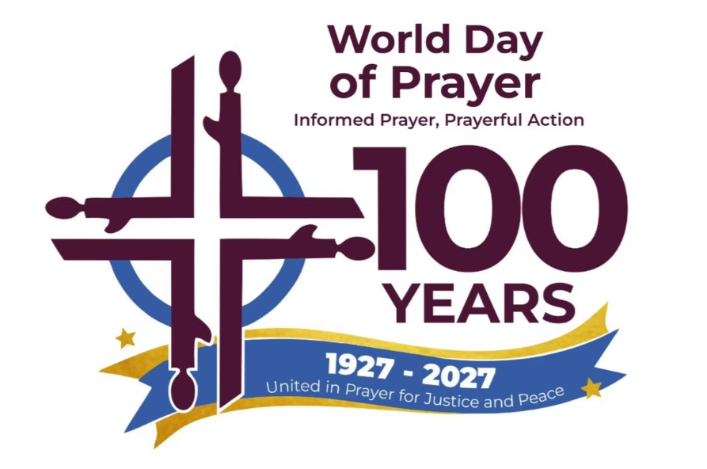
“United in Prayer for Justice and Peace”
Written by the World Day of Prayer International Committee
1 Samuel 2:1–10 • Luke 1:39–55
March 5, 2027
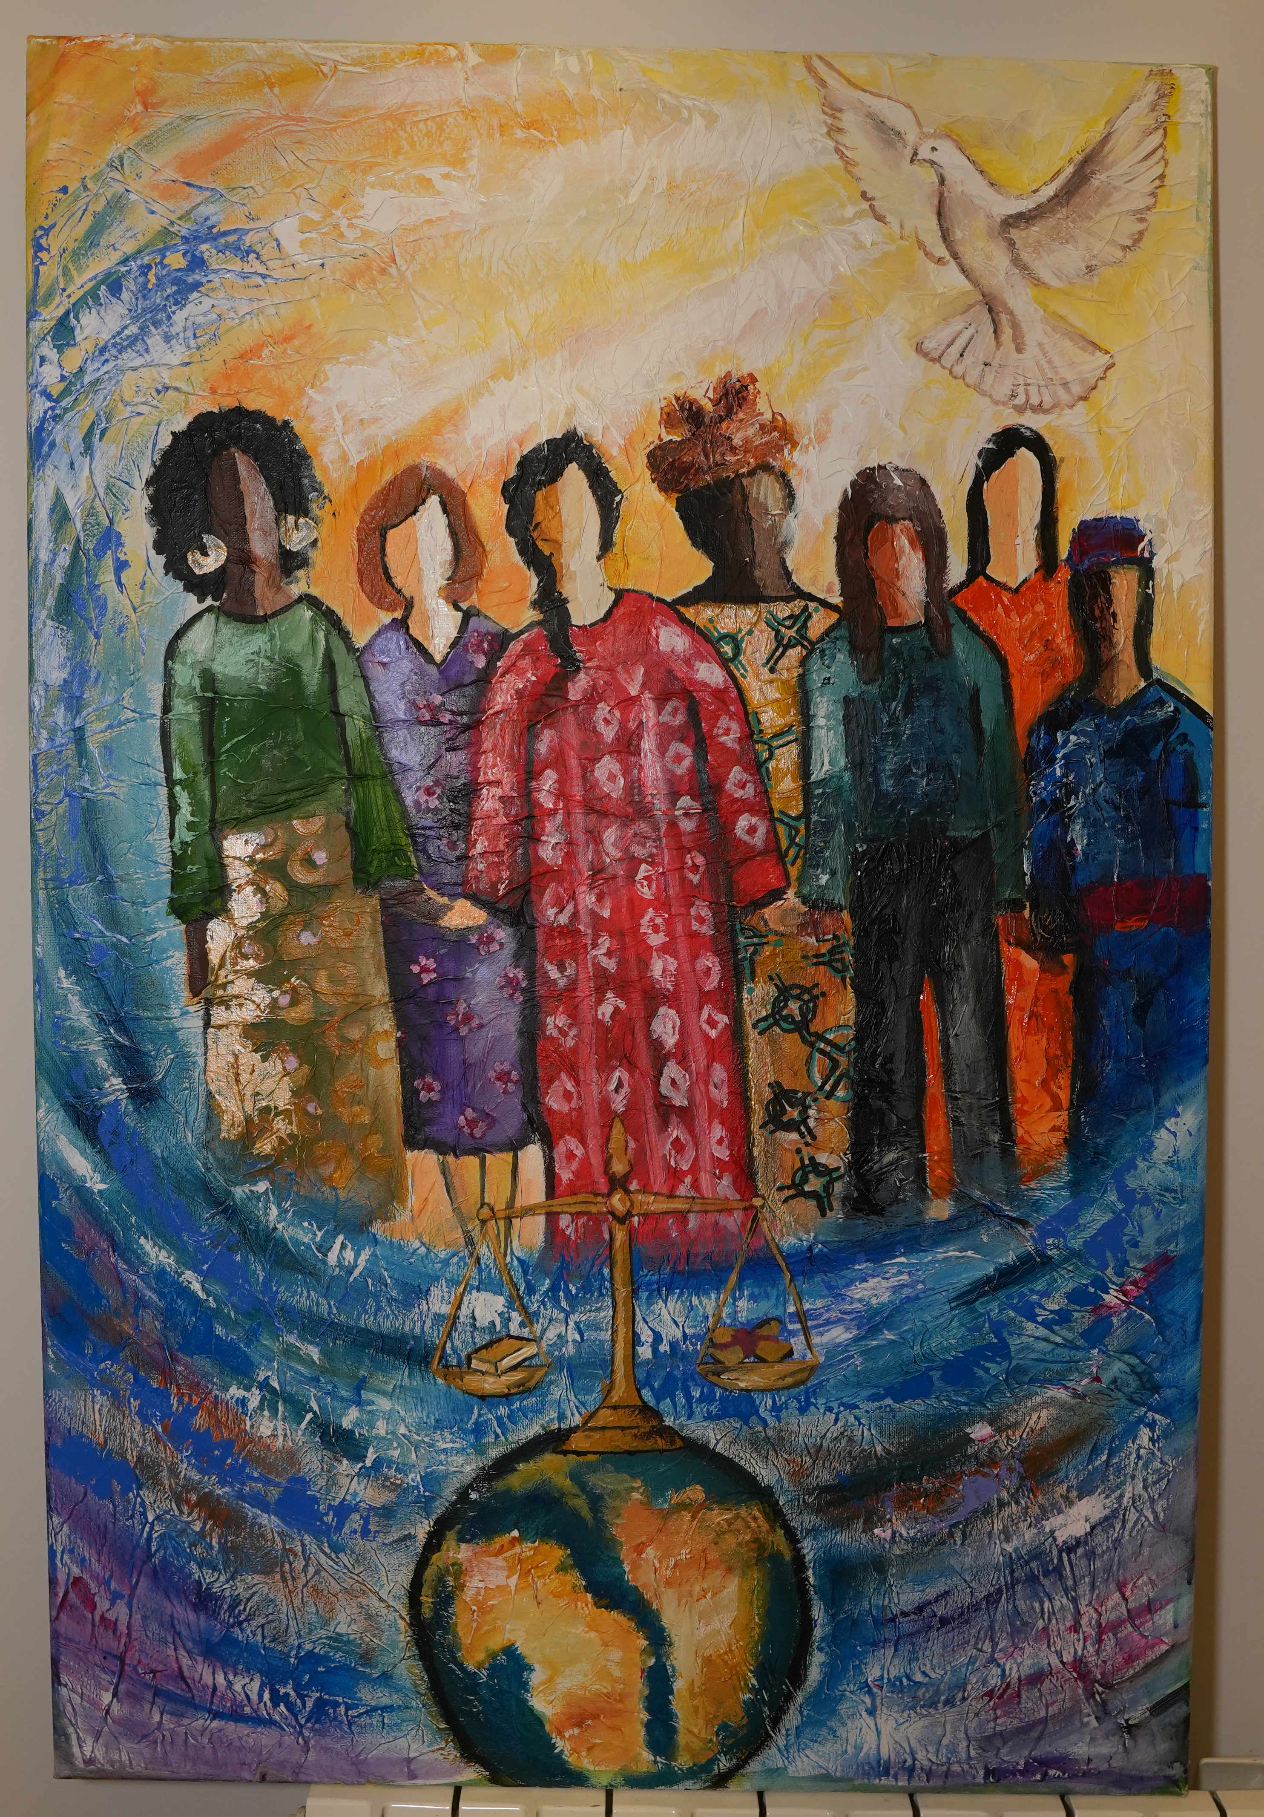

WELCOME Participants
Leader 1:
WE GATHER
Leader 2: Let us stand, as we are able, and sing together a verse of Psalm 133 created for this service.
All: How good, how good to live as one!
How good, how good — God’s blessings come!
Leader 1: Please repeat after me.
Leader 1: Behold!
All: Behold!
Leader 1: How good and pleasant it is
All: How good and pleasant it is
Leader 1: When God’s people live together in unity
All: When God’s people live together in unity
Leader 1: For when we live in unity
All: For when we live in unity
Leader 1: God’s blessings overflow
All: God’s blessings overflow
Leader 1: God’s justice overflows
All: God’s justice overflows
Leader 1: God’s peace overflows
All: God’s peace overflows
Leader 1: Amen
All: Amen
ONE HUNDRED YEARS: A LITANY OF CELEBRATION
Leader 1: Let us say together …
All: Thanks be to God!
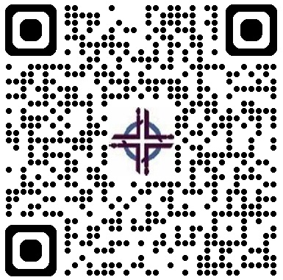
Leader 2: Let us say together …
All: Thanks be to God!
Leader 3:. Let us respond together …
All: Thanks be to God!
Leader 4: Let us respond together …
All: Thanks be to God!
Leader 5: Let us respond together …
All: Thanks be to God!
Leader 6: Let us say together …
All: Thanks be to God!
Leader 7: Let us respond together …
All: Thanks be to God!
Leader 7: Let us say together ….
All: For one hundred years — and for one hundred years to come — we walk together! We work together! We pray together!
Leader 1: Please stand, as you are able, to sing We Are One in the Spirit. We are encouraged to wave our arms during the final verse to symbolize the flowing of a river.

THE STORY OF WORLD DAY OF PRAYER
(a 10-minute WDP history video is available)
Leader 2: We will now share some history of the World Day of Prayer.
SCRIPTURE & REFLECTIONS
Leader 1: Please stand, as you are able, as we sing the theme song created for the 100th anniversary of World Day of Prayer – United in Prayer.
United in prayer, God’s power we proclaim,
united in prayer, we magnify God’s name.
We pray that justice will heal what is torn,
we pray that peace will be reborn.

Leader 1: Today, we unite in prayer as we listen to two songs from Scripture—Hannah’s song and Mary’s song.
HANNAH’S SONG — 1 Samuel 2:1–10 NRSV
Leader 2: We begin with the voice of Hannah, …

HANNAH: My name is (insert your name here), and today I will be sharing the story of Hannah found in 1 Samuel 2:1-10.
MARY’S SONG — Luke 1:39–55
Leader 1: In that same hill country of Hannah, centuries later, another young woman, Mary of Nazareth, …
ELIZABETH: My name is (insert your name here) and today I will be sharing the story of Elizabeth found in Luke 1:39-55. …
MARY: My name is (insert your name here) and today I will be sharing the story of Mary found in Luke 1:39-55.
Leader 1:
All: United in prayer, God’s power we proclaim, …
CONTEMPORARY WOMEN’S VOICES (Guest Speaker(s))
THE RIVER OF PRAYER
Prayer Leader 1: …. You may remain seated as we now sing in prayer.
All: We glorify your way of love,
you turn the world around,
you lead us into justice,
so that peace may abound.
Prayer Leader 2:
Prayer Leader 3:
Prayer Leader 4:
Prayer Leader 5:
Prayer Leader 6:
Prayer Leader 7: … Amen. Let’s sing together in prayer, as above.
All: We glorify your way of love, …
THE LORD’S PRAYER
Leader 2: Now we join our voices with every …
All: Our Father, who art in heaven …
CALL TO PRAYERFUL ACTION
Leader 1:
REFLECTION
Leader 2: Take a moment now to reflect. ….
(A brief silence — at least one minute)
Leader 2: We would ask you to now share these reflections with one or two others nearby.
OFFERING
Leader 1: For one hundred years, the offerings given at World Day of Prayer services have travelled around the world. …
As the offering is collected, we will be singing “In the Waters”, a piece of music selected for the 2027 service by the writing committee. Please stand as you are able. (Please make cheques payable to WICC or Women’s Inter-Church Council of Canada or text (647) 953-5557 from a smartphone.)
Verses 2 – 7
2. Praying together 3. Seeking justice
4. In our weeping 5. Crossing borders
6. In our struggles 7. Finding courage
In the waters, we are one
In the waters, we are one
In the waters, we are one
We are one, we are one, we are one.
BLESSING OF OUR OFFERINGS AND COMMITMENTS
Leader 2: Loving God — receive what we have brought. … Please join together and say …
All: God, make us instruments of your peace. Use our hands, our voices, our resources to be the answer to someone else’s prayer. Amen.
CELEBRATION & SENDING
Affirmation of Belonging
Leader 1: Each of you belongs to this movement. Whether this is your first World Day of Prayer service or your fiftieth, you are part of the same river of prayer that carried Hannah’s song and Mary’s “yes.” When you pray at home, you join millions of women across the world. When you work for justice, welcome strangers, stand with the vulnerable, build bridges across differences, or act for peace in your daily life, you carry this river forward, joining God in the transformation of the world. You belong. You matter. You are part of something beautiful, powerful, and alive.
BLESSING AND COMMISSIONING
Leader 2: Please stand, now, as you are able. …
Leader 1: Go in peace to love and serve the Triune God … Please join together in saying …
All: Thanks be to God! Alleluia!
Copyright © 2025 World Day of Prayer International Committee, Inc.
Distributed in Canada by The Women’s Inter-Church Council of Canada. 47 Queen’s Park Cres., E, Toronto, ON M5G2S5 wicc@wicc.org
Frequently Asked Questions

Frequently Asked Questions:

- Who is writing the 2028 World Day of Prayer service? Costa Rica – “Leading the Way in Grace”.

- Are you seeking funding for a social justice project in your community? WICC distributes WDP grants up to $10,000. The application deadline is March 31, 2027. Go to wdpcanada.ca for details.

- How can I become a WICC board member? Go to https://wdpcanada.ca/get-involved/volunteer-opportunities/

Women’s Inter-Church Council of Canada – home of WDP Canada
47 Queen’s Park Cres E. Toronto, ON M5S 2C3
416.929.5184 wicc@wicc.org wdpcanada.ca

Scripture quotations are from the New Revised Standard Version of the Bible, copyright © 1989 by the Division of Christian Education of the National Council of Churches of Christ in the U.S.A. and are used by permission. All rights reserved.

Any offerings or funds collected related to WDP activities must be reported to the Women’s Inter-Church Council of Canada. Please make cheques payable to WICC or World Day of Prayer.

