Planning Guide for 2026 World Day of Prayer (WDP) Services – prepared by the Women’s Inter-Church Council of Canada (WICC)
WDP 2026 Theme: “I Will Give You Rest: Come” Matthew 11:28-30
Writing Committee Country: Nigeria
Thank you for coordinating a World Day of Prayer 2026 event in your community!
PLANNING STEPS for a World Day of Prayer Service:

- Understand the Basics of a WDP Service
- Register for online WDP Resources
3. Become Familiar with Resources
4. Form a Planning Committee
5. Set a Service Date & Time
6. Choose Location & Delivery Style
7. Assign Roles
8. Choose Materials
9. Select music: provided/ersonal
10. Publicize – invite local churches
11. Organize and Practice
12. Wrap up; Submit Offering and Evaluation
Also included in this guide: WDP Resources Log-In Instructions (p. 11); List of 2024/2025 WDP Grants; Evaluation Survey; Recipe, and Contact Information for Assistance (WDP Field Reps).
Step ONE: Understand the Basics
- What is World Day of Prayer? The World Day of Prayer is an international ecumenical Christian laywomen’s initiative celebrated in over 150 countries on or around the first Friday in March for almost 100 years. Motto: Informed Prayer and Prayerful Action
B. What are the Four Parts of a World Day of Prayer event/service?
1. Prayer for the women of Nigeria
2. Invitations for others to join your event/service
3. An opportunity to donate
4. Use of the WDP service provided by WICC – available in print, online, PowerPoint, USB and video formats

Step TWO: Register for WDP Service Resources
To create an account to access WDP resources on wdpcanada.ca, follow the instructions found near the end of this guide. For those without a computer, there is often a friend or relative or team member or church office contact who can help out. If you have registered online as a WDP Coordinator in past years, you do not need to register again.
WDP resource accounts give people the opportunity to download the Worship Service as well as accessing many other materials. WICC will also email you helpful information.

Step THREE: Become Informed
Become familiar with the Worship Service and it’s length, Nigerian background information, and WDP grant summaries. At least one committee member should be receiving the quarterly WICC e-newsletter: We-Connect. Check out all the free WDP resources at wdpcanada.ca.
Many communities have a World Day of Prayer binder with useful information that is passed along from one Coordinator to the next. Please get in touch with the 2025 Coordinator or service location in your area to see if such a binder exists.
Watch the 55-minute service video, which will be available by January 15, 2026, to gain an overview. You may want to show this video at your service to make organization simpler. Go to page 6 for info about this resource.

If you need help along the way with any aspect of World Day of Prayer, please contact your WDP Field Rep:
Field Rep Area Field Rep Email Address Telephone
BC, AB, SK, MB, YT, NT, NU Linda Ervin fieldrep567@wicc.org 250-493-5333
ON* Cathy Tubb fieldrep45@wicc.org 416-450-1027
*Toronto, ON Janet MacFadyen communications@wicc.org 647-515-7770
QC, NB, PE, NS, NL Julie Ginter fieldrep4@wicc.org 905-550-2307
Or contact the WICC office administrator, Latha Mitchell, at 416-929-5184 or wicc@wicc.org

Step FOUR: Invite others to get involved, especially those from community area churches. A planning committee can be an enjoyable way to share the tasks and more easily do the marketing, technical set-up, materials gathering, etc. Suggested roles:
Service Coordinator: ________________________ #/email: _________________
Publicist (social media, posters): ____________________ #/email: _________________
Treasurer (to count offering) : ____________________ #/email: __________________
Other 2026 WDP Committee Members:
__________________________ #/email: __________________________
__________________________ #/email: __________________________
__________________________ #/email: __________________________
NOTE: If you become unable to coordinate the service, please help choose/recommend a backup Coordinator, and call or email WICC: wicc@wicc.org; 416.929.5184 with this information. If you cannot find a replacement, please let us know that too.
Step FIVE: Choose a date and time for your WDP event that best suits your community.
Date: ______________________
Time: ______________________
Traditionally, World Day of Prayer is held on the first Friday in March. Communities may select a more suitable day in 2026 for their areas.
Weather in Canada can be unpredictable. Please choose a “snow/rain” date for your event if meeting in person.
Rain Date: ______________________

Step SIX: Choose a location and delivery style. Check all equipment.
Church/Venue: __________________________
Address: ________________________________
(Power) Wheelchair accessible? Yes No
Audio/Visual equipment available? Yes No
(projector screens, laptops, internet, etc. - test out in advance at the event/service location)

If your service will be in or connected to a church, contact the clergy person and let him/her know about the World Day of Prayer movement. Clergy are welcome to call the WICC office.
Helpful Questions:
- Will the service be in person or via the internet?
- Will you watch the full-length service video or have live leaders/readers or have a combination of both? Using the service video may provide planning flexibility. A PowerPoint of the service is also available. This can help avoid printing costs.
- Is there a place that you can bless by sharing a service and fellowship? Examples: retirement home, prison, school.

Note your Agreement with WICC: The Women’s Inter-Church Council of Canada (WICC) has provided World Day of Prayer materials. By using these materials, you enter into an agreement with WICC to send the offerings received at your World Day of Prayer service directly to WICC.

Step EIGHT “A”: Materials
- Request Offering ENVELOPES through the WICC online store: https://wdpcanada.ca/wicc-store/ or emailing wicc@wicc.org. The envelopes are free.
OR . . . . . Make Your Own Offering Envelopes. Offering envelopes can be personalized for WDP 2026 by creating a sticker that includes artwork especially created for the service.
Hand out the envelopes or attach them with paper clips or staples to the bulletins distributed. Please note that online donations are possible through canadahelps.org.
- A WDP packet can be ordered by going to the WICC online store: https://wdpcanada.ca/wicc-store/. The cost is $25 and shipping is included.
World Day of Prayer Service Packets contain:
- Printed materials: 1 copy of the WDP Service (11 X 8.5; 12 pages); Participant Service Bulletin (booklet form; 1 page; front and back); Nigeria background information.
- a USB Memory stick with a 55-minute prerecorded WDP service, music from Nigeria, WDP worship service PowerPoint, and a 6-minute video about Nigeria.
Note: If you order a USB, please order the offering envelopes in the same checkout cart.
You may want to photocopy the whole WDP Service or the Participant Service Bulletin for in-person gatherings.
For a PowerPoint of the full service, log into online resources or email wicc@wicc.org or call 416.929.5184.
Step SEVEN: Assign Roles and Decide on Equipment
Assign roles for the event/service: set-up, greeters, readers, leaders, offering collectors and counters, and refreshment providers/servers. These will vary depending on whether or not the service video is used. Have a backup plan in case of illness. At least one committee member or the Coordinator should be registered to access online resources.
The worship service has been organized with 2 leaders, a scripture reader and 3 women sharing stories by Nigerian women. However, please feel free to divide up your reading sections to best suit your group. Another suggestion is to play all or parts of the WDP Service video, produced by WICC, at your gathering.
Recruit a technical person to help with any audio-visual aspects including showing the service video, PowerPoint, sound system, Zoom, etc.
Electronic equipment you may need for the service: microphones, projector, screens, laptop. Test them out ahead of time in the place where you will use them.

Find time to practice your service – in a church or virtually. Test out all equipment in the service or delivery location.

Step EIGHT “B”: Materials
Service Table
It’s nice to place a display table where it can be easily seen at the entrance or in the worship area. The presentation, reflecting Nigeria, could include a candle, rocks (representing burdens), yams, oil, rice, yellow trumpets or similar flowers and colourful cloth with geometric patterns.

Have a Bible open at Matthew 11: 28-30, a print of the WDP 2026 artwork, and a map of Nigeria or the world.

Step EIGHT “C”: Materials
- Artwork: “Rest for the Weary” by Gift Amarachi Ottah

You might want to display the WDP 2026 Artwork – “Rest for the Weary”. This piece depicts the daily reality of rural Nigerian women, whose lives are marked by endless labor from sunrise to sunset.

The artwork also shows three women sitting together, their different traditional attire representing Nigeria's diverse cultures. Though they come from different ethnic groups, their shared experiences unite them. To meet their basic survival needs, these women carry burdens and traumas that are physical, emotional and spiritual.

Yet there is hope for the many burdens these people are carrying. These burdens become bearable when we respond to Jesus’ invitation in Matthew 11:28, “Come to me, all you who are weary and are carrying heavy burdens, and I will give you rest.”
Go to https://wdpcanada.ca/wp-content/uploads/Instructions-to-Create-and-login-to-Service-Coordinator-Resources.pdf to learn how to download this resource and read more about the art and artists.
- WDP 2026 resources for children and youth are available at https://wdpcanada.ca/world-day-of-prayer/how-to-participate/.

ACCESSING MATERIALS
Reminder: All World Day of Prayer 2026 resources can be viewed and/or downloaded by creating an account. Go to page 11 for instructions. A few materials can be accessed at https://wdpcanada.ca/world-day-of-prayer/how-to-participate/ without registering.
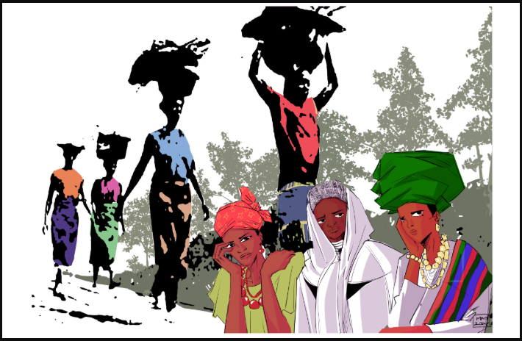
Step EIGHT “D”: Materials - Signage & Greetings
Create a welcoming space with signage and greeters.
Greet people as they arrive. If your service is in-person, you may want to give everyone a square of geometric cloth. Ask your guests to sign in to help track your attendance and create a sense of community connection.
Check signage for wheelchair-accessible paths and washrooms.
For a virtual service, assign someone to admit and/or greet guests as they arrive on the computer screen.

Step EIGHT: “F”: Materials for a Creative Event
WDP 2026 services can be incorporated into a paint session, cloth dying/stamping activity, food demonstration, craft session for a djembe drum, road trip, special guests' performance, church meeting, and much more. Plan ahead and acquire all the materials you may need for these creative events.

Step EIGHT “E”: Materials
Worship Service Video produced by WICC
Available FREE to download from wdpcanada.ca after January 15, 2026
OR
Available on the WDP 2026 USB stick, which can be purchased from wdpcanada.ca/wicc-store for $25.
This wonderful fifty-five-minute recording includes:
- Closed captioning in English for all speaking and singing
- Information about Nigeria
- Prayers, stories, and a Bible study from the Nigerian writing committee
- An opportunity to donate
- Pictures from across Canada of past WDP services
- Special music

Step TEN: Publicize the Service
One of the most important tasks for a WDP Coordinator is promoting World Day of Prayer.
- Print posters, forward media releases, send out invitations, supply bulletin inserts to community churches at least a month in advance of the service.
- Mention World Day of Prayer when you see people. Face-to-face invitations can work best.
- Call, email and text friends, neighbours, and community groups. Use Facebook and Instagram.
- Put up posters in churches, community centers, ice arenas, grocery stores, libraries, post offices, etc.
- Notify community churches with phone calls to pastors, office administrators and contacts for any church organizations. Ask for the service to be marked on church calendars, websites, print bulletins and electronic messaging boards. Check that information can be found via internet search engines.
- Advertise using free sites such as online community newsletters or newspapers.
- Contact local, provincial, and federal politicians, and other community leaders to attend.
- National Service Area Map.
World Day of Prayer 2026 service information in Canada can be shared by coordinators on our national online map. Go to https://wdpcanada.ca/service-locations/ to add your details.

Step NINE: Music and Sounds
The Worship Service does not require certain songs or hymns to be sung. You can choose the music provided by the Nigerian writing team (copyrighted for WDP 2026 service) or hymns from common hymn books or decide on a combination of new and familiar songs of praise or see the list of suggested hymns provided by WICC. Note any copyright requirements for sharing music.
Recordings, sheet music and lyrics for the Nigeria soundtracks, and suggested hymns are available on-line by registering. Go to https://wdpcanada.ca/wp-content/uploads/Instructions-to-Create-and-login-to-Service-Coordinator-Resources.pdf to learn how to download resources; look for + Music.
Discuss with your choir and/or organist about the need to learn any music.

Step ELEVEN “B”: During the Service
Offering
Give everyone attending a WDP service an opportunity to donate.
Donations support World Day of Prayer itself and the WDP grant program.
A list of 2024/2025 grants can be found at the end of this document or go to wdpcanada.ca/grant-programs/ for more detailed information. Please consider sharing more details about a couple of the grant projects prior to the offering. A summary chart of grants is included at the end of this document.

Distribute WDP offering envelopes before the service begins to give people an opportunity to record their addresses for tax receipt purposes. Tax receipts will be issued for amounts of $20 or more.

Cheques should be made out to WICC or Women’s Inter-Church Council of Canada or World Day of Prayer or WDP.

Online donations are encouraged for both virtual and in-person services. Participants can use the DONATE button on the WICC website wdpcanada.ca/donate. Or text “Give 20” (or other amount) to donate at 647.953.5557.

Instructions for submitting offering donations can be found in Step Twelve – After the Service.

Step ELEVEN “C”: During the Service
BIBLE PASSAGE: Matthew 11: 28-30
A complete version of the Bible study can be found by logging into online WDP resources.
The Bible text can be creatively presented using drama or other expressive formats.
Text (NRSV):
"Come to me, all you who are weary and are carrying heavy burdens, and I will give you rest. Take my yoke upon you, and learn from me, for I am gentle and humble in heart, and you will find rest for your souls. For my yoke is easy, and my burden is light." (Matthew 11:28-30)

Step TWELVE “A”: After the Service
Many attending World Day of Prayer enjoy a time of fellowship after the service. If permitted, light refreshments could be served. For recipes to use, see the next page as well as the Service Program & Planning Tools section of the online resources. For virtual services, participants may want to stay after the service to say hello to old and new friends or join a break-out room to create smaller interaction groups.

Step TWELVE “B”: After the Service – Refreshments/Snacks
Thank you to Latha Mitchell, WICC Administrator, for providing and testing this recipe.
Nigerian Street Food – Boiled Corn and Toasted Coconut
In Nigeria, one of the most beloved rainy-season street snacks is boiled corn with roasted coconut — simple, comforting, and delicious!

👉 Nigerian Boiled Corn
- Use 4 fresh corn on the cob (cut each into 4 pieces). If not in season, use frozen corn.
- Tender Method: Boil water, remove from heat, add corn + salt, cover, and let steep for 8–12 minutes.
- Chewier Method: Simmer husked corn in salted water for 30–40 minutes.

👉 Flavoured Butter Sauce (Optional)
Mix together:
- 2 tbsp melted unsalted butter
- 1 tsp paprika (or cayenne for more spice) (optional)
- ½ tsp salt (optional)
- Zest of 1 lime + juice (to taste)
- 1 tbsp chopped fresh coriander or parsley
🌶️ Brush over hot corn for extra flavour!

👉 How to Roast a Coconut 🥥
- Preheat oven to 375°F / 190°C.
- Pierce one of the “eyes” of the coconut, one eye will be the soft to piece, drain the water (drink it – it’s tasty!).
- Bake whole coconut for 15–25 minutes until the shell cracks.
- Cool slightly, tap with cleaver to open, then return halves to oven for another 20 to 25 minutes.
- Flesh should separate easily with a light roasted aroma.
- For crunchy snacks: cut into strips/chunks and roast again at 350°F / 180°C for 10–20 minutes.
✨ To Serve
Enjoy sweet, juicy corn pieces with nutty roasted coconut. Perfect together — a true Nigerian classic!

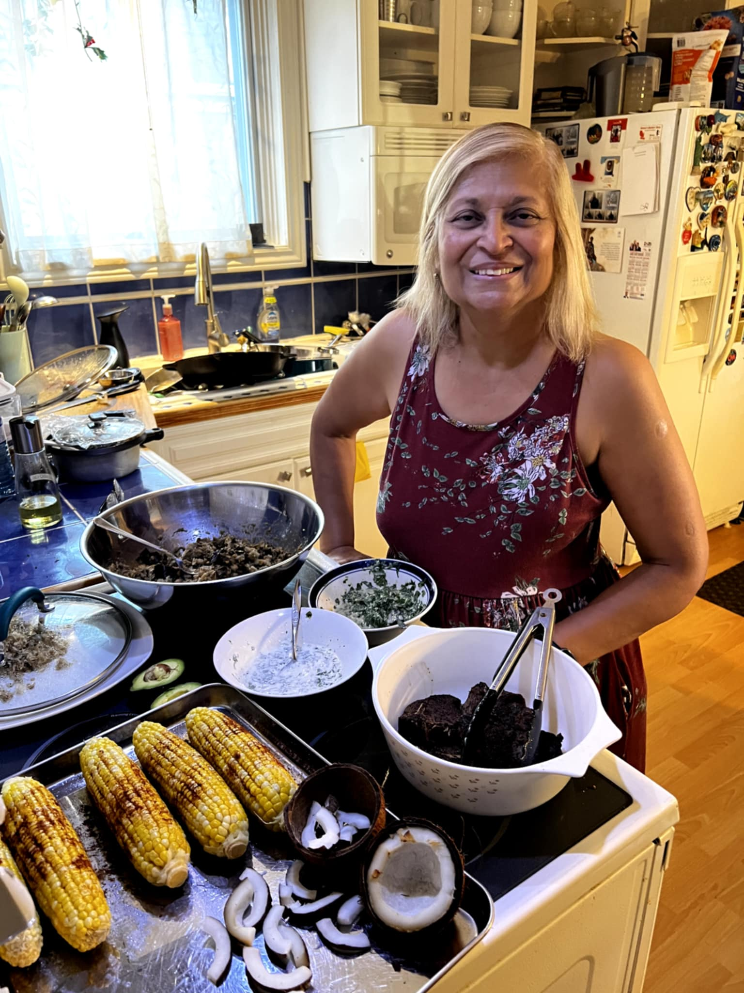

Want to know more about World Day of Prayer?
Visit https://worlddayofprayer.net/index.html

Step TWELVE “B”: After the Service (A, B, C & D relate to In-Person Services)

Processing the Offering

- Print the offering form: https://wdpcanada.ca/wp-content/uploadsOffering-Form-WDP-FINAL.docx (check link with Julie – “upload”)
- Fill in the offering. For all donations of $20 or more, include the person’s name, mailing address and offering amount so WICC can issue them a tax receipt. Do not include the names/donations of people who donate online. For those donating online, a tax receipt will automatically be generated for donations of $10 or more. Please keep the offering envelopes until May 2027 or mail them in with the Offering Form.
- Make sure that your name and phone number are at the top.
- If you want WICC to let you know that we have received your offering, please check the appropriate box at the bottom of this form.
Make a photocopy of your completed Offering Form for your records.

- Gather all the items to be sent.

Include the form (see above) and the cheques individuals’ offering cheques, and a cheque, bank draft or money order for the cash offerings.

B. Mail everything directly to WICC within a month of the service:
WICC (Women’s Inter-Church Council of Canada)
47 Queen’s Park Crescent East
Toronto, ON M5S 2C3
Feel free to call us if you have any questions: 416-929-5184

- An evaluation will be emailed to you on March 5. It asks for the name of the 2027 service Coordinator – or a chance to say that your community will need help from your Field Rep to find someone. Sample questions are on page 18.

Create a World Day of Prayer Service Resources Login

- Go to web address: wdpcanada.ca.

- Click the LOGIN/REGISTER button on the top right corner.
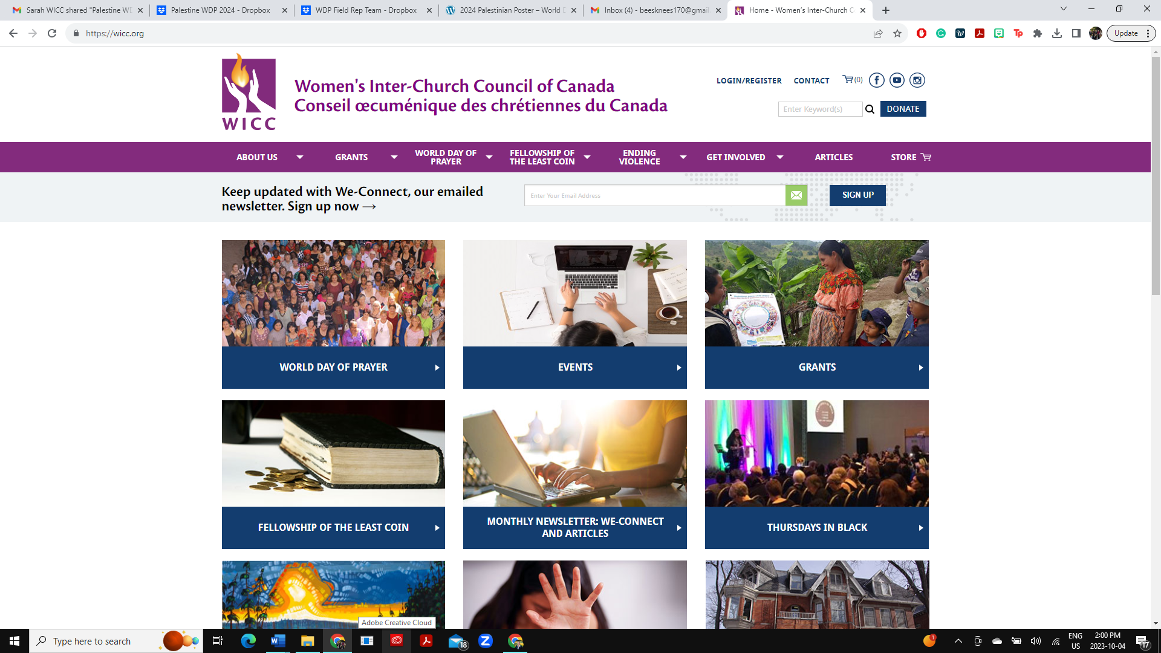

- On the login screen, click “Please use this form” in the register box (bottom middle of page).
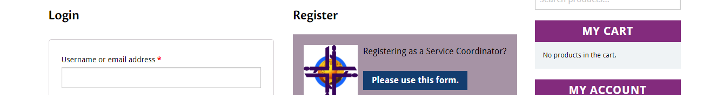

- Please fill in your information. Boxes with a * are mandatory. Create a password, confirm password and click the “REGISTER” button at the bottom.

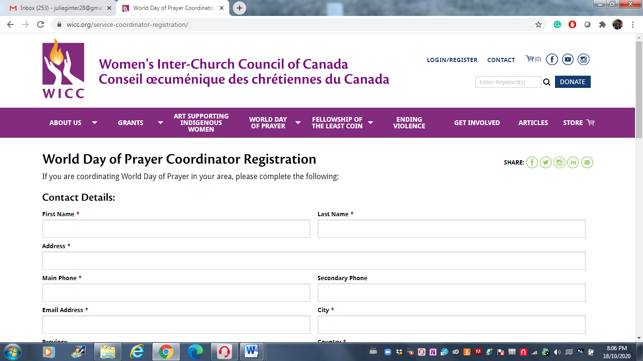
NOTE: Address needs to be your mailing address.
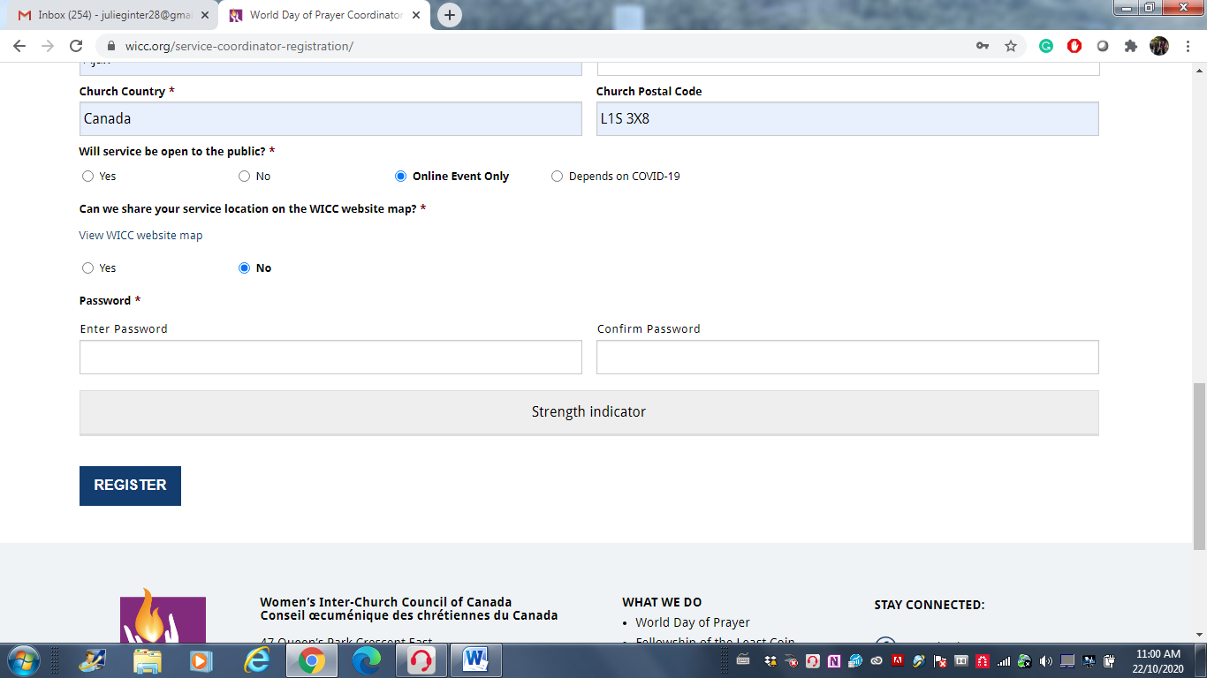

- Enter your email address/password and click Log In.
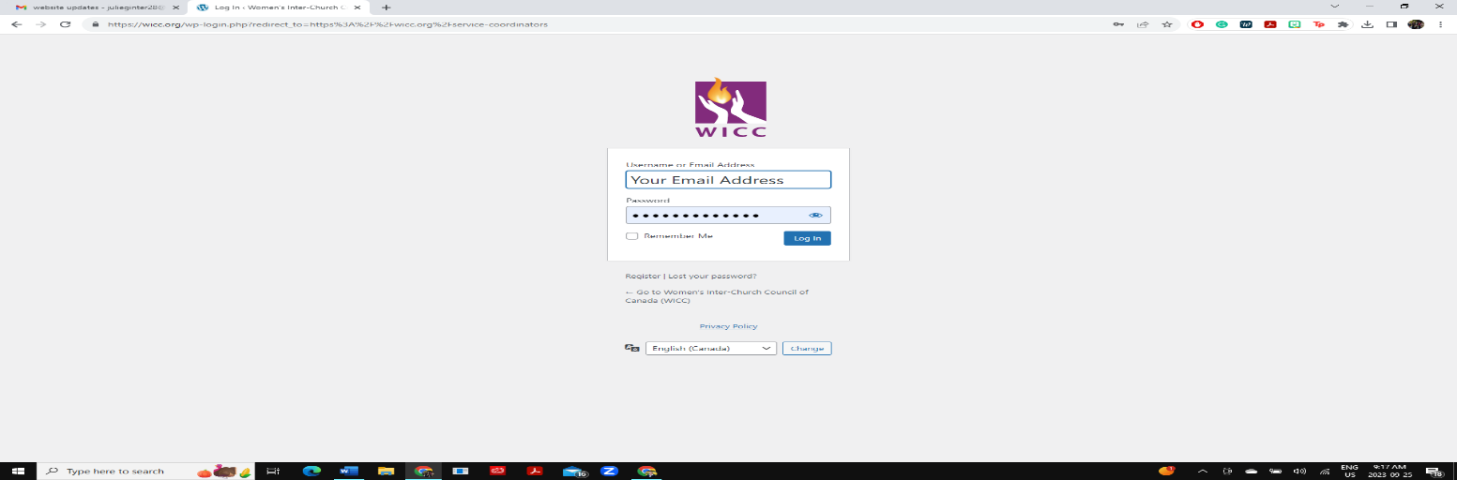

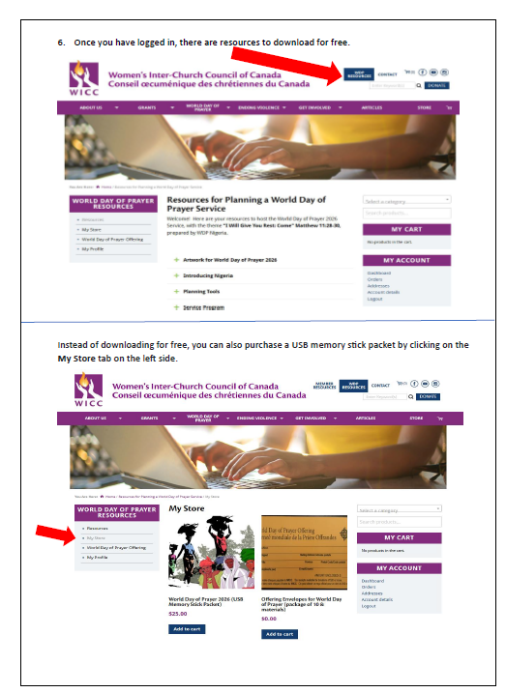

To send in the WDP offering online, click on World Day of Prayer Offering tab on the left menu.
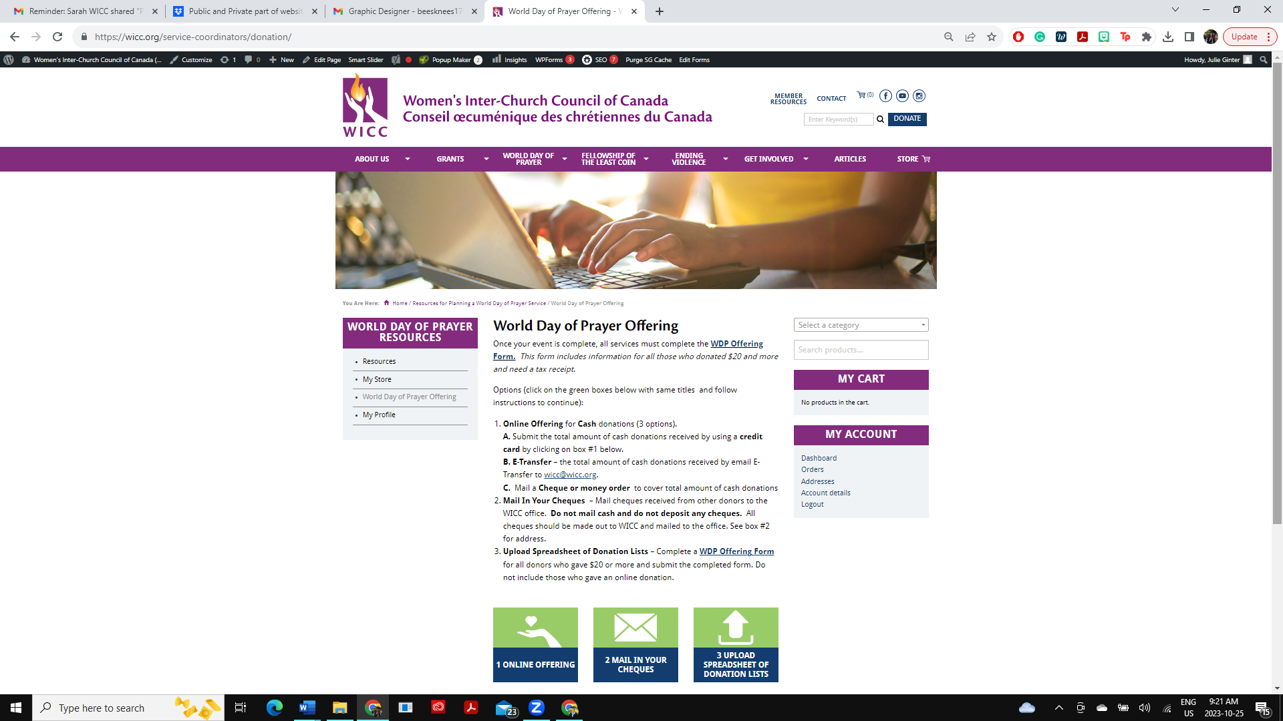

To update your profile, click on My Profile on the left menu.
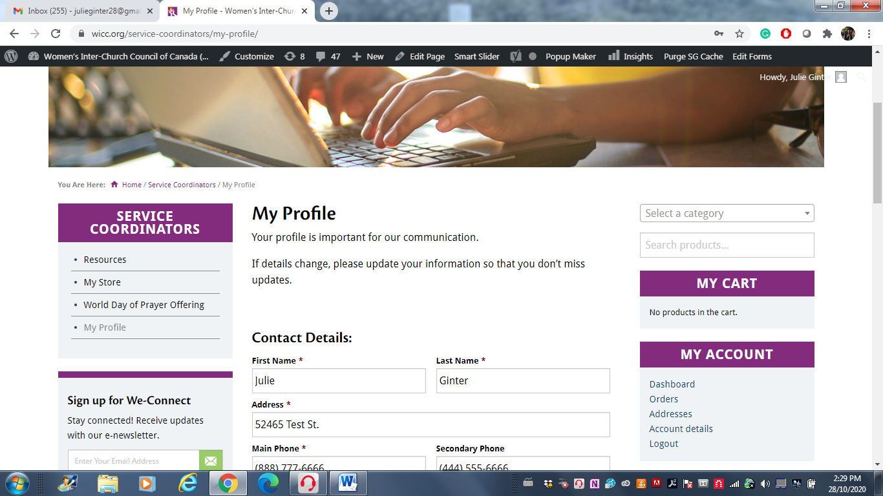

Log in to your World Day of Prayer Resources Account
- LOGIN on the left side with your email address and password the click Log In.
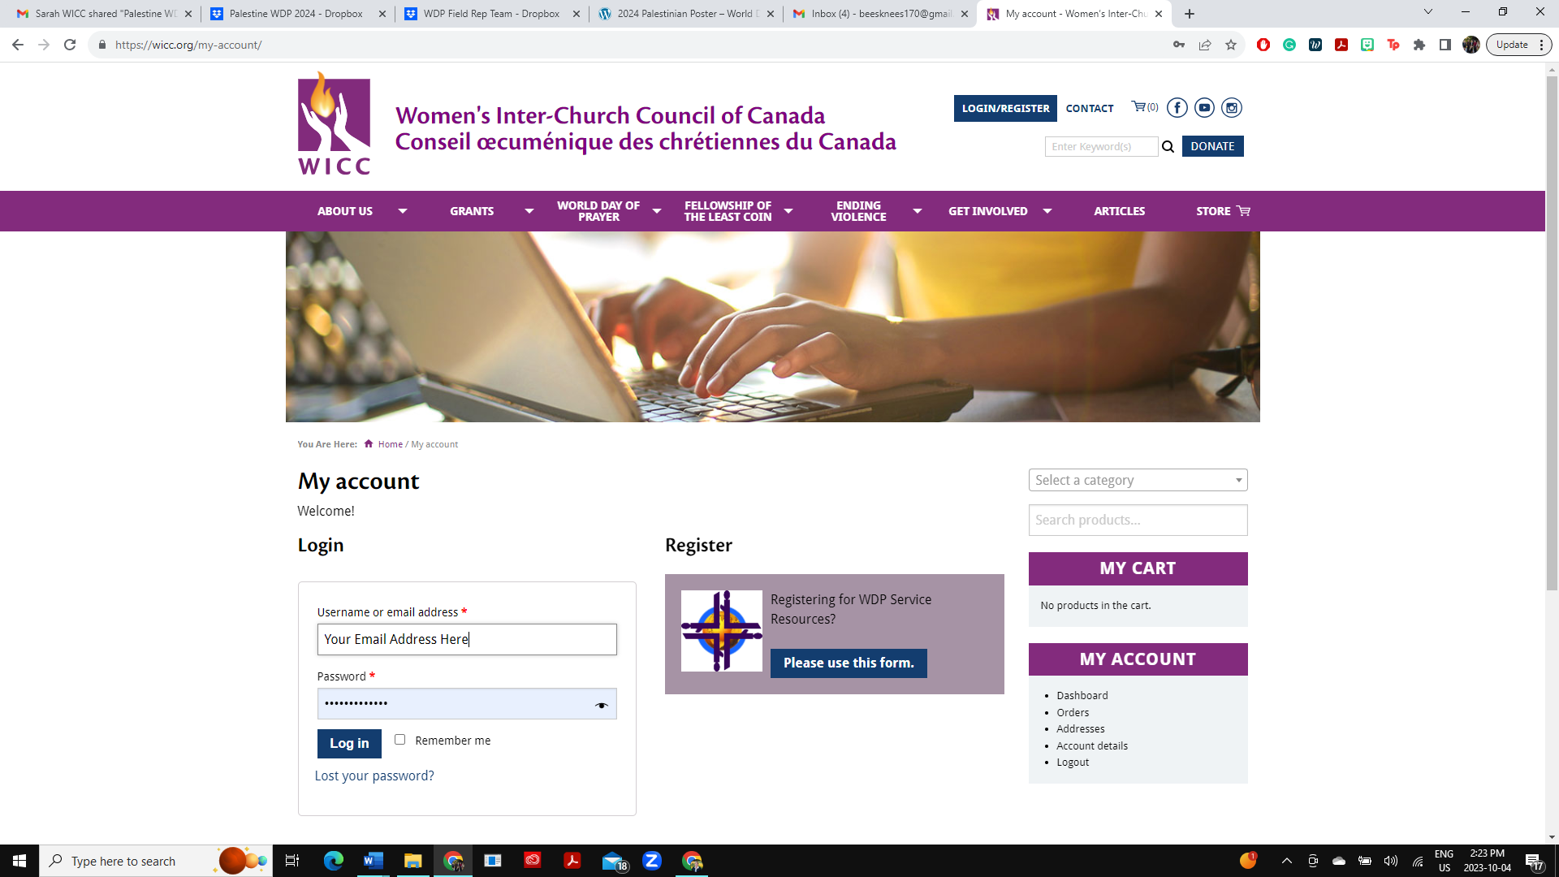
- Click the LOGIN/REGISTER button on the top right corner.
- Go to web address: wdpcanada.ca

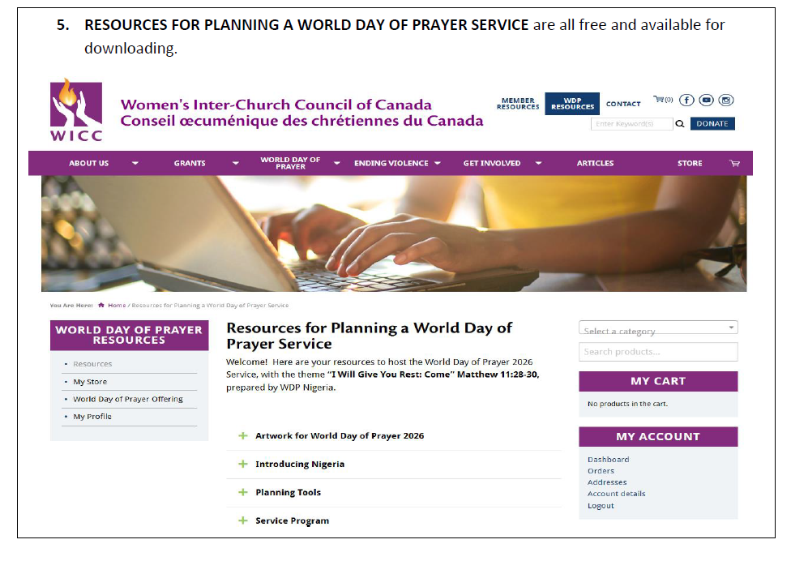
- CLICK on RESOURCES FOR PLANNING A WORLD DAY OF PRAYER SERVICE.
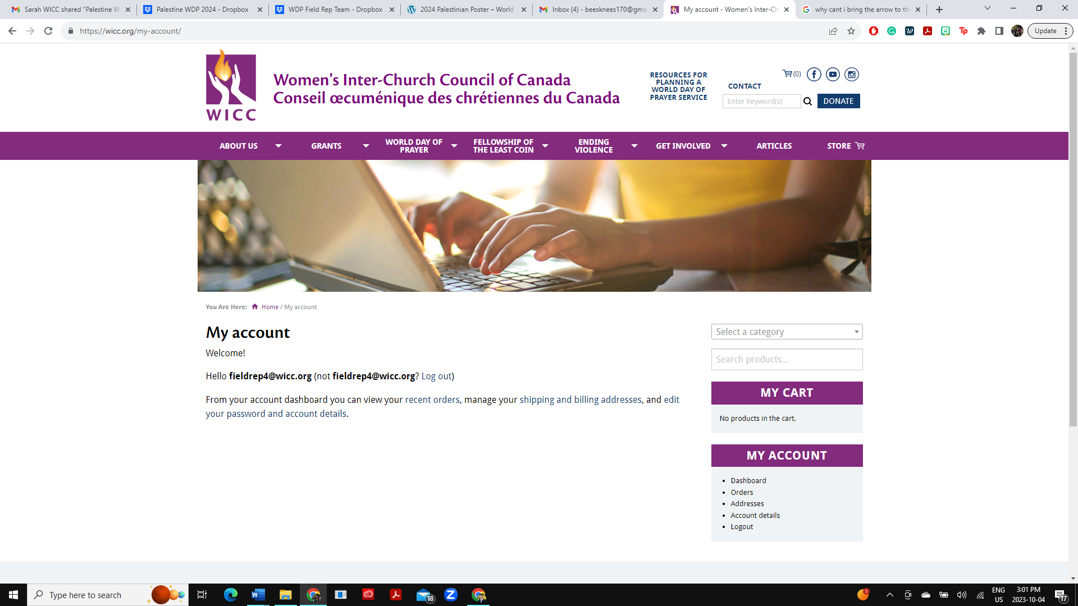
Grant Recipients 2024-25

Location | Organization | Project | Amount
CANADA
British Columbia | A Way Home Kamloops Society | Young Women’s Housing Support Project | $5,000
British Columbia | Salvation Army – Cariboo Tree Temple | BRAVE Counselling Program | $4,000
British Columbia | Kamloops United Church | Menstruation Supplies for Struggling Community Members | $5,000
British Columbia | Central Okanagan United Church | Meals, Groceries, Food Prep And Safety Courses | $5,000
Ontario | Salvation Army – North York | Woven – Empowerment for Girls and Human Trafficking Prevention | $3,500
Ontario | Elora House | Building Hope and Healing for Trafficking Survivors | $1,000
Ontario | Salvation Army – Belleville | Uplifting Experiences for Vulnerable Youth | $2,900
Ontario | FCJ Refugee Centre | Empowering Refugee Women through Art and Recreation Activities | $5,000
Ontario | Tyndale University | WIRED Impact Portal – Amplifying Voices of Christian Researchers | $3,600
Nova Scotia | TREY (Trauma Recovery for Exploited Youth) | Prevention of Sexual Exploitation and Aftercare for Exploited Youths | $5,000
INTERNATIONAL
Angola | Africa Inter-Mennonite Mission Canada | Economic Empowerment for Widowed Women and their Children | $5,000
DR Congo | Canada Africa Community Health Alliance | Tchukudu Women’s Emergency Food Initiative | $5,000
DR Congo | Canadian Baptist Ministries Eastern Congo | Peace & Capacity Building Training for Women Leaders | $5,000
Kenya | Canadian Baptist Ministries/ACC&S Women’s Action | Health Products and Mentoring for Girls and Boys | $5,000
Philippines | Luzon Convention Baptist Fellowship | Climate Change Adaptation and Waste Management Training | $5,000
Guatemala | Horizons of Friendship | Maternal Health – Re-equipping Traditional Midwives | $5,000
Cuba | Mosaic Church | Orphanage Support | $5,000
Kenya | Village of Love | Emergency Grant for Flood Victims | $2,000
Total |  |  | $77,000

WDP 2026 Coordinator Evaluation
WDP evaluations will be completed online by the service coordinators after March 6, 2026.
The survey will take 5-8 minutes. Feedback is very important to the World Day of Prayer program.
The following information, or similar, will be requested:

Your name
Were you able to have a World Day of Prayer 2026 service?
Name of host church for 2026 World Day of Prayer service
Church location (City, Province/Territory)
How many people attended your service (best guess)?
Did people have an opportunity to donate during your service?
What were the highlights of World Day of Prayer 2026 for you?
Any suggestions to make it even better next year?
Did you watch the full-length WDP service video from WICC?
How did you find the process for registering on the WICC website for WDP resources?
How was the ease of accessing WDP resources on the WICC website?
Do you usually read We-Connect, the e-newsletter from WICC?
Do you have suggestions for We-Connect content?
Did you connect with a World Day of Prayer Field Rep?
Which WDP resources did you use?
What additional information would be helpful to receive from WICC?
Do you follow WICC Facebook or Instagram?
Who is the coordinator for World Day of Prayer 2027 prepared by the World Day of Prayer International Committee?
If there is a new contact for WDP 2027, please provide this person’s name, email address, phone number, host church name, and address.

