PLANNING GUIDE for World Day of Prayer (WDP) 2027 Services
Prepared by the Women’s Inter-Church Council of Canada (WICC)
WDP 2027 Theme: “United in Prayer for Justice and Peace”
Scriptures: 1 Samuel 2: 1-10 & Luke 1: 39-55
Writing Group: World Day of Prayer International Committee

Thank you for coordinating a service for the 100th anniversary of World Day of Prayer. Below are helpful PLANNING STEPS with details about each over the next twelve pages.

- Understand the Basics of a WDP service
- Access WDP Resources online
3. Become Familiar with Resources
4. Review WDP Editing Policy
5. Form a Planning Committee
6. Set a Service Date & Time
7. Choose Location & Delivery Style
7. 8. Assign Roles
8. 9. Choose Materials
9. 10. Select Music: provided/personal
10. 11. Publicize – invite local churches
11. 12. During Service
13. Wrap up; Submit Offering
12. 14. Respond to online evaluation survey

Also included in this guide: List of 2025/2026 WDP Grants; Evaluation Survey; 100-Year Summary of Food Trends, Recipe and Contact Information for Assistance (WDP Field Reps).
Step ONE: Understand the Basics
- What is World Day of Prayer? The World Day of Prayer is an international ecumenical Christian laywomen’s initiative that has been celebrated in over 135 countries on or around the first Friday in March. 2027 will be the 100th anniversary of World Day of Prayer. WDP Motto: Informed Prayer and Prayerful Action
B. What are the Four Parts of a World Day of Prayer Event/Service?
1. Prayer for the women all over the world who are seeking justice
2. Invitations for others to join your event/service
3. An opportunity to donate
4. Use of the WDP service provided by WICC – available in print, online, PowerPoint, USB and video formats

Step TWO: Access WDP Service Resources Online
- Go to wdpcanada.ca
- Click on the WDP RESOURCES tab
- Fill out the form with required contact information
- Hit the “send message” button

Step THREE: Become Informed
Become familiar with the Worship Service and its length, World Day of Prayer history, and WDP grant summaries. At least one committee member should be receiving the quarterly WICC e-newsletter: We-Connect. As well, check out all the free WDP resources at wdpcanada.ca.
Many communities have a World Day of Prayer binder with useful information that is passed along from one Coordinator to the next. Please get in touch with the 2026 Coordinator or service location in your area to see if such a binder exists.
Watch the 55-minute WDP service video to gain an overview. You may want to show this video at your service to make organization simpler. Go to page 6 for more info about this resource.

Step FOUR – Review the Editing Policy for WDP Services
It is helpful to know that countries chosen to write yearly services are selected at international meetings held every 5 years, and each country creates its service a few years before the service year.
WDPIC guidelines for editing the World Day of Prayer (WDP) service emphasize honouring the writer country's/committee’s original, gifted content while adapting it with care, respect, and accuracy to the local context.
Key Editing and Adaptation Guidelines:
- Respect the Source: The service is a gift from the women of the writer country. Study their context thoroughly before making changes.
- Contextualization: Adapt the liturgy to make it meaningful for your local congregation while keeping the core message.
- Include Key Components: Retain the essential four parts: prayers for the writer country/committee, global connection, offering, and the provided service structure.
- Use Official Resources: Utilize the Planning Guide for background info, reflections on text, and symbol descriptions.
- Ecumenical Focus: Ensure adaptations reflect the WDP as a celebration of unity and diversity.
- Manageable Changes: While editing is allowed, ensure the essence of the worship experience designed by the host country is maintained.

If you need help along the way with any aspect of World Day of Prayer,
please contact our new
WDP Program Coordinator, Caroline Voitovici.
She will direct you to the WDP Field Rep for your region.

WICC office hours are Monday to Thursday from 9am to 5pm.
Please leave a message.
Email: wicc@wicc.org Phone: 416.929.5184

Step FIVE: Invite others to get involved, especially those from community area churches. A planning committee can be an enjoyable way to share the tasks and more easily do the marketing, technical set-up, materials gathering, etc. Suggested roles:
Service Coordinator: ________________________ #/email: _________________
Publicist (social media, posters): ____________________ #/email: _________________
Treasurer (to count offering): ____________________ #/email: __________________
Other 2027 WDP Committee Members:
__________________________ #/email: __________________________
__________________________ #/email: __________________________
__________________________ #/email: __________________________
NOTE: If you become unable to coordinate the service, please help choose/recommend a backup Coordinator, and email or call WICC: wicc@wicc.org or 416.929.5184 with this information. If you cannot find a replacement, please let us know that too.

Step SIX: Choose a date and time for your WDP event that best suits your community.
Date: ______________________
Time: ______________________
Traditionally, World Day of Prayer is held on the first Friday in March. Communities may select a more suitable day in 2027 for their areas.
Weather in Canada can be unpredictable. Please choose a “snow/rain” date for your event if meeting in person.
Snow/Rain Date: ______________________

Step SEVEN: Choose a location and delivery style. Check all equipment.
Church/Venue: __________________________
Address: ________________________________
(Power) Wheelchair accessible? Yes No
Audio/Visual equipment available? Yes No
(projector screens, laptops, internet, etc. - test out in advance at the event/service location)

If your service venue is a church, contact the clergy person and let him/her know about the 100th anniversary of the World Day of Prayer movement. Clergy are welcome to call the WICC office.
Helpful Questions:
- Will the service be in person or via the internet or a hybrid option?
- Will you watch the full-length service video or have live leaders/readers or have a combination of both? Using the service video may provide planning flexibility. A PowerPoint of the service is also available. This can help avoid printing costs.
- Is there a place you can bless by sharing a WDP service and fellowship? Examples: retirement home, prison, school.

Note your Agreement with WICC: The Women’s Inter-Church Council of Canada (WICC) has provided World Day of Prayer materials. By using these materials, you enter into an agreement with WICC to send the offerings received at your World Day of Prayer service directly to WICC.

Step NINE “A”: Materials
- Request Offering ENVELOPES through the WICC online store: wdpcanada.ca/wicc-store/ or emailing wicc@wicc.org. The envelopes are free.
OR . . . . . Make Your Own Offering Envelopes. Offering envelopes can be personalized for WDP 2027 by creating a sticker that includes artwork especially created for the service.
Hand out the envelopes or attach them with paper clips or staples to the bulletins distributed. Please note that online donations are possible through canadahelps.org or wdpcanada.ca/donate.
- A WDP packet can be ordered by going to the WICC online store: https://wdpcanada.ca/wicc-store/. The cost is $25 and shipping is included.

A World Day of Prayer Service Packets contains:
- Printed materials: 1 copy of the WDP Service (11 X 8.5; 12 pages); Participant Service Bulletin (booklet form; 1 page; front and back); WDP history information.
- a USB Memory stick with a 55-minute prerecorded WDP service, music from the 2027 committee, WDP worship service PowerPoint, and a 10-minute video about the history of World Day of Prayer plus much more!
Note: If you order a USB, please order the offering envelopes in the same checkout cart.
You may want to photocopy the whole WDP Service or the Participant Service Bulletin for in-person gatherings.
For a PowerPoint of the full service, go to the online resources or email wicc@wicc.org or call 416.929.5184.
Step EIGHT: Assign Roles and Decide on Equipment
Assign roles for the event/service: set-up, greeters, readers, leaders, offering collectors and counters, and refreshment providers/servers. These will vary depending on whether or not the service video is used. Have a backup plan in case of illness. Reminder: At least one committee member or the Coordinator should have access online resources.
The worship service has been organized with seven leaders representing the seven WDP regions worldwide. However, please feel free to divide up your reading sections to best suit your group. Another suggestion is to play all or parts of the WDP Service video, produced by WICC, at your gathering.
Recruit a technical person to help with any audio-visual aspects including showing the service video, WDP history video, service PowerPoint, sound system, Zoom, etc.
Electronic equipment you may need for the service: microphones, projector, screens, and a laptop. Test them out ahead of time in the place where you will use them.

Find time to practice your service – in a church or virtually. Test out all equipment in the service or delivery location.

Step NINE “B”: Materials - Service Table
It’s nice to place a display table where it can be easily seen at the entrance or in the worship area. The presentation could include seven candles and/or cloths to represent the seven regions of the world, blue cloth symbolizing the river of history, and WDP history artifacts, if available.
Have a Bible open at 1 Samuel 2: 1-10 and/or Luke 1: 39-55, a print of the WDP 2027 artwork, and a world map or globe.

Step NINE “C”: Materials - Artwork: “River of Prayer” by Sham Saad

Go wdpcanada.ca/resources to learn how to download this resource and read more about the art and artist, or refer to the files on the USB.

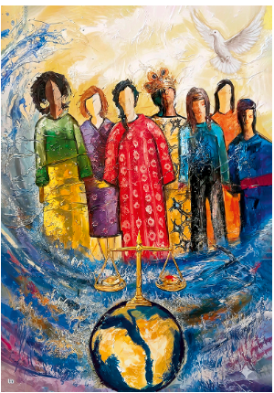
River of Prayer portrays women from around the globe, each representing different cultures and regions, united in worship and prayer, standing together in strength and humility.
At the heart of the artwork flows a river, symbolizing the Holy Spirit, peace, and the continuous movement of God's presence. The river gently surrounds the women, connecting them in one body and one spirit. Their posture is lifted in prayer, and their faces reflect faith, hope, and resilience.
The colors are vibrant and diverse, echoing the richness of every nation and the beauty of unity in diversity — a visual call for justice, peace, and spiritual togetherness.

ACCESSING MATERIALS
Reminder: All World Day of Prayer 2027 resources can be viewed and/or downloaded by going to wdpcanada.ca and completing a simple form (with each visit to the website).
Step NINE “D”: Materials - Signage & Greetings
Create a welcoming space with signage and greeters.
Greet people as they arrive. If your service is in-person, you may want to give everyone a colourful ribbon to wave during a hymn to symbolize a river. Or they could wave scarves.
Ask your guests to sign in to help track your attendance and create a sense of community connection.
Check signage for wheelchair-accessible paths and washrooms.
For a virtual service, assign someone to admit and/or greet guests as they arrive on the computer screen.

WDP 2027 resources for children and youth are available for three different age ranges at https://wdpcanada.ca/world-day-of-prayer/how-to-participate/.

Step NINE: “F”: Materials for a Creative Event
WDP 2027 services can be incorporated into a paint, craft, quilting, writing or music session, food demonstration, road trip, special guest(s)performance, existing church and community groups, and much more. Plan ahead and gather any materials you may need for these creative events.

Step NINE “E”: Materials - Worship Service Video produced by WICC
Available FREE to download from wdpcanada.ca OR
on the WDP 2027 USB stick, which can be purchased from
wdpcanada.ca/wicc-store for $25.

This wonderful 55-minute service recording includes:
- Closed captioning in English for all speaking and singing
- Information about the history of World Day of Prayer
- Prayers, stories, and a Bible study from the writing committee
- An opportunity to donate
- Pictures from across Canada of 2026 WDP services
- Special music

Step TEN: Music and Sounds
The Worship Service does not require certain songs or hymns to be sung. You can choose the music provided by the writing team (copyrighted for WDP 2027 service) or hymns from common hymn books or a combination of new and familiar songs of praise or use those from the list of suggested hymns provided by WICC. Note copyright requirements for sharing music.
Recordings, sheet music and lyrics for the soundtracks, and suggested hymns are available online through wdpcanada.ca. Look for the + Music tab.
Discuss with your choir and/or organist about the need to learn any music.

World Day of Prayer 2027 Theme Music – United in Prayer
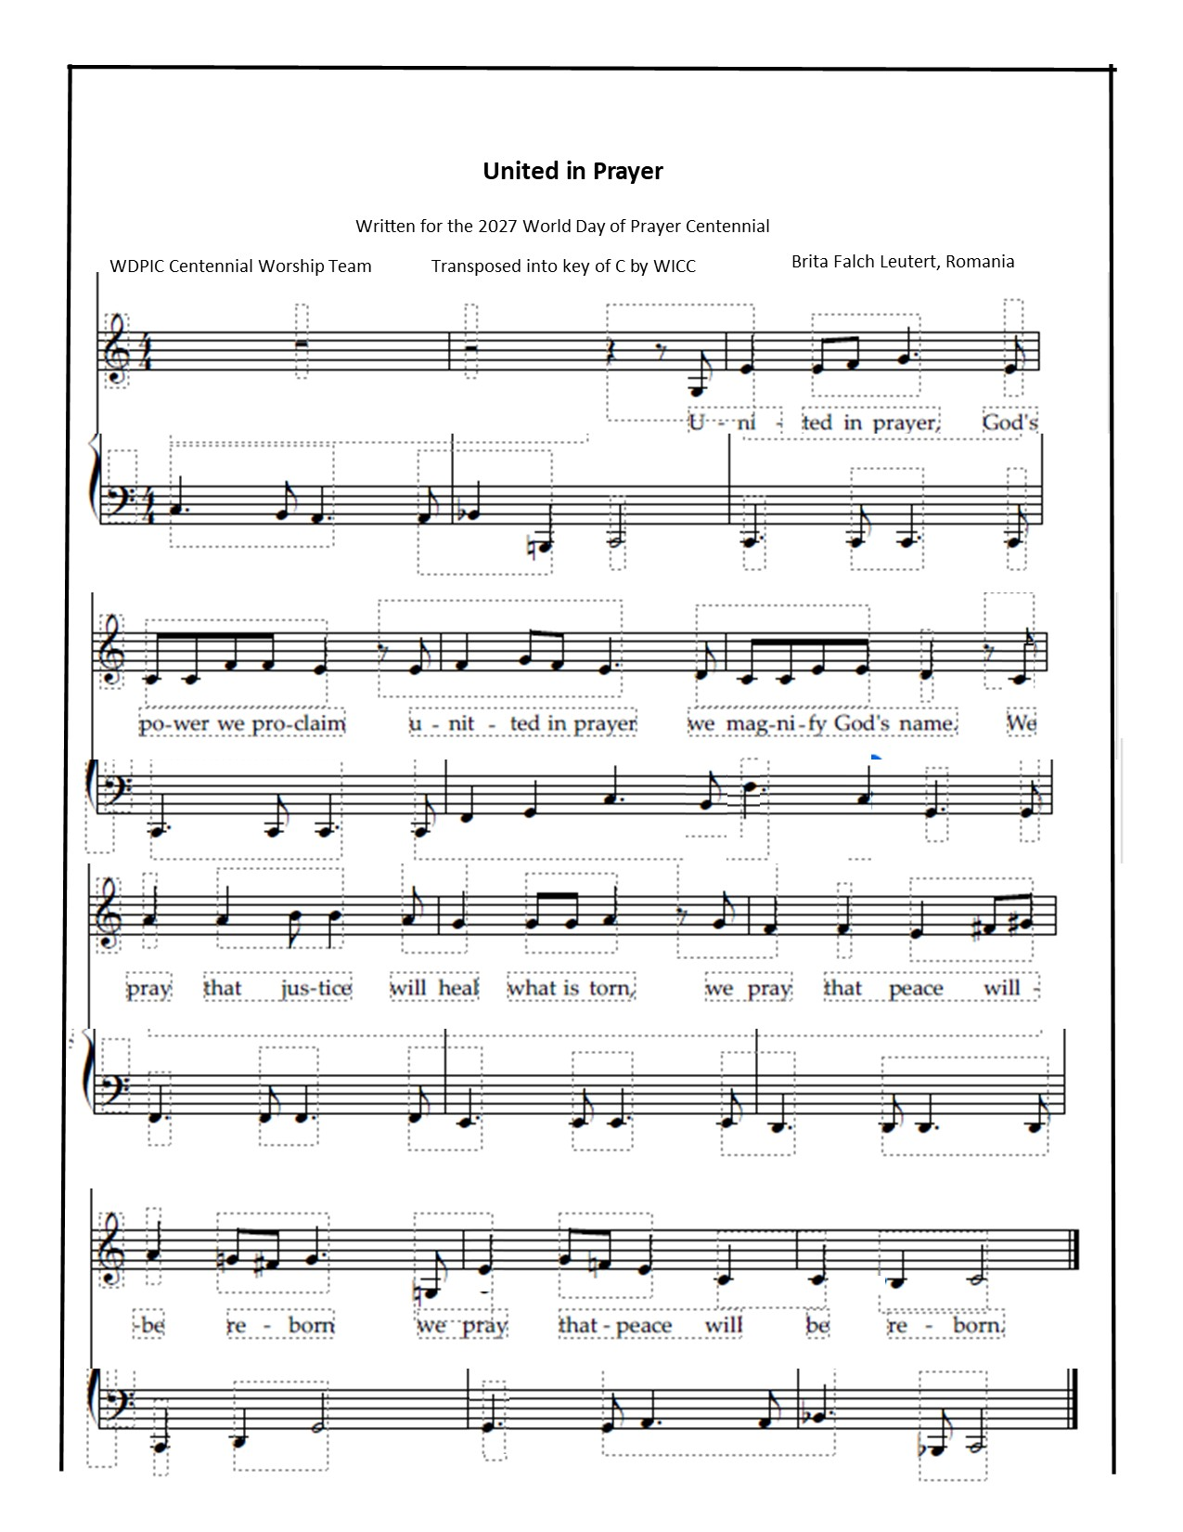
Step ELEVEN: Publicize the Service
One of the most important tasks for a WDP Coordinator is promoting World Day of Prayer. Some ideas to do this include:
- Print posters, forward media releases, send out invitations, supply bulletin inserts to community churches at least a month in advance of the service.
- Mention World Day of Prayer when you see people. Face-to-face invitations can work best.
- Call, email and text friends, neighbours, and community groups. Use social media like Facebook and Instagram.
- Put up posters in churches, community centers, ice arenas, grocery stores, libraries, post offices, etc.
- Notify community churches with phone calls to pastors, office administrators and contacts for any church organizations. Ask for the service to be marked on church calendars, websites, print bulletins and electronic messaging boards. Check that information can be found via internet search engines.
- Advertise using free sites such as online community newsletters or newspapers.
- Contact local, provincial, and federal politicians, and other community leaders to attend.
- National Service Area Map.
World Day of Prayer 2027 service information in Canada can be shared by coordinators on our national online map. Go to https://wdpcanada.ca/service-locations/ to add your details.

Practice
It’s very helpful to book a date at the service location to practice in-person readings, music and technical setup.
Step TWELVE A: During the Service
Offering
Give everyone attending a WDP service an opportunity to donate.
Donations support World Day of Prayer itself and the WDP grant program.
A list of 2025/2026 grants can be found at the end of this document or go to wdpcanada.ca/grant-programs/ for more detailed information. Please consider sharing more details about a couple of the grant projects prior to the offering. A summary chart of grants is included at the end of this document.

Distribute WDP offering envelopes before the service begins to give people an opportunity to record their addresses for tax receipt purposes. Tax receipts will be issued for amounts of $20 or more.

Cheques should be made out to WICC or Women’s Inter-Church Council of Canada.

Online donations are encouraged for both virtual and in-person services. Participants can use the DONATE button on the WICC website wdpcanada.ca/donate. Or text 647.953.5557, and type “Give 20” (or other amount) to donate. Then follow the automatic instructions.

Instructions for submitting offering donations can be found in Step Thirteen – After the Service.

Step TWELVE “B”: During the Service
BIBLE PASSAGES: 1 Samuel 2: 1-10 & Luke 1: 39-55
The Bible text used in the 2027 service has been dramatized.
A complete version of the Bible study can be found by with the online WDP resources.

⁶ The Lord kills and brings to life;
he brings down to Sheol and raises up.
⁷ The Lord makes poor and makes rich;
he brings low; he also exalts.
⁸ He raises up the poor from the dust;
he lifts the needy from the ash heap
to make them sit with princes
and inherit a seat of honor.
For the pillars of the earth are the Lord’s,
and on them he has set the world.
⁹ He will guard the feet of his faithful ones,
but the wicked will perish in darkness,
for not by might does one prevail.
¹⁰ The Lord! His adversaries will be shattered;
the Most High^{[b]} will thunder in heaven.
The Lord will judge the ends of the earth;
he will give strength to his king
and exalt the power of his anointed.”

1 Samuel 2: 1-10
Hannah prayed and said,
“My heart exults in the Lord;
my strength is exalted in my God.^{[a]}
My mouth derides my enemies
because I rejoice in your victory.
² There is no Holy One like the Lord,
no one besides you;
there is no Rock like our God.
³ Talk no more so very proudly;
let not arrogance come from your mouth,
for the Lord is a God of knowledge,
and by him actions are weighed.
⁴ The bows of the mighty are broken,
but the feeble gird on strength.
⁵ Those who were full have hired themselves out for bread,
but those who were hungry are fat with spoil.
The barren has borne seven,
but she who has many children is forlorn.

⁴⁸ for he has looked with favor on the lowly state of his servant.
Surely from now on all generations will call me blessed,
⁴⁹ for the Mighty One has done great things for me,
and holy is his name;
⁵⁰ indeed, his mercy is for those who fear him
from generation to generation.
⁵¹ He has shown strength with his arm;
he has scattered the proud in the imagination of their hearts.
⁵² He has brought down the powerful from their thrones
and lifted up the lowly;
⁵³ he has filled the hungry with good things
and sent the rich away empty.
⁵⁴ He has come to the aid of his child Israel,
in remembrance of his mercy,
⁵⁵ according to the promise he made to our ancestors,
to Abraham and to his descendants forever.”
Luke 1 39-55

³⁹ In those days Mary set out and went with haste to a Judean town in the hill country, ⁴⁰ where she entered the house of Zechariah and greeted Elizabeth. ⁴¹ When Elizabeth heard Mary’s greeting, the child leaped in her womb. And Elizabeth was filled with the Holy Spirit ⁴² and exclaimed with a loud cry, “Blessed are you among women, and blessed is the fruit of your womb. ⁴³ And why has this happened to me, that the mother of my Lord comes to me? ⁴⁴ For as soon as I heard the sound of your greeting, the child in my womb leaped for joy. ⁴⁵ And blessed is she who believed that there would be^{[a]} a fulfillment of what was spoken to her by the Lord.”
Mary’s Song of Praise
⁴⁶ And Mary^{[b]} said,
“My soul magnifies the Lord,
⁴⁷ and my spirit rejoices in God my Savior,

Step THIRTEEN “A”: After the Service
Many attending World Day of Prayer enjoy a time of fellowship after the service. If permitted, light refreshments could be served. For food suggestions, see the next page as well as the Service Program & Planning Tools section of the online resources. For virtual services, participants may want to stay after the service to say hello to old and new friends or join a break-out room to create smaller interaction groups.

Step THIRTEEN “B”: After the Service – Refreshments/Snacks
People enjoy a time of refreshments after WDP services. You may be inspired to offer food that represents some culinary trends from the past 100 years. Thank you to Sheila Ford of Toronto for her excellent summary, a page of which is featured below. Go to wdpcanada.ca for the full document.
100 Years of World Day of Prayer
100 Years of Culinary Trends and Iconic Foods

1920s: Social recovery, economic growth, increase in canned goods especially pineapple, new technology in iceboxes and electric mixers, increase in media (Pineapple Upside Down Cake, Angel Food Cake, Ice Box Cookies);
1930s: Financial hardship triggered extreme resourcefulness, stretching, replacing expensive ingredients with less expensive (Tomato Soup Cake, Applesauce Cake, Bread Pudding, Meatloaf);
1940s: Full mobilization of men and women, rationing, limited supplies, later emphasis on families and home making, processed convenience products, new appliances (Molasses Bars, Oatmeal Cookies, Rice Crispy Treats);
1950s: Baby Boom, mass produced convenience foods, intense branding especially on TV, women, home and entertaining focused media, immigration increasing (Banana Bread, Onion Soup Dip, Swedish Meatballs);
1960s: Social cultural revolution, more frozen and international foods, sophisticated entertaining, branded convenience foods, gourmet cooking and family life promoted in media (Pizza, Party Mix, Fondue);
1970s: Intense media coverage food and entertainment, Julia Child, availability convenience and ethnic foods especially French, (Cheese Balls, Quiche, Crepes, Carrot Cake, Black Forrest Cake);
1980s Unapologetic extravagance, sophisticated luxury, indulgence contrasted by diet and exercise culture, flashy presentation (Decadent Chocolate Chip Cookies, Sushi, Tiramisu);
1990s: Globalization, early digital age, coffee and shopping mall cultures, animal rights, Martha Stewart, microwaves, gourmet donuts (Tacos, Salsa, Molten Lava Cake, Red Velvet Cake);
2000s: Food channels encourage home cooking and baking, Foodie Culture with artisan ingredients, comfort food, organic, farmer’s markets, bacon (Gourmet Cupcakes, Macarons, Bubble Tea);
2010s: Eating for Instagram/Instagram worthy food, sustainable, gluten free, donuts, kale, meal kits, home delivery (Avocado toast, Pumpkin Spice Muffins, Salted Caramel Cookies, Unicorn Cake);
2020s: COVID pushed digital and short form video explosion, homemade, vintage, air fryers, plant based, showstopper desserts (Sour Dough Bread, Matcha Cookies, Dubai Chocolate Brownies).

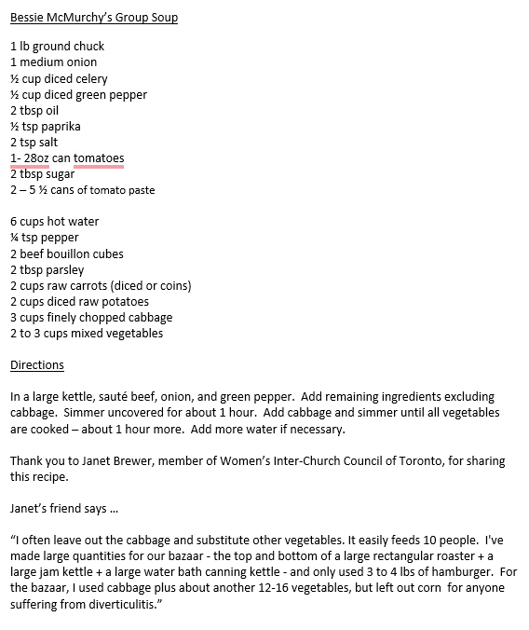

Want to know more about World Day of Prayer?
Visit wdpcanada.ca.

Step THIRTEEN “C”: After the Service (A, B, & C relate to In-Person Services)

Processing the Offering

- Print the Offering Remittance Form: the form can be found on https://wdpcanada.ca/wp-content/uploads/WDP2027-Offering-Remittance-Form.docx
- Fill in the offering form. For all donations of $20 or more, include the person’s name, mailing address and offering amount so WICC can issue them a tax receipt. Do not include the names/donations of people who donate online. For those donating online, a tax receipt will automatically be generated for donations of $10 or more. Please keep the offering envelopes until May 2028 or mail them in with the Offering Form.
- Make sure that your name and phone number are at the top.
- If you want WICC to let you know that we have received your offering form, please check the appropriate box at the bottom of this form.
- Make a photocopy of your completed Offering Remittance Form for your records.

- Gather all the items to be sent.

Include the form (see above) and the cheques individuals’ offering cheques, and a cheque, bank draft or money order for the cash offerings.

B. Mail everything directly to WICC within a month of the service:
WICC (Women’s Inter-Church Council of Canada)
47 Queen’s Park Crescent East
Toronto, ON M5S 2C3
Feel free to call us if you have any questions: 416-929-5184

- An evaluation will be emailed to you on March 4. It asks for the name of the 2028 service Coordinator – or a chance to say that your community will need help from your Field Rep to find someone. Sample questions are on page 17.

World Day of Prayer Grant Recipients 2025-26

Location | Organization | Project | Amount
CANADA
British Columbia | Neighbourhood Homes of BC – Frog Hollow | Frame Films Project | $5000
British Columbia | Talitha Korum Society | Women & Children – Equine Counselling | $5000
Saskatchewan | Battlefords Family Health | Community Garden | $5000
Quebec | Christian Direction | Women – Violence to Liberty Journey | $3500
New Brunswick | BullyingCanada | Bullied Youth - Lifeline | $5000
Prince Edward Island | Boys and Girls Club - Summerside | Lifehouse – Support Beyond Housing | $4000
Ontario | Salvation Army - Georgina | Girl Empowerment - BRAVE | $500
Ontario | Salvation Army – Lakeshore | Girl Empowerment – BRAVE | $1000
Ontario | Salvation Army – Acton | Wonderfully Made! | $5000
Ontario | Canadian Council of Churches | Indigenous Healing from Violence | $5000
Ontario | Canadian Council of Churches | People in Poverty – Faithful Response | $2000
Ontario | Salvation Army – Thunder Bay | Open Homes – Women in Community | $2500
Ontario | IAFR Canada | Refugee Women – Hamilton – Empowerment | $5000
Canada Total |  |  | $48,500
International
Angola | Africa Iner-Mennonite Mission | Widows – Small Business Set-Up | $5000
DR Congo | Canadian Baptist Ministries | Women in Goma City – Emergency Food | $5000
Zambia | International Teams | Women’s Skills Training | $5000
Kenya | Village of Love | Vulnerable Children – Economic Empowerment | $5000
India | Canadian Baptist Ministries | KUI – Female Children Empowerment | $5000
India | Step International Canada | Widows – Self-Sustaining Businesses | $4000
Guatemala | Horizons of Friendship | Sexual Assault: Reduction & Support of Young Survivors | $2500
Lebanon | Canadian Baptist Ministries | The Little Friendly Space | $5000
Bolivia | Canadian Baptist Ministries | House of Friendship | $5000
Bolivia | Canadian Baptist Ministries | Healthy Homes | $5000
Ukraine | Multi-Nation Missions Foundations | Golden Years: Supporting Elderly Women Affected by War in Ukraine | $5000
Int Total |  |  | $51,500
Total |  |  | $100,000

Step FOURTEEN: WDP 2027 Coordinator Evaluation
WDP evaluations will be emailed to the service coordinators after March 5, 2027. These are to be completed online.
The survey will take 5-8 minutes. Feedback is very important to the World Day of Prayer program.
The following information, or similar, will be requested:

Your name
Were you able to have a World Day of Prayer 2027 service?
Name of host church for 2027 World Day of Prayer service
Church location (City, Province/Territory)
How many people attended your service (best guess)?
Did people have an opportunity to donate during your service?
What were the highlights of World Day of Prayer 2027 for you?
Any suggestions to make it even better next year?
Did you watch the full-length WDP service video from WICC?
How did you find the process for registering on the WICC website for WDP resources?
How was the ease of accessing WDP resources on the WICC website?
Do you usually read We-Connect, the e-newsletter from WICC?
Do you have suggestions for We-Connect content?
Did you connect with a World Day of Prayer Field Rep?
Which WDP resources did you use?
What additional information would be helpful to receive from WICC?
Do you follow WICC Facebook or Instagram?
Who is the coordinator for World Day of Prayer 2028 prepared by Costa Rica?
If there is a new contact for WDP 2028, please provide this person’s name, email address, phone number, host church name, and address.

