Mini Planning Guide for World Day of Prayer 2027
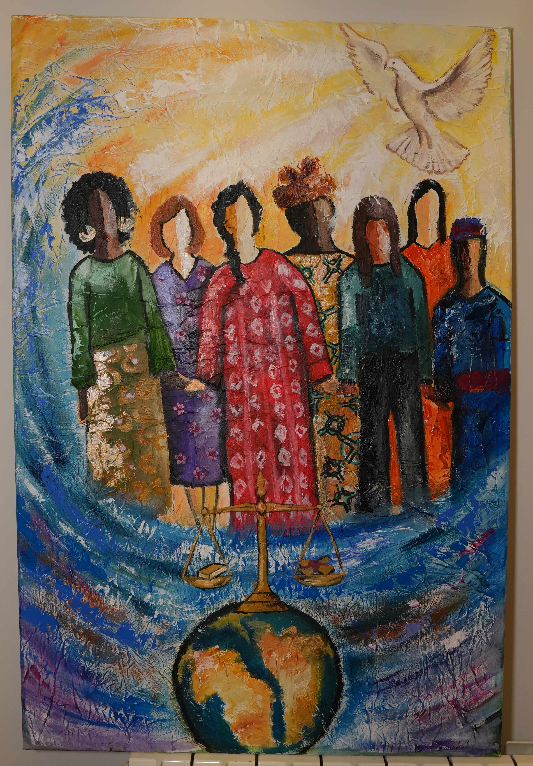
100th Anniversary
Theme: “United in Prayer for Justice and Peace”
Bible Passage: 1 Samuel 2: 1-10 & Luke 1: 39-55

Writing Committee: World Day of Prayer International Committee
World Day of Prayer (WDP) brings Christians together in prayer, action, and solidarity. Thank you for helping host a service in your community!
1. Accessing World Day of Prayer 2027 Resources
Go to wdpcanada.ca and click on the World Day of Prayer tab, and then “Access World Day of Prayer Resources”. Enter your contact information on the form to access all WDP 2027 materials (print, video, PowerPoint, music recordings, etc). If you need help accessing resources, ask someone from your church or contact our new WDP Program Coordinator, Caroline Voitovici. She will direct you to the WDP Field Rep for your region.
Office hours are Monday to Thursday from 9 am to 5 pm. Please leave a message.
Email: wicc@wicc.org Phone: 416.929.5184

2. Planning Your Service

• Day of Prayer services and events have four parts:
- prayer for the women of the world;
- invitations for others to join your service or event;
- an opportunity to donate; and
- use of the WDP service and resources provided by the Women’s Inter-Church Council of Canada.

• Traditional date: First Friday in March (another date may be chosen that better suits the community; choose a backup “rain/snow” date in case of weather cancellation).
• Add your service to the National Service Map: https://wdpcanada.ca/service-locations/
• Decide if you’ll show the 55-minute worship video (available online or on USB for $25).
• Decorate with symbols: globe or world map, artwork, 7 candles

3. Music Options
Choose familiar hymns or use the committee-recommended music selections under Music at https://wdpcanada.ca/service-coordinators/.
4. Promotion Ideas
Spread the word through:
• Church bulletins and community papers
• Church websites
• Social media- Facebook or Instagram
• Posters and word of mouth
💡 Tip: Feature local women or youth as readers or musicians to boost attendance.

5. Offering & Donations
By using the WDP 2027 materials, you agree to forward offerings to WICC:
Women’s Inter-Church Council of Canada,
47 Queen’s Park Crescent East, Toronto, ON M5S 2C3.
Order offering envelopes through the WICC online store: https://wdpcanada.ca/wicc-store/
• Complete the Offering Remittance Form and list donors giving $20+.
• Mail the form and the cheques (individual offering cheques, and a cheque, bank draft or money order for any cash offerings) to the WICC office within a month of the service.
• Keep envelopes filled out for WDP 2027 until February 2028 or mail them with your cheques.
• Make a photocopy of your completed Offering Remittance Form for your records.

6. After the Service
Notify WICC who will host the 2028 World Day of Prayer in your community. Provide as much as you know, on the Offering Remittance Form and/or your WDP 2027 evaluation, about the 2028 coordinator’s name, church, city, postal code, and email or mailing address.

7. Recipe:
Go to wdpcanada.ca to enjoy an article about food trends over the past 100 years and consider the cabbage soup recipe served for Bessie McMurchy’s group over 100 years ago.

