Mini Planning Guide for World Day of Prayer 2026 – Nigeria
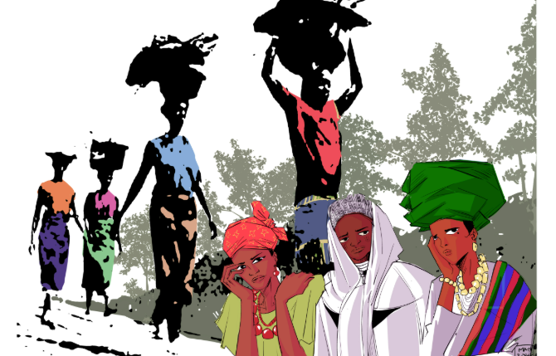
Theme: “I Will Give You Rest: Come”
Bible Passage: Matthew 11:28–30
Writing Country: Nigeria 🇳🇬
World Day of Prayer (WDP) brings Christians together in prayer, action, and solidarity. Thank you for helping host a service in your community!
1. Coordinator Registration
Register at https://wdpcanada.ca/create-a-coordinator-login-account/ to access all WDP 2026 materials (print, video, PowerPoint, and music). If you need help registering, ask someone from your church or contact your Field Rep or the WICC office.
2. Contact Information
• BC, AB, SK, MB, YT, NT, NU – Linda Ervin – fieldrep567@wicc.org – 250-493-5333
• Ontario – Cathy Tubb – fieldrep45@wicc.org – 416-450-1027
• Toronto – Janet MacFadyen – communications@wicc.org – 647-515-7770
• QC, NB, PE, NS, NL – Julie Ginter – fieldrep4@wicc.org – 905-550-2307
WICC Office: Latha Mitchell, Administrator – 416-929-5184 – wicc@wicc.org
3. Planning Your Service
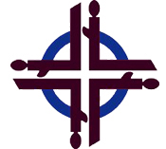
• Day of Prayer services and events have four parts:
- prayer for the women of Nigeria;
- invitations for others to join your service or event;
- an opportunity to donate; and
- use of the WDP service provided by the Women’s Inter-Church Council of Canada.

• Traditional date: First Friday in March (another date may be chosen that better suits the community; choose a backup “rain/snow” date in case of weather cancellation).
• Add your service to the National Service Map: https://wdpcanada.ca/service-locations/
• Decide if you’ll show the 55-minute worship video (available Jan 15 online or on USB for $25).
• Decorate with Nigerian symbols: yellow trumpet flowers, yams, rice, oil, candle, geometric fabrics, flag.

4. Music Options
Choose familiar hymns such as “Abide with Me,” “Softly and Tenderly,” or “Jesus Is Calling,” or use the Nigerian music selections under Music at https://wdpcanada.ca/service-coordinators/.
5. Promotion Ideas
Spread the word through:
• Church bulletins and community papers
• Facebook or church websites
• Posters and word of mouth
💡 Tip: Feature local women or youth as readers or musicians to boost attendance.
6. Offering & Donations
By using the WDP 2026 materials, you agree to forward offerings to WICC:
Women’s Inter-Church Council of Canada,
47 Queen’s Park Crescent East, Toronto, ON M5S 2C3.
Order offering envelopes through the WICC online store: https://wdpcanada.ca/wicc-store/
• Complete the Offering Remittance Form and list donors giving $20+.
• Mail this form and the cheques (individual offering cheques, and a cheque, bank draft or money order for any cash offerings to the WICC office
• Keep envelopes filled out for WDP 2026 until February 2027 or mail them with your cheques.
• Make a copy of your completed Offering Remittance Form for your records.

7. After the Service
Notify WICC who will host the 2027 World Day of Prayer in your community. Provide as much as you know, on the Offering Remittance Form and/or your WDP 2026 evaluation, about the 2027 coordinator’s name, church, city, postal code, and email or mailing address.
8. Recipe: Nigerian Butter Biscuits
Preheat oven to 350°F. Cream together 1 cup butter and 3/5 cup sugar. Mix in 2 eggs and 1 tsp vanilla. Combine 1 3/5 cups flour, 1 tsp baking powder, and pinch of salt. Add to butter mixture. Wrap dough, chill 20 mins, slice, and bake 15 mins until edges brown. Cool before serving. Optional: add coconut or lemon for flavour.

