- If you are no longer the World Day of Prayer Coordinator for your area, please forward this letter to the new Coordinator and let us know their name (email wicc@wicc.org).
(Or) if there is no Coordinator for your area, kindly inform us as well.

October 2026

Hello World Day of Prayer Coordinators 2027!

We are excited to soon bring you the World Day of Prayer (WDP) 2027 program which was written by the World Day of Prayer International Committee with a global focus. The theme for this 100th anniversary service is “United in Prayer for Justice and Peace”, based on 1 Samuel 2: 1-10 and Luke 1: 39-55.
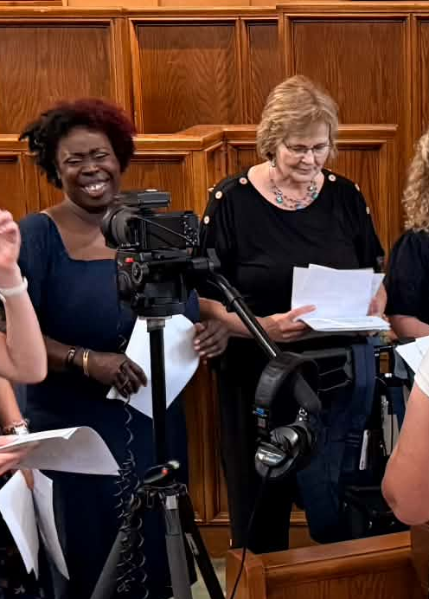

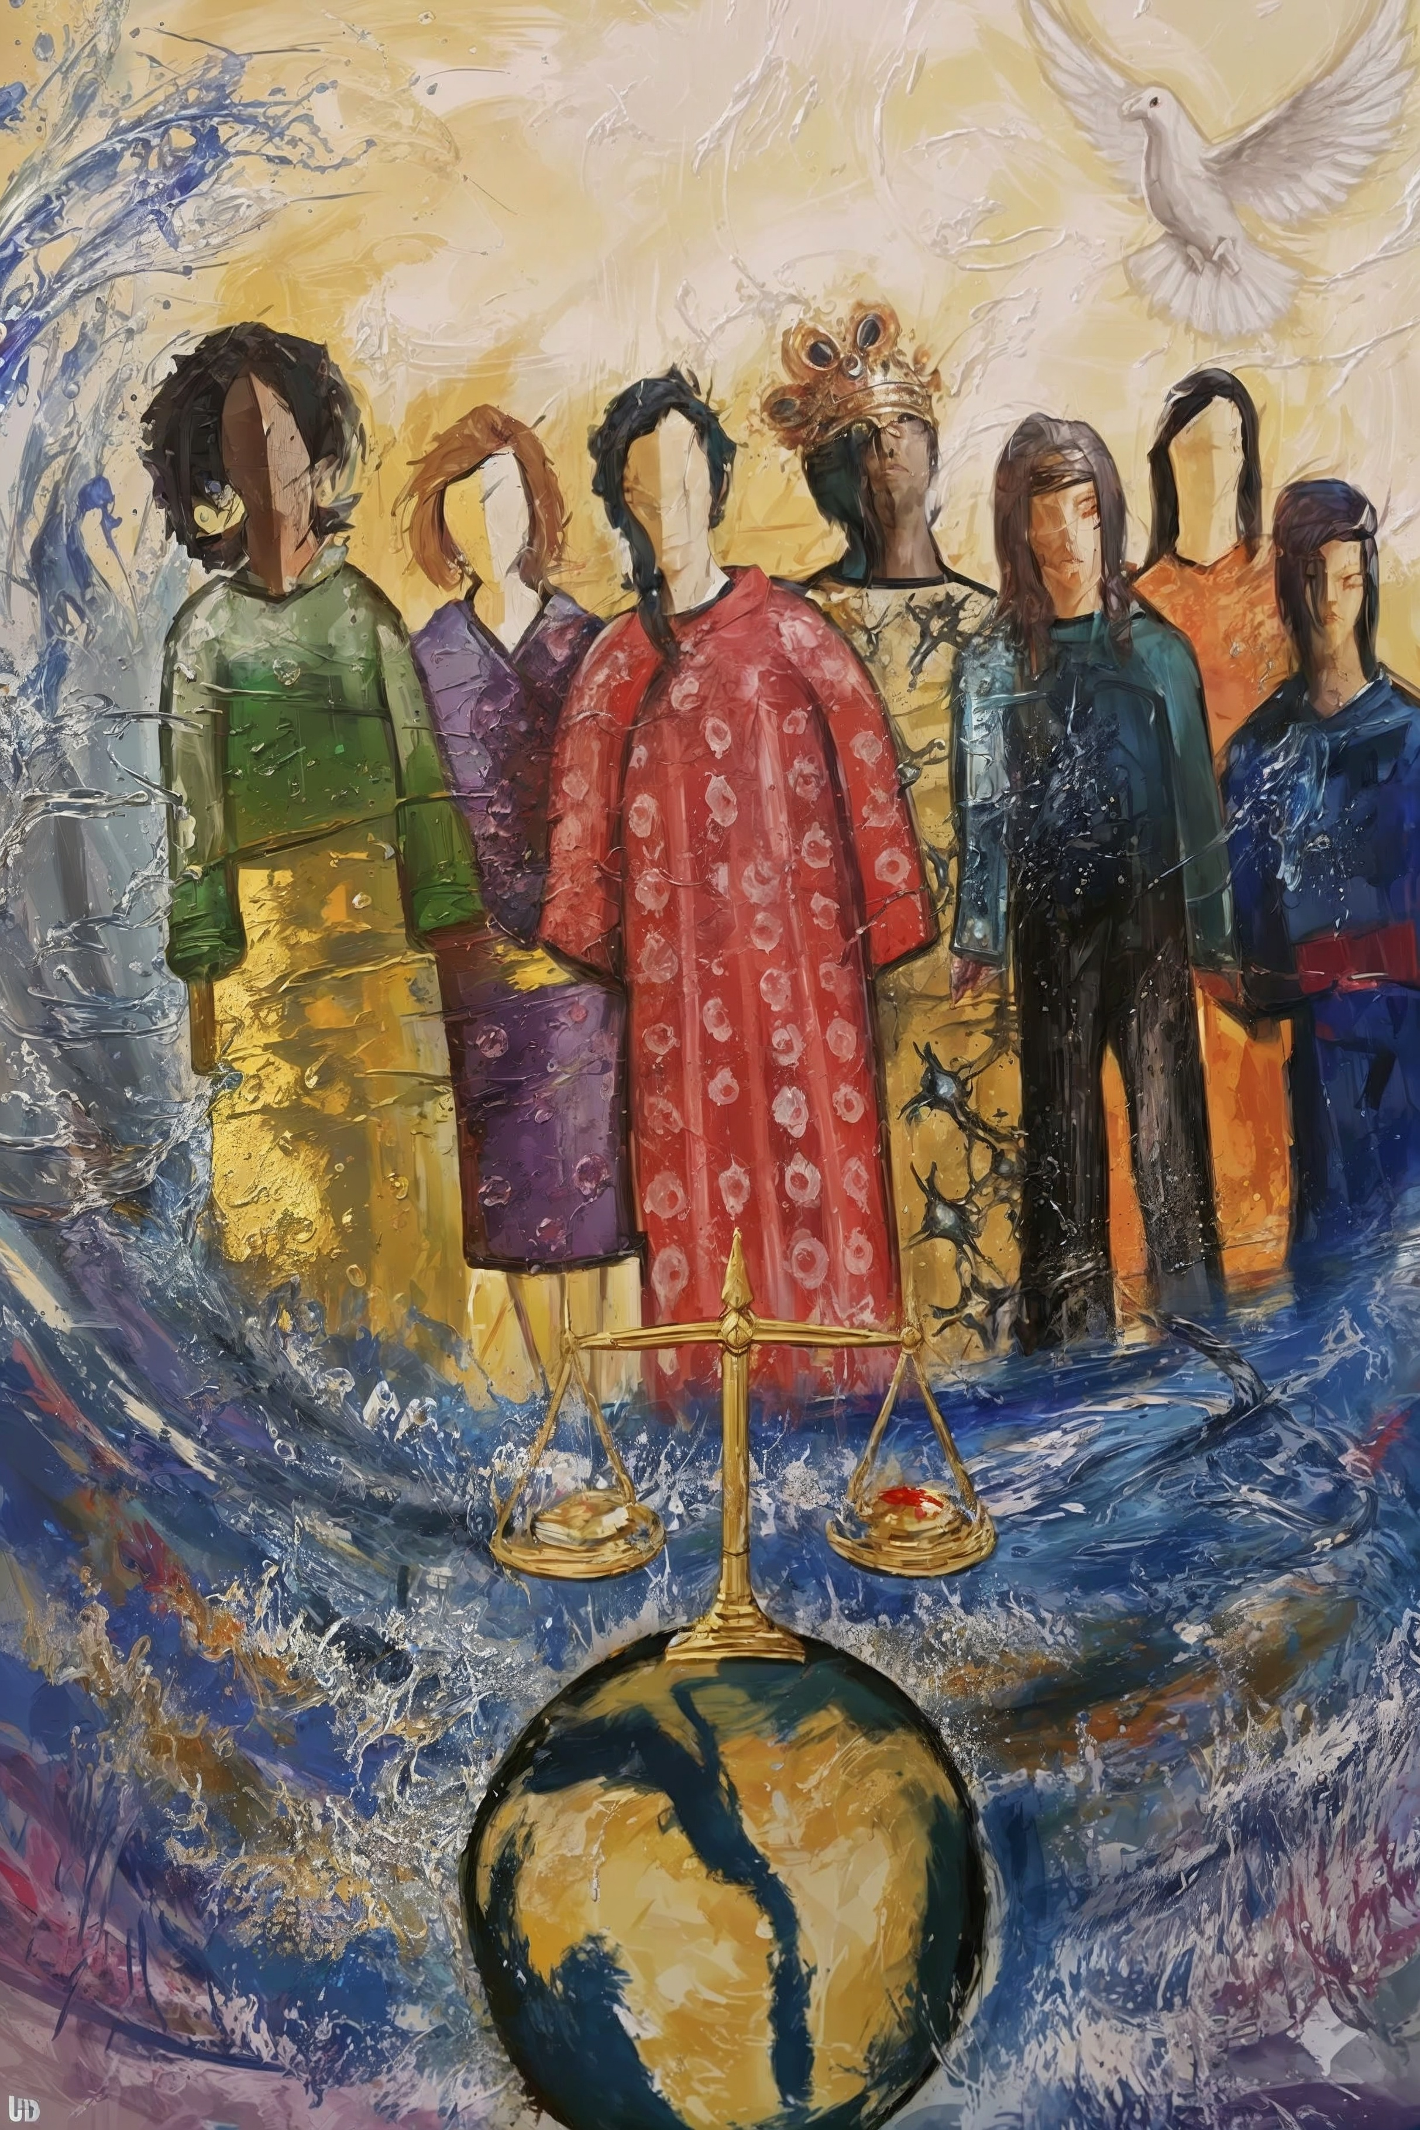

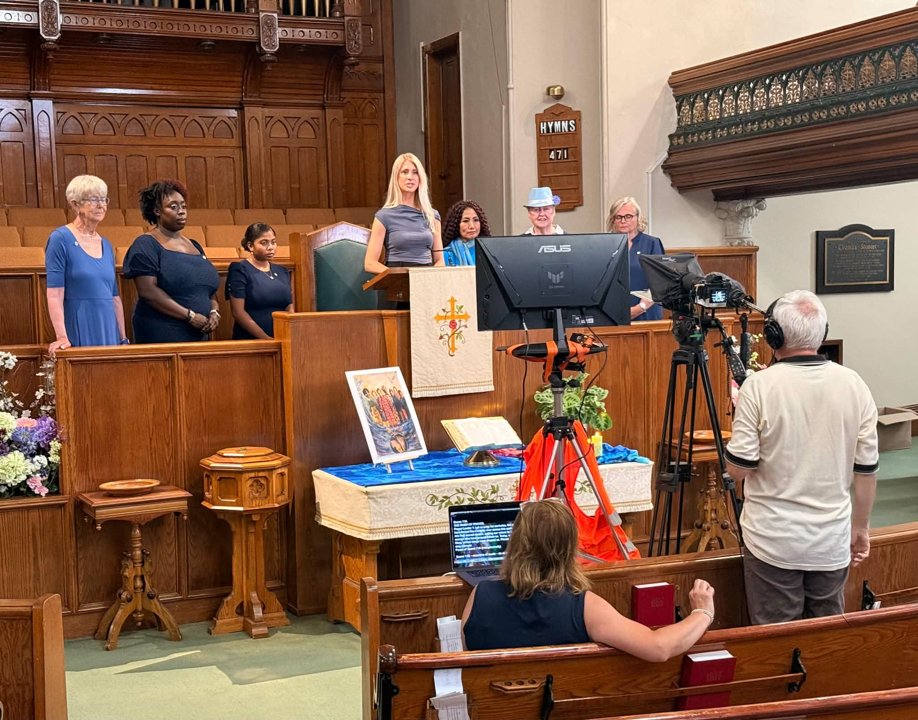
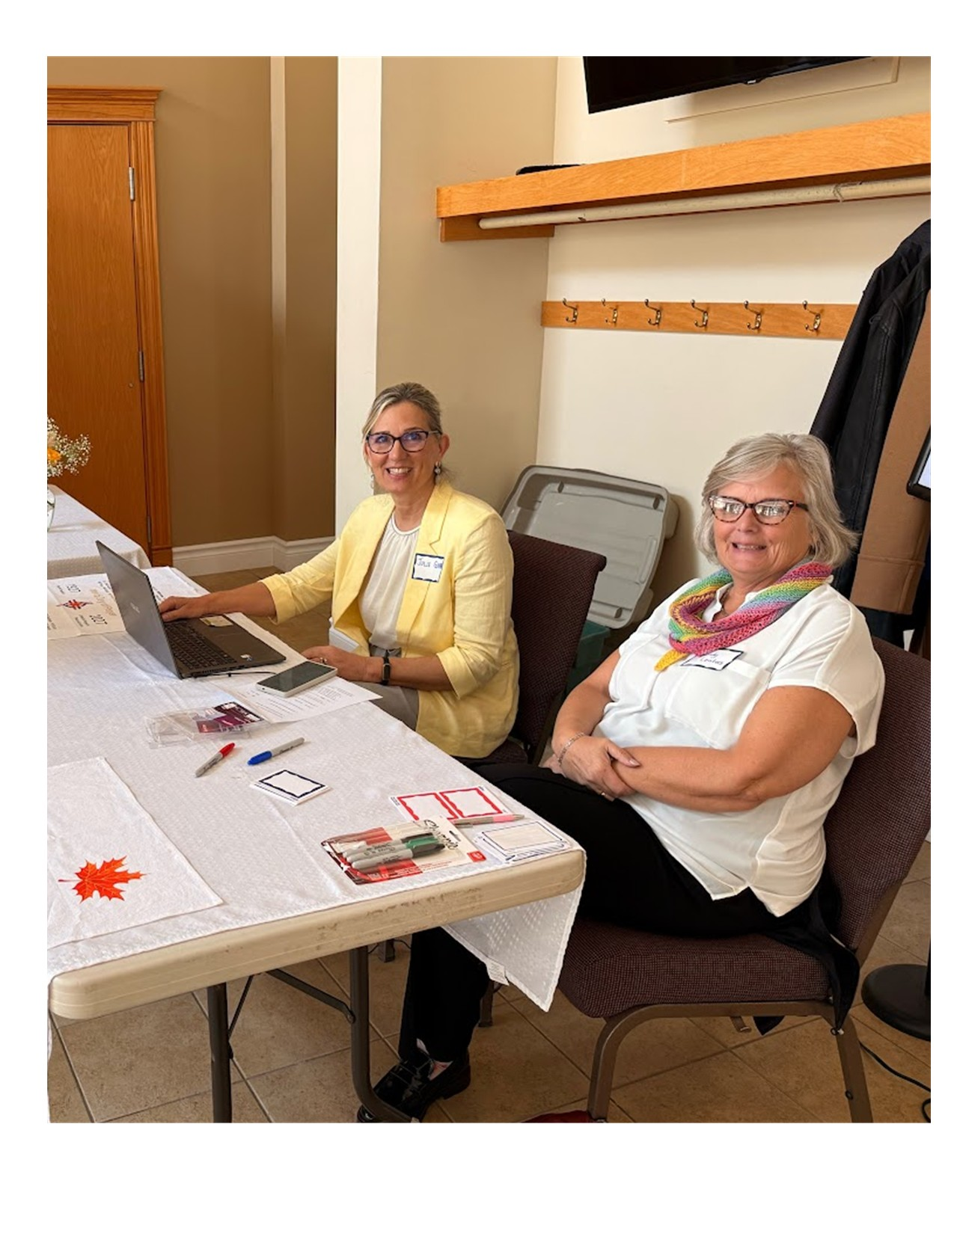

The World Day of Prayer Coordinator role is important, and we greatly appreciate your help in planning a service and telling others in your community about it.

We are happy to bring you all the information you need to coordinate a service:

- By November 1, 2026, the WICC website - wdpcanada.ca - will have all the WDP 2027 service resources you need. Go to https://wdpcanada.ca/access-world-day-of-prayer-resources/ and fill out a short form to access the online resources for free. An account and login are no longer required. However, you do need an email address. If you do not have an email address, please ask a friend, relative, or church member if you can use theirs to receive WDP information. Need help accessing resources? Contact us for support (see below). You will also receive emails with WDP updates and information about special events.

- The WDP 2027 service Planning Guide includes ideas to help prepare for the service.

- For free Offering Envelopes, please order these online at wdpcanada.ca/wicc-store or call or email shipping@wicc.org.

- The WDP 2027 service video features WICC staff and volunteers with closed captioning.
For the convenience of having all resources in one place or if you have limited Wifi or computer storage space, you can buy a USB memory stick ($25) that includes the service video as well as many WDP 2027 resources such as music, service PowerPoint, and a WDP history background video that you can play during your WDP gathering. Order online at wdpcanada.ca/wicc-store. With the USB, you will also receive a paper copy of the worship service, a participant bulletin version, and WDP history. When you order a USB, remember to order free Offering envelopes at the same time.

- There are many resources for World Day of Prayer that will be available on our website as of November 1st: the WDP worship service in English, bilingual (French and English), Spanish and German, posters, music, history of food trends, hymn suggestions, PowerPoint service and much more. All resources are available to download for free.

- Returning for 2027 … the National Service Area Map!
World Day of Prayer 2027 service locations in Canada can be shared by coordinators by going to https://wdpcanada.ca/service-locations
If you have been a coordinator before, these changes may be new to you:
- You no longer need to register online to access WDP resources. We have eliminated the step of logging in with a password to simplify our website.
- The Online WDP Planning event is scheduled for both a Saturday and a Thursday for your convenience (see below for event details and how to register).
- Children’s Programs are available for three age ranges: 4-7 years; 8-12 years; 13-18 years.

We Are Here to Support You
If you need assistance with any other aspect of World Day of Prayer, please contact our new
WDP Program Coordinator, Caroline Voitovici. She will direct you to the WDP Field Rep for your region.
Office hours are Monday to Thursday from 9am to 5pm. Please leave a message.
Email: wicc@wicc.org Phone: 416.929.5184

SAVE THE DATES:
Saturday, November 7, 2026 from 1:00 - 2:30 pm EST - Online WDP Planning Event.
Thursday, November 12, 2026 from 7:00 to 8:30 pm EST – Online WDP Planning Event
Saturday, January 16, 2026 - Three Regional Online World Day of Prayer Gathering Events.
For more information and to register for an event, go to wdpcanada.ca/get-involved/events/.


With gratitude and blessings,

Catherine MacKeil
Executive Director WICC
Together we are part of a worldwide movement
of informed prayer and prayerful action
for peace, justice, and reconciliation.

