United in Prayer for Justice and Peace
United in Prayer for Justice and Peace
Service location:
Date/Time:
More information is available from:

This service is organized by :
World Day of Prayer 2027
Please join us for the World Day of Prayer, a prayer movement that invites us to enrich our faith experience through the life events of Christians from other countries and cultures, and to bring hope to women touched by injustice. The 2027 service was written by the World Day of Prayer International Committee to celebrate the WDP 100th Anniversary!
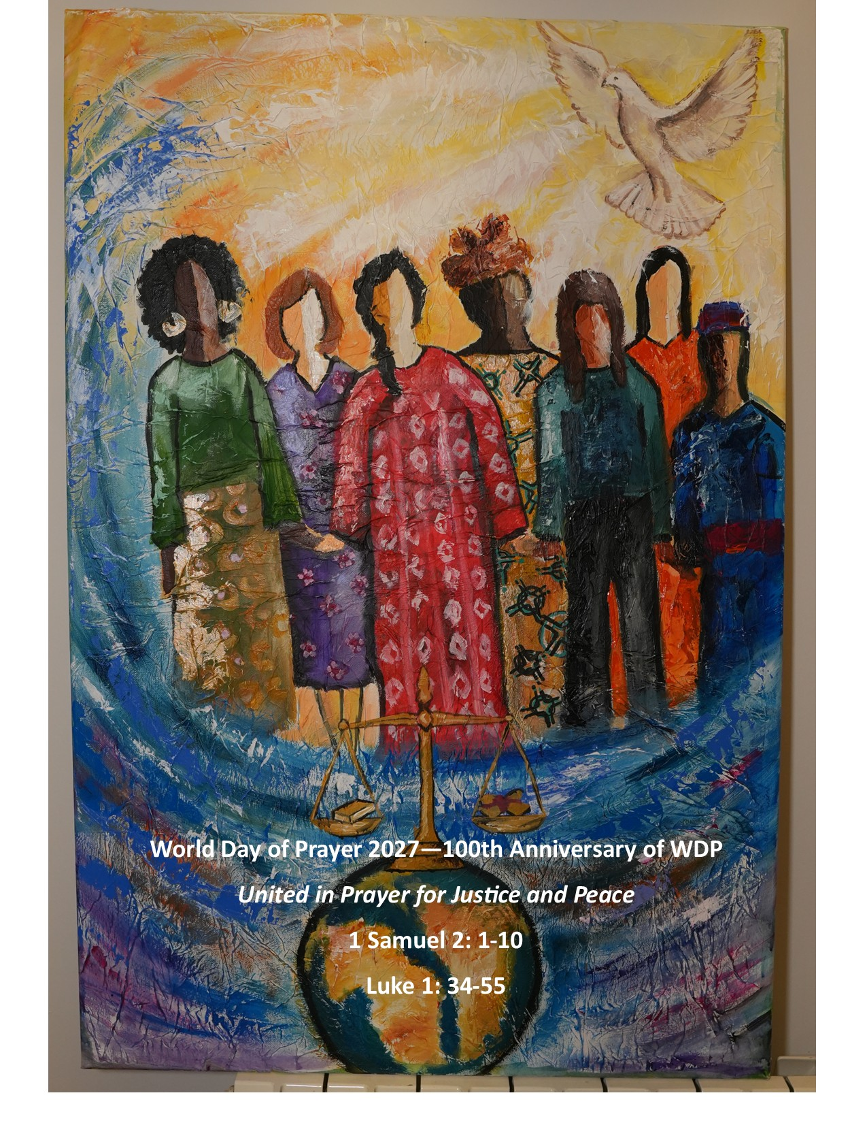
Service location:
Date/Time:
More information is available from:

This service is organized by :
World Day of Prayer 2027
Please join us for the World Day of Prayer, a prayer movement that invites us to enrich our faith experience through the life events of Christians from other countries and cultures, and to bring hope to women touched by injustice. The 2027 service was written by the World Day of Prayer International Committee to celebrate the WDP 100th anniversary!

World Day of Prayer resource distribution is coordinated by the Women’s Inter-Church Council of Canada.

47 Queen’s Park Crescent, East
Toronto, ON
M5S 2C3
416.929.5184

wicc@wicc.org wdpcanada.ca
facebook.com/WICCanada

World Day of Prayer resource distribution is coordinated by the Women’s Inter-Church Council of Canada.

47 Queen’s Park Crescent, East
Toronto, ON
M5S 2C3
416.929.5184

wicc@wicc.org wdpcanada.ca
facebook.com/WICCanada



