I Will Give You Rest: Come
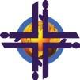
The World Day of Prayer is coordinated by the Women’s Inter-Church Council of Canada.

47 Queen’s Park Crescent, East
Toronto, ON
M5S 2C3
416.929.5184

wicc@wicc.org wdpcanada.ca
facebook.com/WICCanada

The World Day of Prayer is coordinated by the Women’s Inter-Church Council of Canada.

47 Queen’s Park Crescent, East
Toronto, ON
M5S 2C3
416.929.5184

wicc@wicc.org wdpcanada.ca
facebook.com/WICCanada


Service location:
Date/Time:
More information is available from:

This service is organized by :
World Day of Prayer 2026
Please join us for the World Day of Prayer, a prayer movement that invites us to enrich our faith experience through the life events of Christians from other countries and cultures, and to bring hope to women touched by injustice. The 2026 service was written by the Nigerian World Day of Prayer committee.
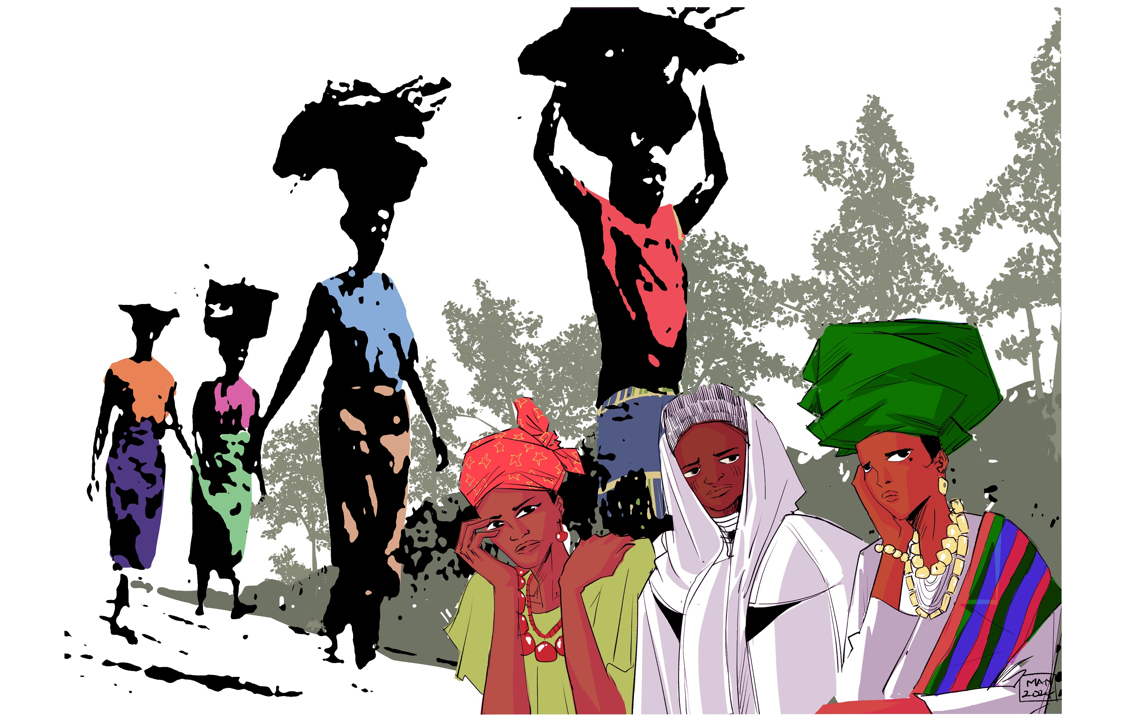
Service location:
Date/Time:
More information is available from:

This service is organized by :
World Day of Prayer 2026
Please join us for the World Day of Prayer, a prayer movement that invites us to enrich our faith experience through the life events of Christians from other countries and cultures, and to bring hope to women touched by injustice. The 2026 service was written by the Nigerian World Day of Prayer committee.
I Will Give You Rest: Come

