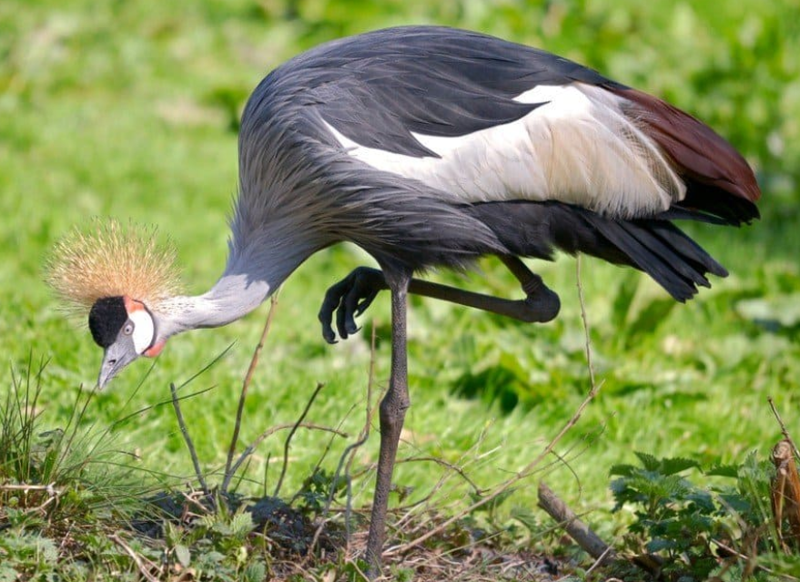
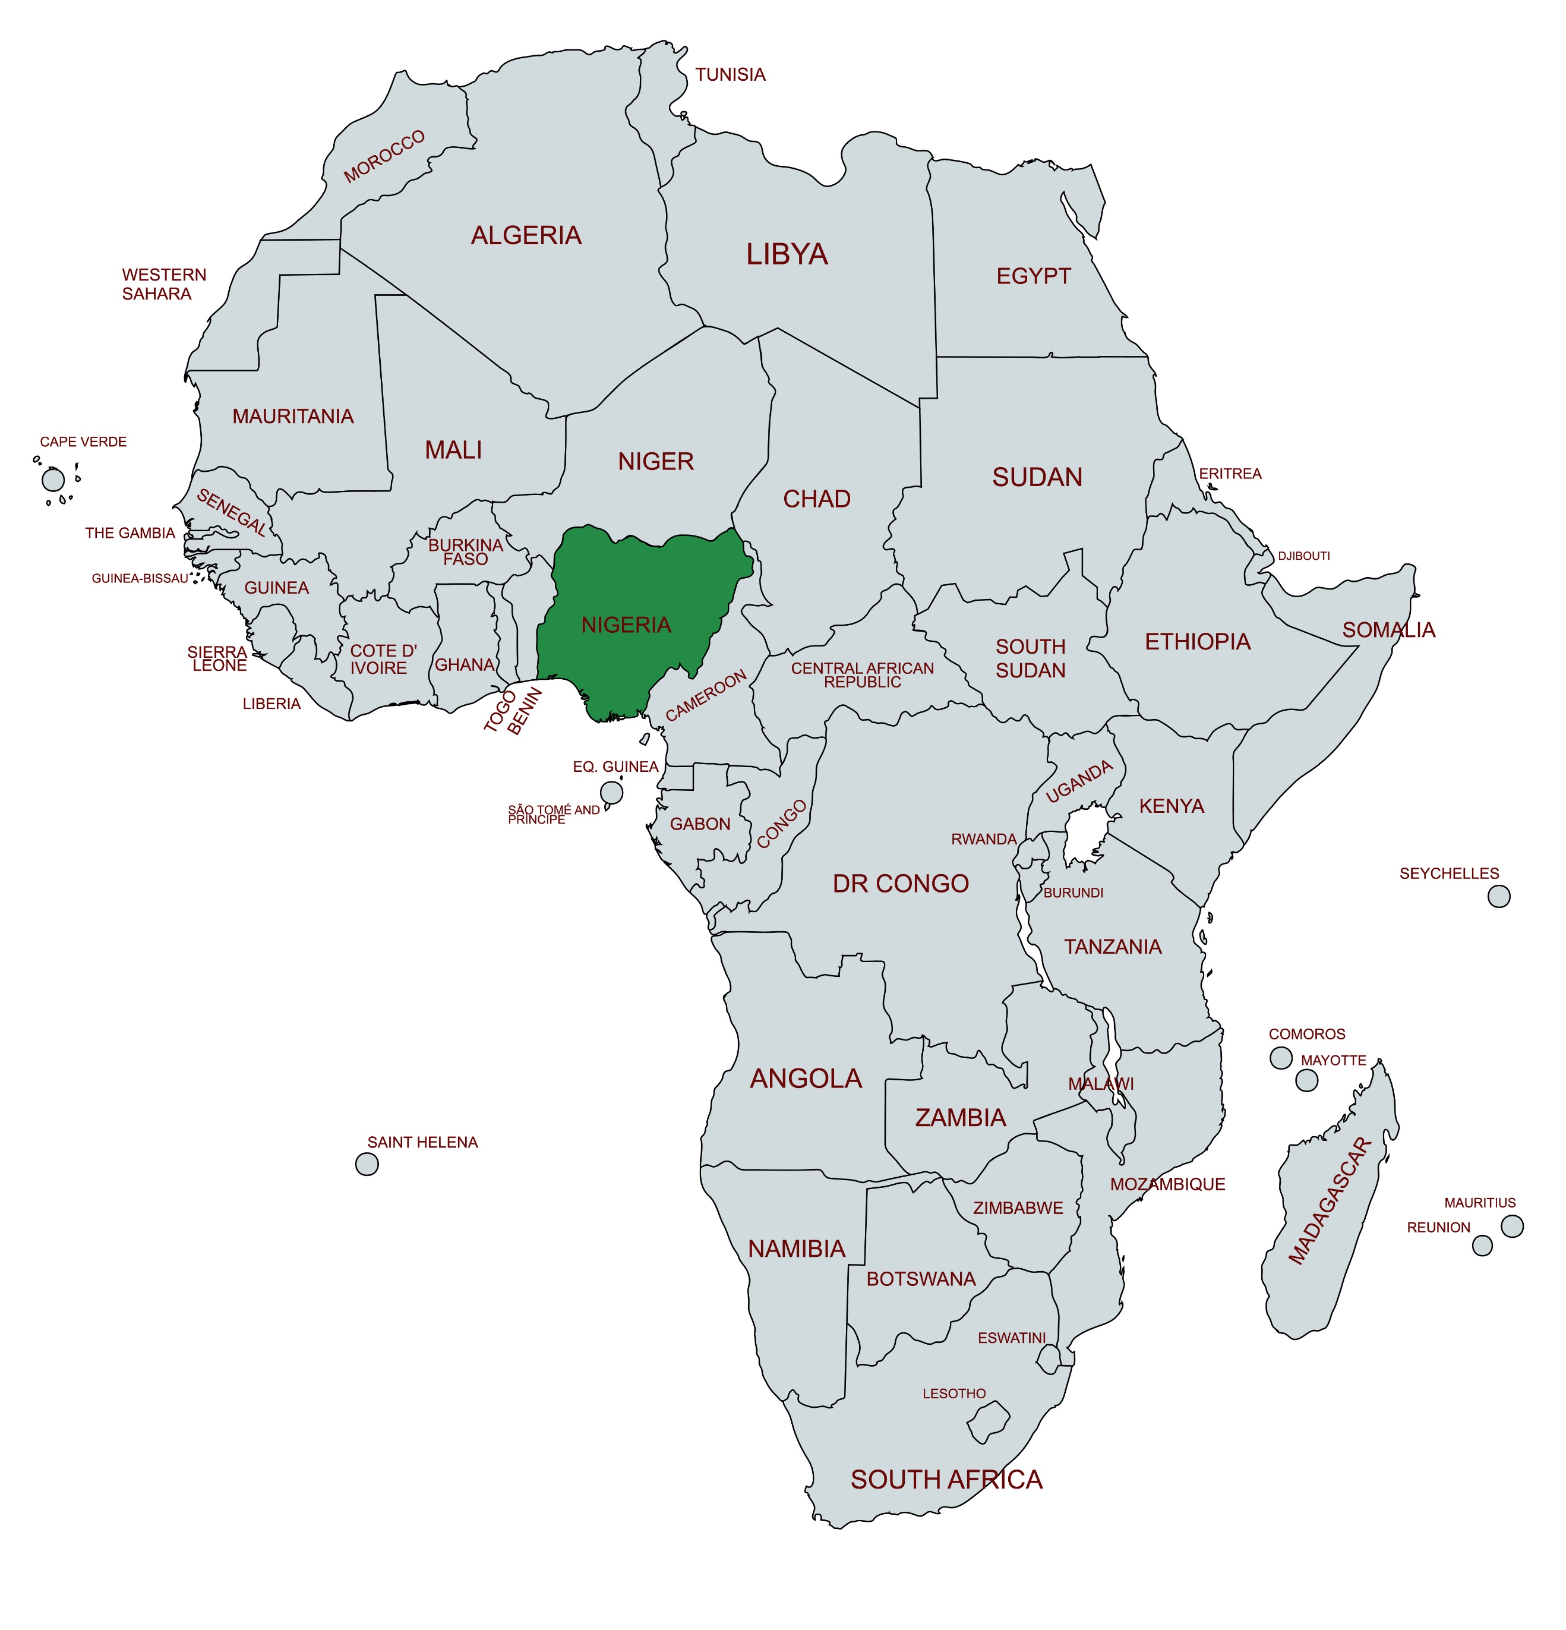

Nigeria (The Federal Republic of Nigeria) spans 910,7770 km² on the western coast of Africa. Its name derives from the Niger River and was coined in 1897 by the British journalist Flora Shaw.

Nigeria is a land of diverse ecosystems, including deserts, plains, swamps, mountains, and jungles. The third-largest river delta in the world is within its boundaries. Climate ranges from equatorial in the south to arid in the north, with a tropical climate in the central regions. One of the most recognizable sites is Zuma Rock, a 725m-tall monolith outside the capital of Abuja that’s pictured on the national currency.

The Costus spectabilis, also known as the Yellow Trumpet, is Nigeria's national flower. It is abundant in forests and on riverbanks. The flower is also featured on the Nigerian Coat of Arms.

The black-crowned crane is the official animal of Nigeria, endemic to the country and thought to be a sign of prosperity. Some of the rarest animals in Nigeria include the Cross River gorilla, the African manatee and the pangolin.

Nigeria's population of over 230 million makes it the most populous country in Africa and the sixth most populous in the world. The three largest ethnic groups are the Hausa-Fulani, Yoruba, and Igbo. Over 500 indigenous languages are spoken, including Hausa, Igbo, and Yoruba. English serves as the official language.

One of the earliest known civilizations in the area was the Nok culture, which flourished between 1000 BC and 500 AD. The Nok people, renowned for their terracotta sculptures, laid the foundation for iron smelting in West Africa. Much later, European colonization established their presence and administered different regions. Portuguese explorers were the first Europeans to begin direct trade with the peoples of southern Nigeria in the 1500s.

During the transatlantic slave trade, millions were forcibly taken from Nigeria and transported to different parts of the Americas, resulting in the African diaspora. The return of some descendants of these slaves has contributed to the cultural diversity in Nigeria.

Under British leadership, the Northern and Southern Protectorates were amalgamated in 1914, creating the entity known as Nigeria. Nigeria's political landscape has evolved significantly since gaining independence from British colonial rule on October 1, 1960.

Women's participation in politics has gradually increased over the years, although significant gaps persist. Efforts have been made to address gender imbalance in Nigerian politics, including the implementation of the National Gender Policy of 2006 and the Gender and Equal Opportunities Bill.

Nigeria is known for its religious diversity. Major religions include Christianity, Islam, traditional African religions, and a small percentage of adherents to other faiths. The impact of Christianity extends beyond spiritual practices, playing a vital role in the development of education and healthcare infrastructure through missionary schools and hospitals.

Religious coexistence and tolerance are essential aspects of Nigerian society, as the country strives to maintain peace and harmony among its diverse population. Interfaith dialogue, religious organizations, and government initiatives have been instrumental in fostering understanding, promoting religious tolerance, and mitigating religious conflicts.

Nigeria's rich cultural tapestry is woven from the traditions of over 250 ethnic groups, each contributing unique elements to the nation's vibrant arts scene. The Yoruba are known for their talking drums, the Hausa and Fulani for the goje lute, and the Igbo for the ekwe wooden slit drum. Other traditional instruments include flutes, xylophones, and percussion instruments, all playing crucial roles in storytelling and cultural preservation. Contemporary Nigerian music evolved from 1920s palm-wine music and highlife, blending traditional and Western influences.

Each ethnic group has its own traditional dances, such as the Yoruba Bata dance, the Hausa Koroso, or the Igbo Aladinma. These dances often tell stories, celebrate harvests, or mark important life events. Nigerian visual arts also include vibrant textile traditions, such as Adire (indigo-dyed cloth) among the Yoruba, and elaborately decorated calabashes. In the mid-20th century, playwrights like Wole Soyinka (who later won the Nobel Prize in Literature) and Ola Rotimi developed a distinctly Nigerian theatrical tradition that often addressed social and political issues. The film industry, popularly known as Nollywood, has become the second largest in the world in terms of annual film productions.

Nigeria is the fourth-largest economy in Africa, with a nominal gross domestic product (GDP) of $363 billion (USD). Oil and gas account for about 10% of its GDP, while the agricultural sector is a major source of employment, contributing about 20% to the GDP.

There are two major seasons: dry and rainy (wet), contributing to its rich agricultural potential. In the northern regions of Nigeria, millet and sorghum are widely cultivated and serve as primary staple crops. In the southeastern area, cassava and yam are the primary staple foods while seafood plays a significant role in the cuisine of the Niger Delta. Other crops grown in Nigeria include beans, rice, sesame, cashew nuts, cocoa beans, groundnuts, gum arabic, kolanut, maize (corn), melon, palms, plantains, rubber soybeans, and bananas.

The services sector, including telecommunications, financial services, and trade, is rapidly growing and is expected to contribute to Nigeria's economic future significantly. Despite these strengths, the country faces economic challenges, including high unemployment rates, infrastructure deficits, and a need to diversify its foreign exchange sources.

Nigeria has made progress in increasing access to education, with efforts focused on achieving the United Nations Sustainable Development Goal of providing inclusive and equitable education for all. However, challenges remain, particularly in remote and marginalized areas.

The National Health Act of 2014 established a framework for universal health coverage and outlined the roles and responsibilities of different stakeholders in the healthcare system. One of the primary concerns is the high burden of communicable diseases, including malaria, tuberculosis, and HIV/AIDS. Another area of concern is non-communicable diseases (NCDs) such as cardiovascular diseases, diabetes, and cancer. Maternal and child health is another significant area where political commitment is crucial. Nigeria has one of the highest maternal and child mortality rates globally.

Nigeria has made efforts to expand health insurance to provide financial protection and improve access to healthcare services. Transparent and accountable governance systems can help curb corruption, ensure the efficient use of healthcare resources, and foster public trust in the healthcare system.

Women’s Voices: Ngozi Okonjo-Iweala is the first woman and African to be appointed Director-General of the World Trade Organization (WTO). Ndidi Nwuneli, co-founder of Sahel Consulting Agriculture & Nutrition Ltd and founder of LEAP Africa, focuses on transforming African agriculture and improving food security through innovative practices. Evangelist Dame Florence Uche’s leadership in World Day of Prayer lead to ecumenical strength.

Gender discrimination: Girls often receive fewer educational opportunities than boys, leading to lower literacy rates and limited career prospects. In the workplace, women face discrimination in hiring, promotion, and pay, despite laws prohibiting such practices.

Early marriage, particularly in rural and northern areas, forces girls as young as 12 or 13 into marriages that cut short their education and expose them to health risks. Marital violence and rape often go unreported due to cultural stigma and inadequate legal protections, while the absence of comprehensive domestic violence legislation in some states compounds these issues.

Widows are subjected to cruel and degrading traditional practices, including drinking water used to clean their husbands’ corpses to “prove” their innocence and in-laws forcefully taking assets that rightfully belong to the widow and her children.

The World Day of Prayer movement in Nigeria began in 1961, introduced by Lady Eudora Olayinka Akanu-Ibiam of the Presbyterian Church. It was initially embraced by member churches of the Christian Council of Nigeria, including Anglican, Methodist, Presbyterian, Baptist, and others. Since then, WDP Nigeria has continued to grow as an organization by establishing zonal structures across the country.

