JOLLOF RICE – a traditional Nigerian recipe
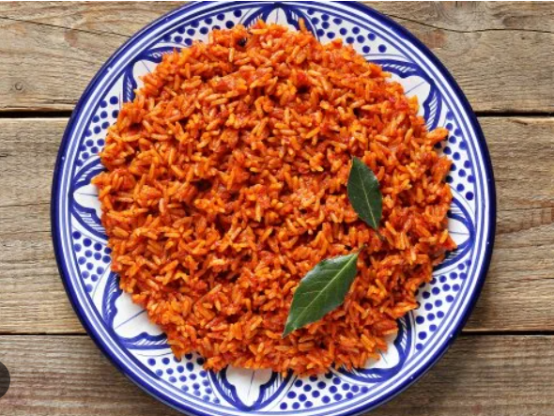
INGREDIENTS
- Cooking spray or vegetable oil to grease the baking dish
- 3 medium fresh tomatoes (older tomatoes can also work well)
- 1 Scotch bonnet or habanero pepper (seeded for less heat)
- 1 medium onion, 1/2 coarsely chopped, 1/2 sliced (choose your preferred texture) – red or white – red are milder and slightly sweeter
- 3 red bell peppers, cored, roughly chopped (or choose your preferred texture)
- 1 cup chicken stock or water, or more or less if necessary; enhances the depth of flavour
- 1/3 cup vegetable oil
- 1 tsp. Kosher salt (use half the amount of table salt as the recipe calls for kosher salt)
- 2 bay leaves – infuses the dish with subtle, savoury aromas
- 1 tsp. curry powder – adds warmth and complexity
- 1 tsp. sweet or smoky paprika
- 1 Tbsp. dried thyme – earthy and herbal; balances the tomato and spice
- 1/2 tsp. ground ginger – adds a sharp, zesty taste; essential for fragrant sauce
- 1 Tbsp. garlic powder
- 1 Tbsp. onion powder
- 1 tsp. freshly ground black pepper
- 1 Tbsp. tomato paste
- 2 cups long-grain rice, rinsed, strained until water runs clear
- 2 Tbsp. unsalted butter
DIRECTIONS
Step 1 Adjust oven rack to center position and preheat oven to 350°. Grease a 13" x 9" baking dish with cooking spray or vegetable oil.
Step 2 In a blender, combine tomatoes, Scotch bonnet pepper, chopped onions, and bell peppers. Blend until smooth. This base gives the iconic red hue and flavour to rice jollof.
Step 3 In a large pan, heat oil over medium heat, and add the sliced onions. Season with salt, and cook 2 to 3 minutes. Add bay leaves, curry powder, paprika, dried thyme, ginger, garlic powder, onion powder, and black pepper. Cook over medium heat for about 1 minute to let the spices bloom. Add tomato paste, and stir for another 2 minutes.
Step 4 Add tomato-pepper-Scotch bonnet mixture, stir, and cook over medium heat 10 to 12 minutes, or until mixture is reduced by half. Note: you may want to try adding in the spices after the rendering for a different taste experience.
Step 5 Add 1 c. stock to the mixture and bring to a boil, 1 to 2 minutes.
Step 6 Stir in rice and butter. Season with salt to taste.
Step 7 Transfer mixture to the greased baking dish. (Be careful, it will be hot!)
Step 8 Cover baking dish tightly with foil, and bake until rice is tender, about 40 to 50 minutes. Check rice after about 30 minutes, and add water or stock if it looks dry or the rice is still hard. Fluff with a fork before serving.
Note: Set aside 2 hours for prep and cooking if it’s the first time one is making this delicious dish.

