RECIPE: Nigerian Butter Biscuits
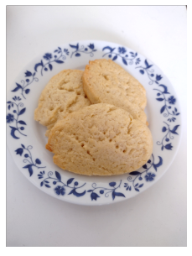
Ingredients:
1 cup softened butter
3/5 cups white granulated sugar
2 eggs
1 tsp vanilla
1 & 3/5 cups all-purpose flour
1 tsp baking powder
Pinch of salt

- Preheat oven to 350 degrees F
- Cream together 1 cup of softened butter and 3/5 cups of white granulated sugar.
- Thoroughly mix in two eggs and 1 tsp of vanilla to the butter/sugar bowl.
- In a separate bowl, combine 1 3/5 cups of flour, 1 tsp baking powder and a pinch of salt.
- Add the flour, baking powder and salt combination into the butter/sugar bowl in four stages. Blend thoroughly at each stage until smooth.
- Once you have a smooth batter, roll the mixture in cling wrap into the shape of a log. The diameter will depend on the desired size of biscuits.
- Put this shape on a flat pan, and cool in the fridge for at least 20 minutes.
- Using a sharp knife, slice the cooled batter into biscuit shapes. Lie flat on parchment paper-lined cookie sheets. Use a fork to make holes in the top of each biscuit.
- Cook for 15 minutes. Check after 12 minutes – biscuits are done when edges are slightly brown. Note that these uncooked shapes will double in diameter when baking. It’s recommended that two cooking sheets be used.
- Cool before serving.
- Note: Coconut, lemon juice or other may be added for taste.

