World Day of Prayer Grant Recipients 2025-26

Location | Organization | Project | Amount
CANADA
British Columbia | Neighbourhood Homes of BC – Frog Hollow  Forty-five multi-barried youth aged 16 to 30 participated in a thirteen-week filming cycle funded in part by a $5000 World Day of Prayer grant. The program involved weekly lessons, two shooting-and-editing weekends, refreshments and a graduation ceremony. The youths received support from a full youth Case Management Team, a Frames program coordinator and a Film Instructor. Gains included life and employment skills, stronger community connections, industry knowledge from guest speakers, and technical filmmaking skills.  Sample video: https://www.youtube.com/watch?v=8I_7eSXmulA  Impact Story:  I want to work in film, and I had financial and mental health barriers to be able to pursue a career. I thought about going to school for it or securing work on set, but I never could get the money together nor could I work on set with my complex PTSD and panic attacks. This program makes me confident that  despite these issues, I will let my passion prevail over childhood trauma. I will be taking acting/voice acting classes on my low-income pass at the rec centre and I’m hoping to afford more expensive classes after, and see about getting into screenwriting/directing courses when I have the money to do so. Also on a side note, I’m really happy there’s a graduation ceremony. I never got to attend my elementary (homeschooled in 7th grade) or high school (11th grade expulsion) or adult night school (parents separated that month and I didn’t attend) ceremonies, and couldn’t afford to go to college. So the fact there is a grad ceremony is great, and I’m really excited to finally be able to be a part of one. | Frame Films Project  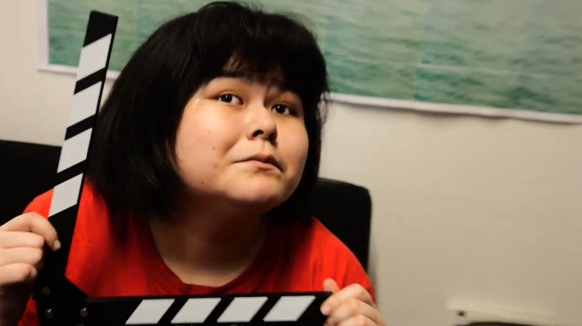 | $5,000
British Columbia | Talitha Korum Society  The Talitha Korum Society empowers marginalized women recovering from addiction through counselling and shelter for clients and their children under 6 years of age. A $5000 WDP grant paid for five equine-assisted counselling sessions for 20 mother/child pairings, providing a real-time practice of communication, boundaries, trust and co-regulation.  Participant comment:  Being with the horses helped me slow down and really see my child again... It gave me hope that healing is possible for both of us. | Women & Children – Equine Counselling  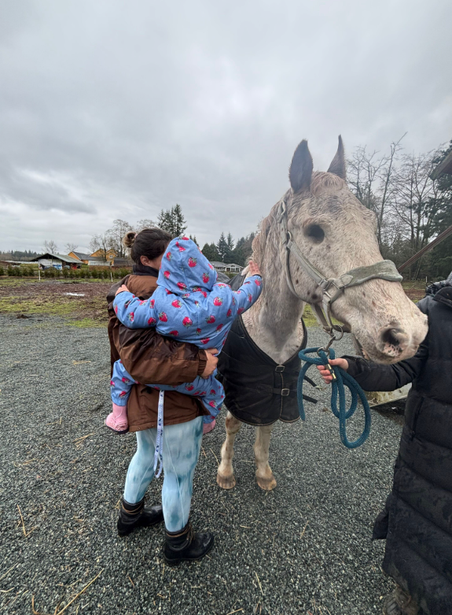 | $5,000
Saskatchewan | Battlefords Family Health Centres  The Battleford Family Health and Battle River Community Health centres received a $5000 WDP grant to support the Coffee Group that the Healthy Living program offered in partnership with the Counsellor from the KidsFirst program. This coffee group offers a low-barrier, easy-access point for pre- and postnatal women and families to connect with each other and build relationships with support people in the community. By structuring the group informally around an everyday activity like coming together for coffee, 96 women were able to build participants' relationships, skills, and capacity. There was a rotating structure of topics and themes, including healthy meals and prep, creative activities, mental health, and links to community.  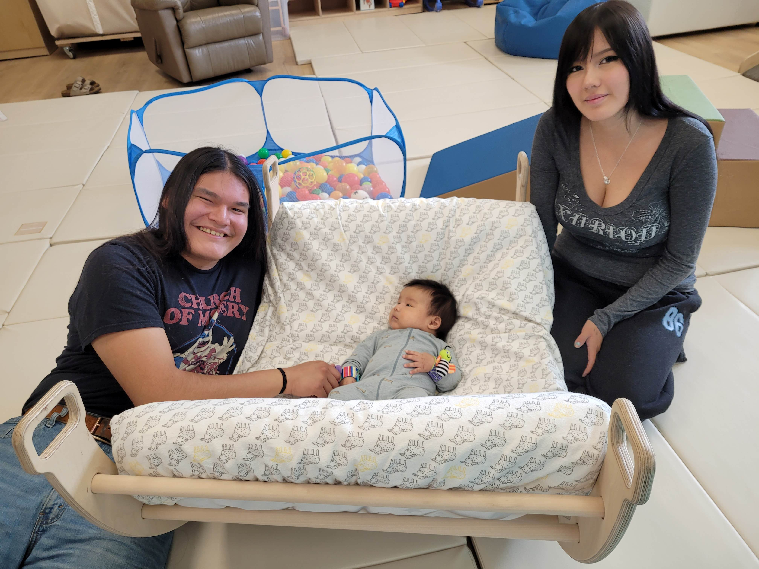  A KidsFirst Program Facilitator shared the following about a client who was part of the groups:  A prenatal mother was persuaded by her mother to attend the weekly groups and our Before Baby class, when she was initially hesitant. Mom attended every week, fitting it in around dentist appointments and other medical appointments. The mom told staff she never took her kids anywhere, they were so “bad” and now that mom goes to a variety of playgroups with her kids and now newborn baby, has a home visitor and has regular visits. From saying she didn’t like to take her kids anywhere, she is now a regular attendee at different playgroups and has said she wishes she had the group with her first child years ago and gotten help earlier. With the help of her home visitor, her kids are now referred to Pediatric therapies so she can get support for them as well. | Healthy Living Community Garden | $5,000
Quebec | Christian Direction  Over 200 people participated in webinars, discussion groups or reading circles based on a French language theological resource addressing violence, gender inequality and injustice against women written by 14 women. This ecumenical project received a $3500 WDP grant.  The writing group wanted to offer alternative, intelligent and balanced scriptural interpretations that would centre the voice of women, shedding light on real experiences.  Impact Message:  Upon completing our collective book, the Webinar participants took the opportunity to write to our group, and one woman wrote,“I read your essay, and I burst into tears,yes, I CRIED, so many of them were so beautiful, and we have finally given a voice to those who have suffered in justice! We have to keep going! | Women – Violence to Liberty Journey  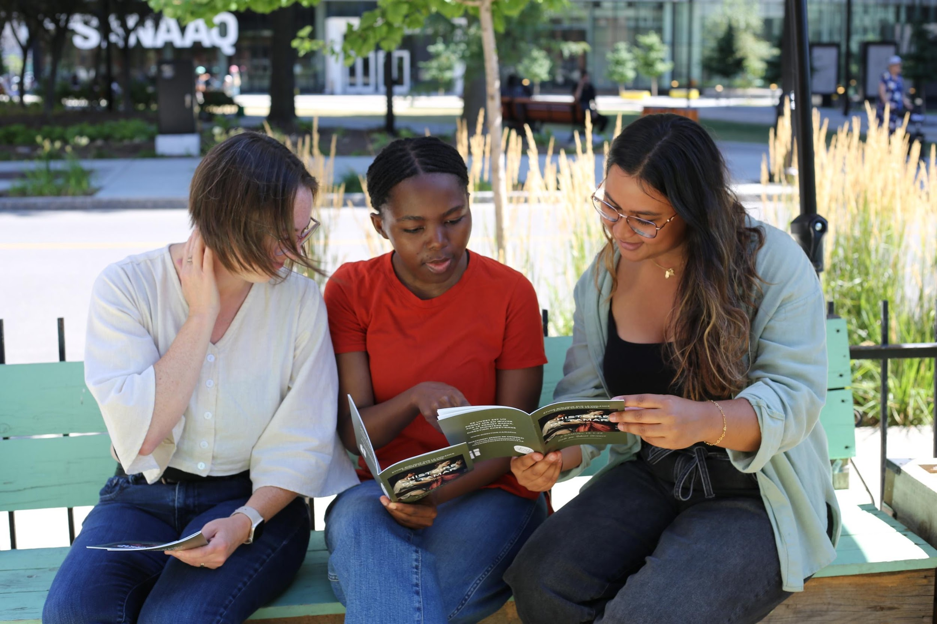 | $3,500
New Brunswick | BullyingCanada  BullyingCanada, which operates out of Fredericton, NB, provides a 24/7/365 network which can be accessed via phone, text or email. Volunteers help bullied children and youth create lasting solutions and heal from the trauma. The network also brings together parents, teachers, tormentors, social services and police to ensure that strategies and bullying prevention policies are widely known. A WDP grant of $5,000 paid for approximately 90,000 communications contacts in one month.  Impact Statement:  A 13-year-old girl reached out after months of bullying. With ongoing support, she regained confidence, safely engaged her school, and returned to class feeling protected. Her mother later shared that Lifeline gave their family hope when they felt completely alone. | Bullied Youth – Lifeline    BullyingCanadaWebsite image | $5,000
Prince Edward Island | Boys and Girls Club – Summerside  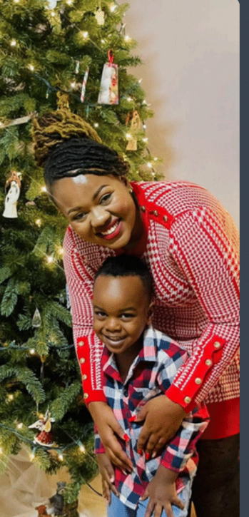  A $4000 WDP grant supported safe housing and trauma-informed case management for 72 women and their children. Outcomes included improved mental health, housing stability, rebuilt lives and food/hygiene essentials  Priscilla’s Testimonial:  I arrived at LifeHouse as a single mother with no home or support. LifeHouse gave my son and me safety, stability, and hope. Through housing, childcare, educational scholarship, and employment support, we rebuilt our lives. To everyone who supports LifeHouse, you make stories like mine possible. Thank you from the bottom of my heart. | Lifehouse – Support Beyond Housing | $4,000
Ontario | Salvation Army Church – Georgina  A $500 grant supported a BRAVE empowerment day for 18 girls. They had a self-defence class, a make-up/nail demonstration, supper and a presentation on modern-day slavery. All went home with a swag bag. This event was a launch to BRAVE Circle with a focus on human trafficking awareness.  Impact statement from a mother:  I wanted to say thank you. You see, my daughter is autistic and has never wanted to go to things, but she has been having a blast and actually tells me if they have another event, she wants to go. This has made me tear up, as this is huge for her social anxiety. | 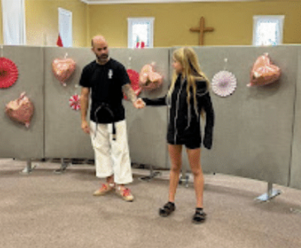  Girl Empowerment - BRAVE | $500
Ontario | Salvation Army – Lakeshore  BRAVE hosted a small event for girls in Etobicoke, ON. A community liaison from a local police station spoke about internet/social media safety. A follow-up BRAVE girl event in February 2026 also benefited from the $1000 WDP grant.  Impact:  I (program coordinator) had talked to the grandmother/guardian of one girl. She told me that her granddaughter thoroughly enjoyed the day and was excited to share all the information she learned with her grandmother. This girl is usually reserved and so the impact was positive. | Girl Empowerment – BRAVE  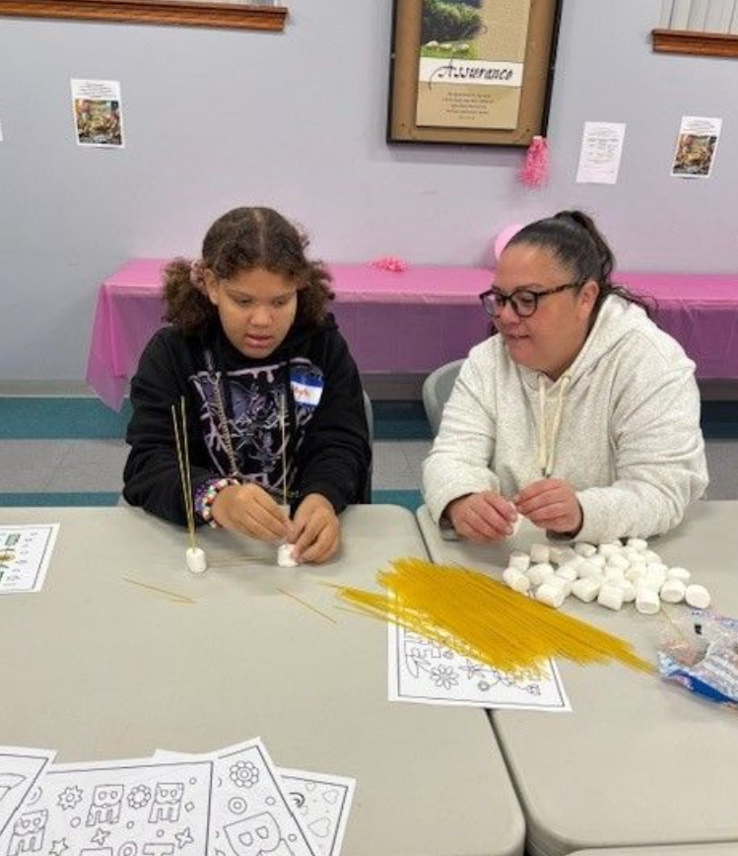 | $1,000
Ontario | Salvation Army – Acton  The primary focus of the Wonderfully Made project for community women in Acton was to provide a nutritious breakfast as well as the opportunity to form community, provide a caring and loving environment for friendships to flourish, and provide an opportunity for women to receive a gift of cleaning supplies (an identified need through our family service program). When women (single moms, widows, and low-income families) visit the family service program at the Acton Salvation Army Church, they often ask for help with toiletries, including household cleaning products, laundry detergent, and paper products. These items are frequently unavailable at local food banks, including the SA pantry. The $5000 grant from World Day of Prayer made a significant difference for 75 families/207 individuals.  Testimony from MB:  The Angels Among Us Women’s Breakfast at the Salvation Army was an incredible experience.From the moment I arrived, there was a sense of warmth, connection and purpose in the room.The guest speaker was inspiring. Her message was powerful and heartfelt...The timing of this breakfast was perfect for me personally. It provided space for reflection, renewal, and encouragement...I was inspired and felt good about myself when I left the room. I was reminded of the importance of faith, community and connection. | Wonderfully Made!  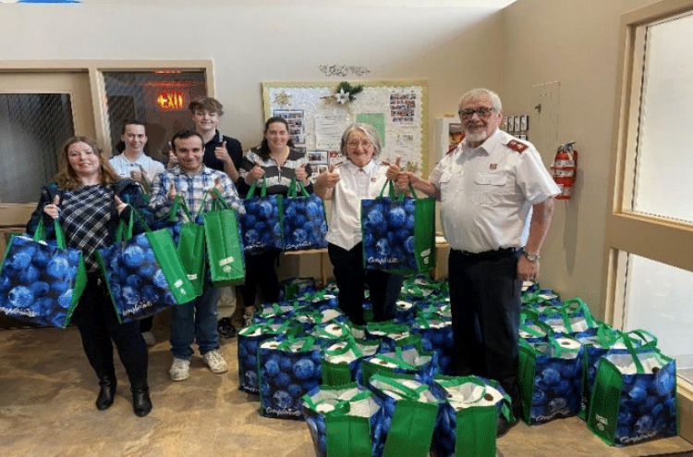 | $5,000
Ontario | Canadian Council of Churches  A priority for the Canadian Council of Churches is“Growing in Respect for Indigenous Spiritualities and Healing from Spiritual Violence” with an aim to resource the CCC and its member churches in living into the covenant commitment made in their Expression of Reconciliation at the 2014 Truth and Reconciliation Commission of Canada (TRC) national event:“to respect the right and freedom of Indigenous communities to practise traditional spirituality and teachings.”  A WDP $5000 grant helped support the reality of The Christian Interfaith Reference Group’s (CIRG) Reflective Report which will provide ecumenical and cross-Canadian perspectives on the complexities of establishing relationships between Christian and traditional Indigenous spiritual communities and practical guidance for local and regional ecumenical and interfaith groups working in this area. The process of deep listening, learning, and relationship-building has already proved transformative for members of the CIRG, and we hope that it will be equally transformative for regional and local ecumenical and interfaith leaders | Growing Respect for Indigenous Spiritualities and Healing from Spiritual Violence  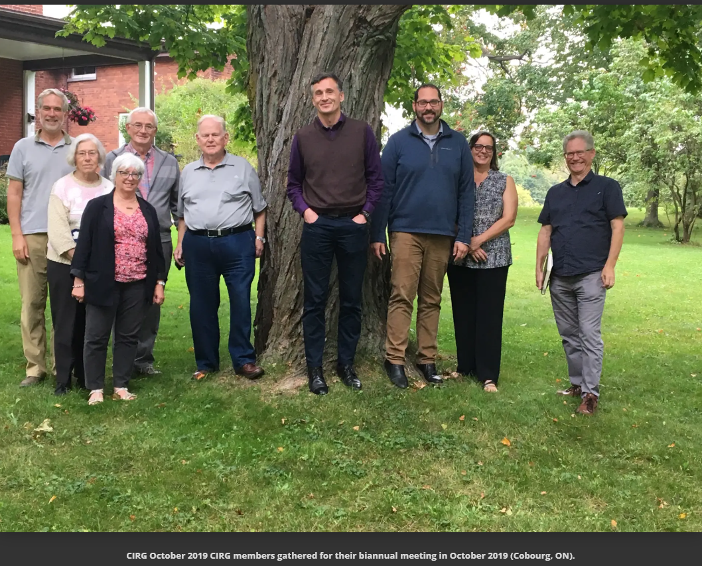 | $5,000
Ontario | Canadian Council of Churches  The Poverty Working Group of the Canadian Council of Churches is preparing a “Roadmap for Churches: Listening and Responding to Poverty”. Researchers are travelling to various locations in Canada to hear stories to increase shared understanding/reciprocity, honour dignity/exude humility and engage in active solidarity. This resource, in part funded by a $2000 WDP grant, will be available to all churches and interested organizations. The first session was held at Silver Spire UC in St. Catharines, ON, where 15 gathered to hear experiences of poverty. | People in Poverty – Faithful Response  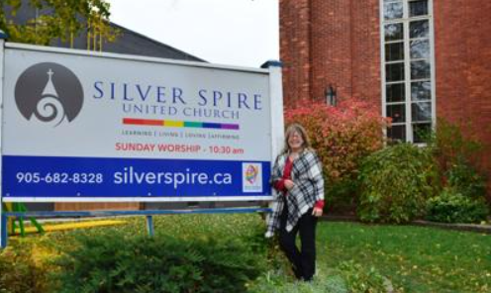 | 2,000
Ontario | Salvation Army – Thunder Bay  The Salvation Army Church in Thunder Bay received a $2500 WDP grant to support their Women in Community initiatives. The funds were used, specifically, to assist in the continuation of their food outreach programs. | Open Homes – Women in Community  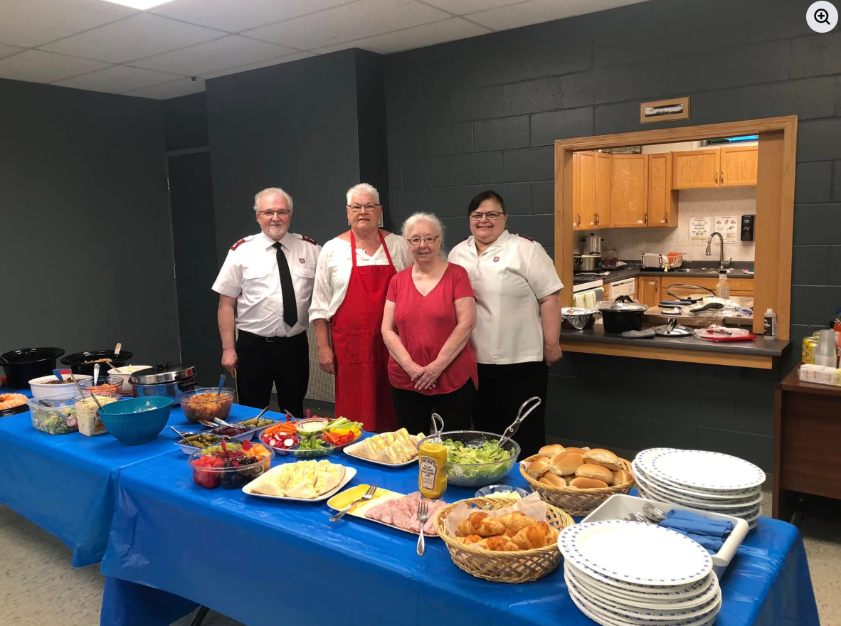 | $2,500
Ontario | IAFR Canada  A $5,000 WDP grant was used by Open Homes Hamilton/International Association for Refugees (IARF) to fund an honorarium for a Kinship Circle trainee leader and hospitality costs for six new refugee claimants in Hamilton.  Esther’s Statement:  My training period enabled me to build skills to support refugee claimants as they adjust to life in Canada. My cultural sensitivity, communication skills, problem-solving, interpersonal skills, and digital skills were all put to use. I have been empowered to help provide newcomers with excellent settlement support. | Refugee Women – Hamilton – Empowerment  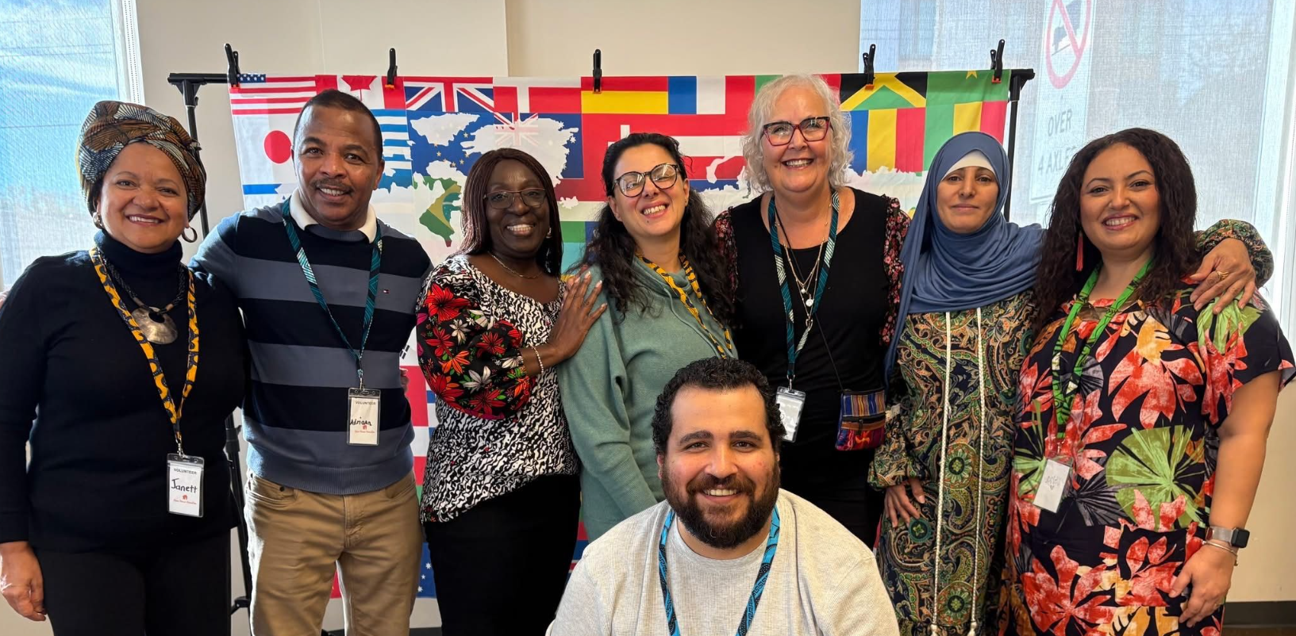 | $5,000
Canada Total |  |  | $48,500
International
Angola | Africa Inter-Mennonite Mission  Thirteen widows and/or women who had been abandoned by their husbands were each given $250 to $300 to start small businesses to support their families. These ranged from selling onions, embers, corn and cassava flour and fish at markets. Some funding covered the project manager's taxi costs to supervise the project.  Testimony from Irene A, a woman abandoned by her Muslim husband:  I am very grateful for the help the church gave me. I was very desperate about my life since my husband abandoned me. This help has given me hope again. Now I have a way to support my children. | Widows – Small Business Set-Up  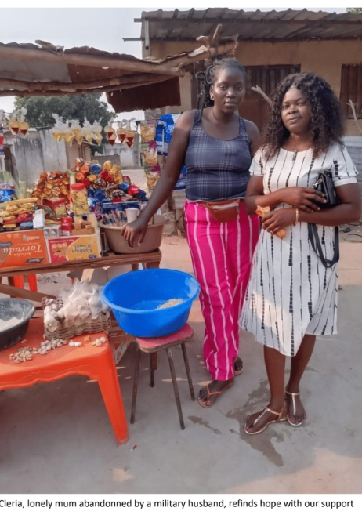 | $5,000
DR Congo | CBCA Baptist Community in Central Africa  A WDP grant of $5000 provided food during a time of famine due to war for 52 women living in Goma City between the ages of 18 and 45 who had been displaced in war, and were either pregnant or breastfeeding. Each woman received maize, beans, rice, oil, soya, sugar, salt and soap. A psychosocial assistant helped identify and distribute food to those most in need. The effects of war continue, and efforts to assist with food needs were gratefully appreciated.  Testimony:  The situation is getting worse and worse because of the effects of war, which does not cease to increase in the region, especially in the North-Kivu province. The population is without relief, but the grace of charitable hearts, mutual aid, and non-governmental organizations (NGOs) support “ONG”, the displaced of war can survive their hunger and regain a smile. | Women in Goma City – Emergency Food  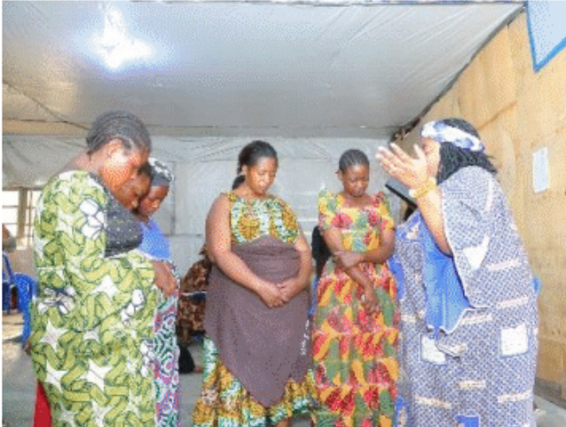 | $5,000
Zambia | iTeams Canada  A $ 5,000 WDP grant supported a 10-day training conference and a 3-week carpentry course, serving a total of 47 women. During an introductory conference, women could choose from food production, tailoring, hand and machine knitting, and crocheting. 60 women also participating in a mental health seminar. Costs were primarily dedicated to food and training operations, with 15% spent on travel costs.  Individual Story of Transformation Statement:  Caustrenace Malambo, a mother of four and a widow, changed her life by learning carpentry. She dedicated herself to studying a typically male-dominated trade while caring for two young sons, ages 6 and 11. Caustreance gained confidence and useful abilities during training by constructing two tables and four chairs. She went to her trainer, Mr. Musemali, after finishing the program, and he invited her to work from his carpenter shop in the neighbourhood market. She supports and educates her children with dignity by earning money by creating furniture, especially beds, which she sells through her neighbourhood and churches. | Women’s Skills Training  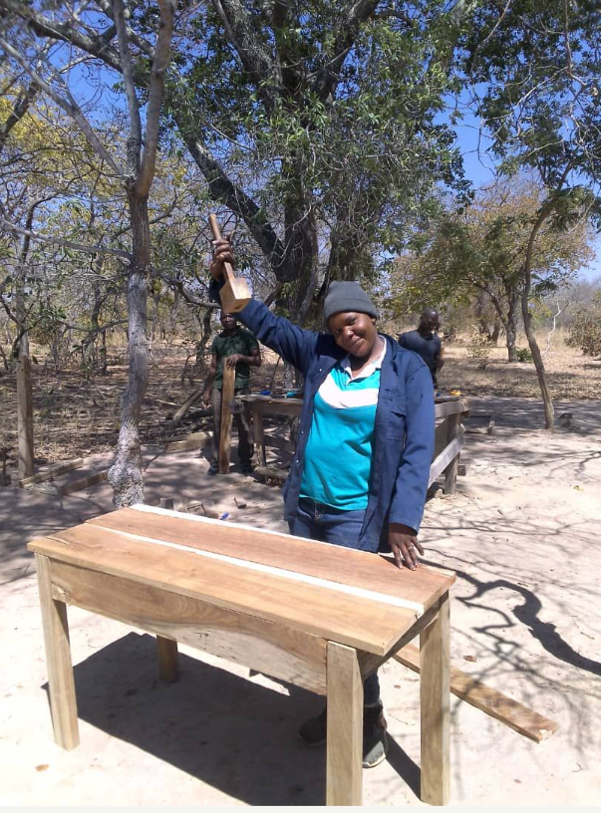 | $5,000
Kenya | Village of Love  Fifteen women caring for Aids/HIV orphans in the Kibera Project were given training, access to capital, follow-up, mentorship and peer support to establish businesses that shifted from survival-based income generators to ones more planned and predictable. Along with the women, 60 orphans, 30 suppliers, 10 transporters, 100 community members, and 5 employees benefited economically and psychologically from the grant.  Testimonies:  Before this project, I depended on well-wishers to pay school fees. Now I can plan and support my children with dignity.” “When my business faced challenges, the mentor helped me adjust instead of giving up. | Women Caring for Aids/HIV Orphans – Economic Empowerment  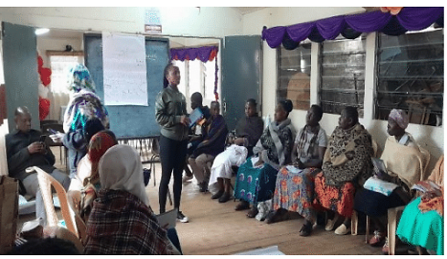 | $5,000
India | Kui Baptist Association (KBA)  Fifty girls from rural villages in India benefited from a $ 5,000 WDP grant that supported the Kui Baptist Association hostel. This building provides housing, food and education to girls from very poor economic circumstances in a secure location. Spiritual nurturing included learning about women from the Bible. The KBA hostel’s goals include gender equity, employment, reduced child marriages and an overall better quality of life.  Gita’s Story  Gita Majhiaged is a 13-year-old student from Hapelua village – Rayagada district who stays at the Kui Baptist Association hostel. Gita’s family of six lives below the poverty line. They depend on farm cultivation and daily wages to meet the family's needs. Gita’s parents are unable to meet the family's basic needs and cannot send the children to school. Through the local church, she joined in the KBA hostel. Now, Gita's thriving! She is doing well in studies, cultural activities, and spiritually. She recently won first prize in her school's drawing competition.Gita says, "I can sing, read the Bible, recite verses, and pray boldly. "She is very much thankful to the sponsors for giving her an opportunity.” | Female Children Empowerment  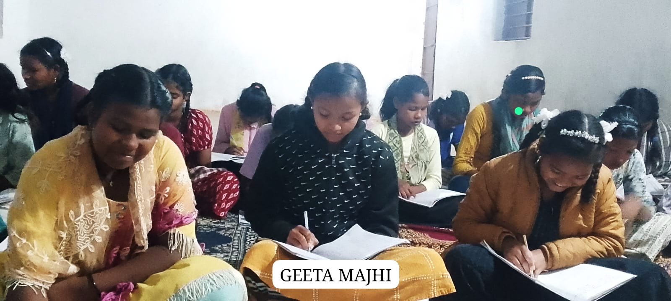 | $5,000
India | Step International Canada  Five widows with less than a high school education, 3-4 children each, and living in remote areas of India benefited from a $ 4,000 World Day of Prayer grant. The funds were used to establish self-sustaining businesses for each woman, including a grocery store serving a village of 50 people, a home-based sewing shop, goat farms, and organic vegetable production. Each of these businesses could be operated with the children close by, and led to stability, independence, confidence and dignity.  Babita’s Story  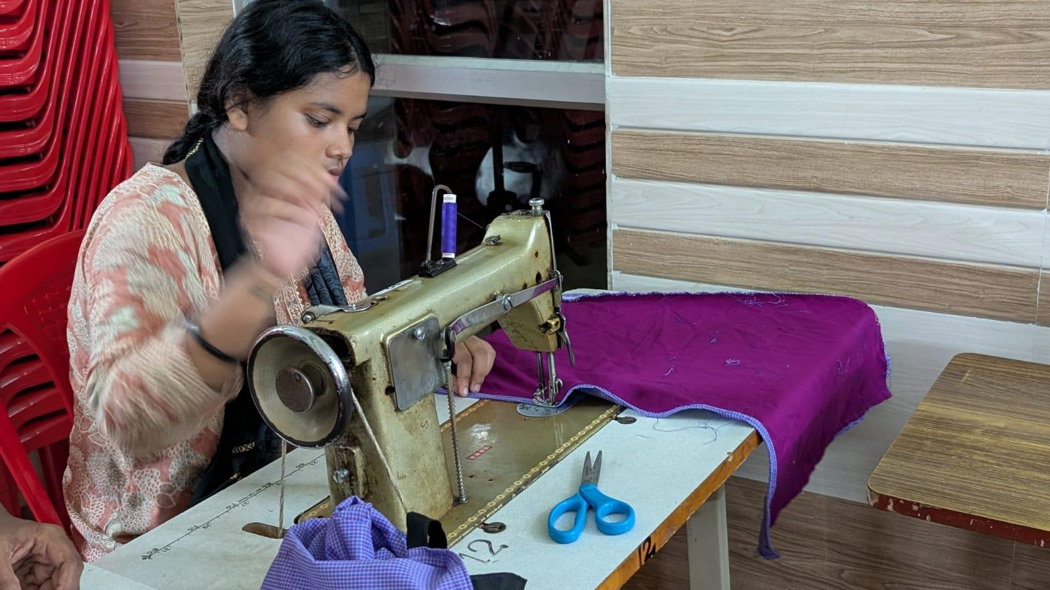  I am Babita from the Bargarh district of Odisha state of India. I studied up to the 10th grade, but due to financial difficulties, I could not continue my education. Sadly, in the year 2023, my husband passed away due to kidney problems. His death brought deep sorrow and many challenges into my life. After his passing, I began living with my mother-in-law, who is also a widow. At present, my son is 9 years old, and my daughter is 5 years old. Because my children are still very young, life has become especially difficult. They need constant care, guidance, and support. As a mother, it has been challenging to manage their education, health, food, and daily needs while also dealing with my own grief. The Sewing and Cloth project provided me with a steady source of income. | Widows – Self-Sustaining Businesses | $4,000
Guatemala | Horizons of Friendship  A $2500 World Day of Prayer Grant funded proactive diploma courses and workshops to 27 parents/guardians, 79 secondary school teachers and 113 university medical school students on identifying forms of violence, laws and protocols to protect children, stages of human development and reproduction, as well as continual support required for adolescent victims of sexual violence. Among other projects, the Horizons of Friendship backs a shelter in Quetzaltenango, Guatemala, that includes females aged 9 to 17, victims of sexual assault, who benefit from healing trauma therapy, self-love and self-care practices. Hope constantly rises from tragedy, including the burning of an area shelter on March 8, 2017. | Sexual Assault: Reduction & Support for Young Survivors  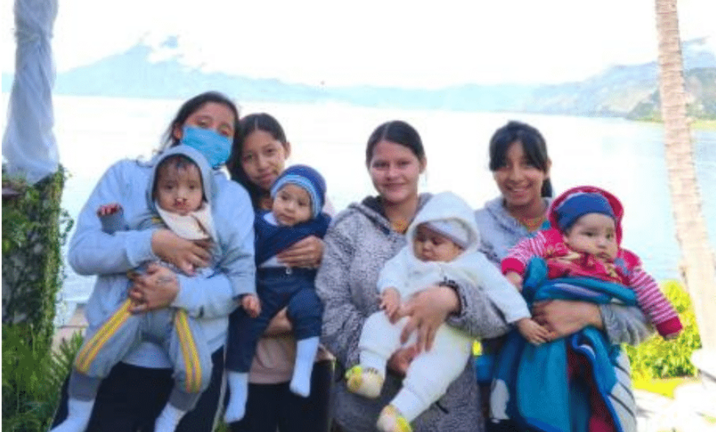 | $2,500
Lebanon | Middle East Revive and Thrive  The Little Friendly Space, which offered education and psychosocial support to 60 Syrian children aged 2 to 5 who were displaced with their families from the Bekaa Valley during 2024/2025 conflicts, received a $5,000 World Day of Prayer grant. Daily snacks, one home-cooked meal per week, winter preparedness, including boots, and numeracy/literacy curriculum were part of the project. 80% of the mothers attended awareness sessions.  December was a special month for the children at the LFS. Made possible by WICC funding, the staff hosted a beautiful Christmas event at which they distributed new winter boots to each child. The footwear, as well as the new Christmas decorations, which will be used year after year, brought genuine happiness and excitement. | The Little Friendly Space – a supportive place for displaced Syrian Children  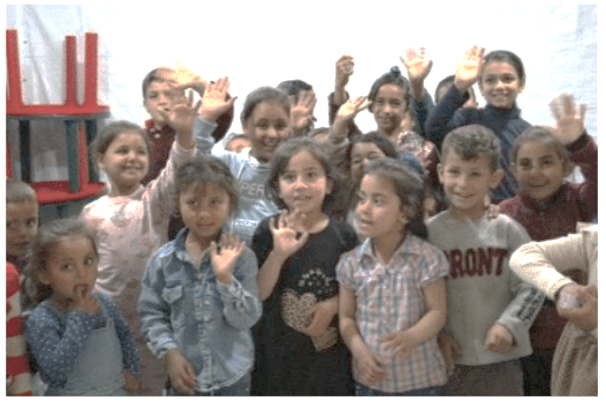 | $5,000
Bolivia | Baptist Organization of Social Justice (Bolivia)  The House of Friendship supports 80 vulnerable children, who have at least one parent in prison, through nutrition, medicine, education, psychological assistance and sharing the love of Christ. The Baptist Organization on Social Development in Bolivia received a $ 5,000 WDP grant to support this centre. Local churches and individuals were engaged to assist.  Jade’s Story:  Jade Abigail Pacheco Alvarez is a 6-year-old participant in Casa de la Amistad. She lives with her mother and younger sister in a rented single room in a peri-urban area, where there is no potable water or sewer system, water must be purchased by tanker, and the neighbourhood is described as unsafe. Her father is incarcerated in San Sebastián de Varones prison (with a 10-year sentence), and her mother—who is the family’s sole provider—is living with stage-two uterine cancer, which often prevents her from working except when her health temporarily improves. Jade entered the project after her father learned about Casa de la Amistad in prison and informed her mother, who then enrolled both daughters. Through the project,the girls receive breakfast and lunch, homework support,and regular counselling. The transformation in Jade’s life is both practical and deeply personal. Staff describe her as previously shy, insecure, withdrawn, and struggling socially at school, where rejection by peers contributed to troubling behaviours. With support from the project—including accompaniment during a school change, educational reinforcement, and integral care—Jade became more communicative, affectionate, obedient, and engaged in learning. She now expresses herself more openly, shares with others, and attends the project with joy. Even while carrying the emotional strain of her mother’s illness, she is described as showing a positive attitude and unusual maturity for her age. Jade says she wants to continue studying and become a doctor so she can care for her mother and help children living in poverty. | House of Friendship (Casa de la Amistad)  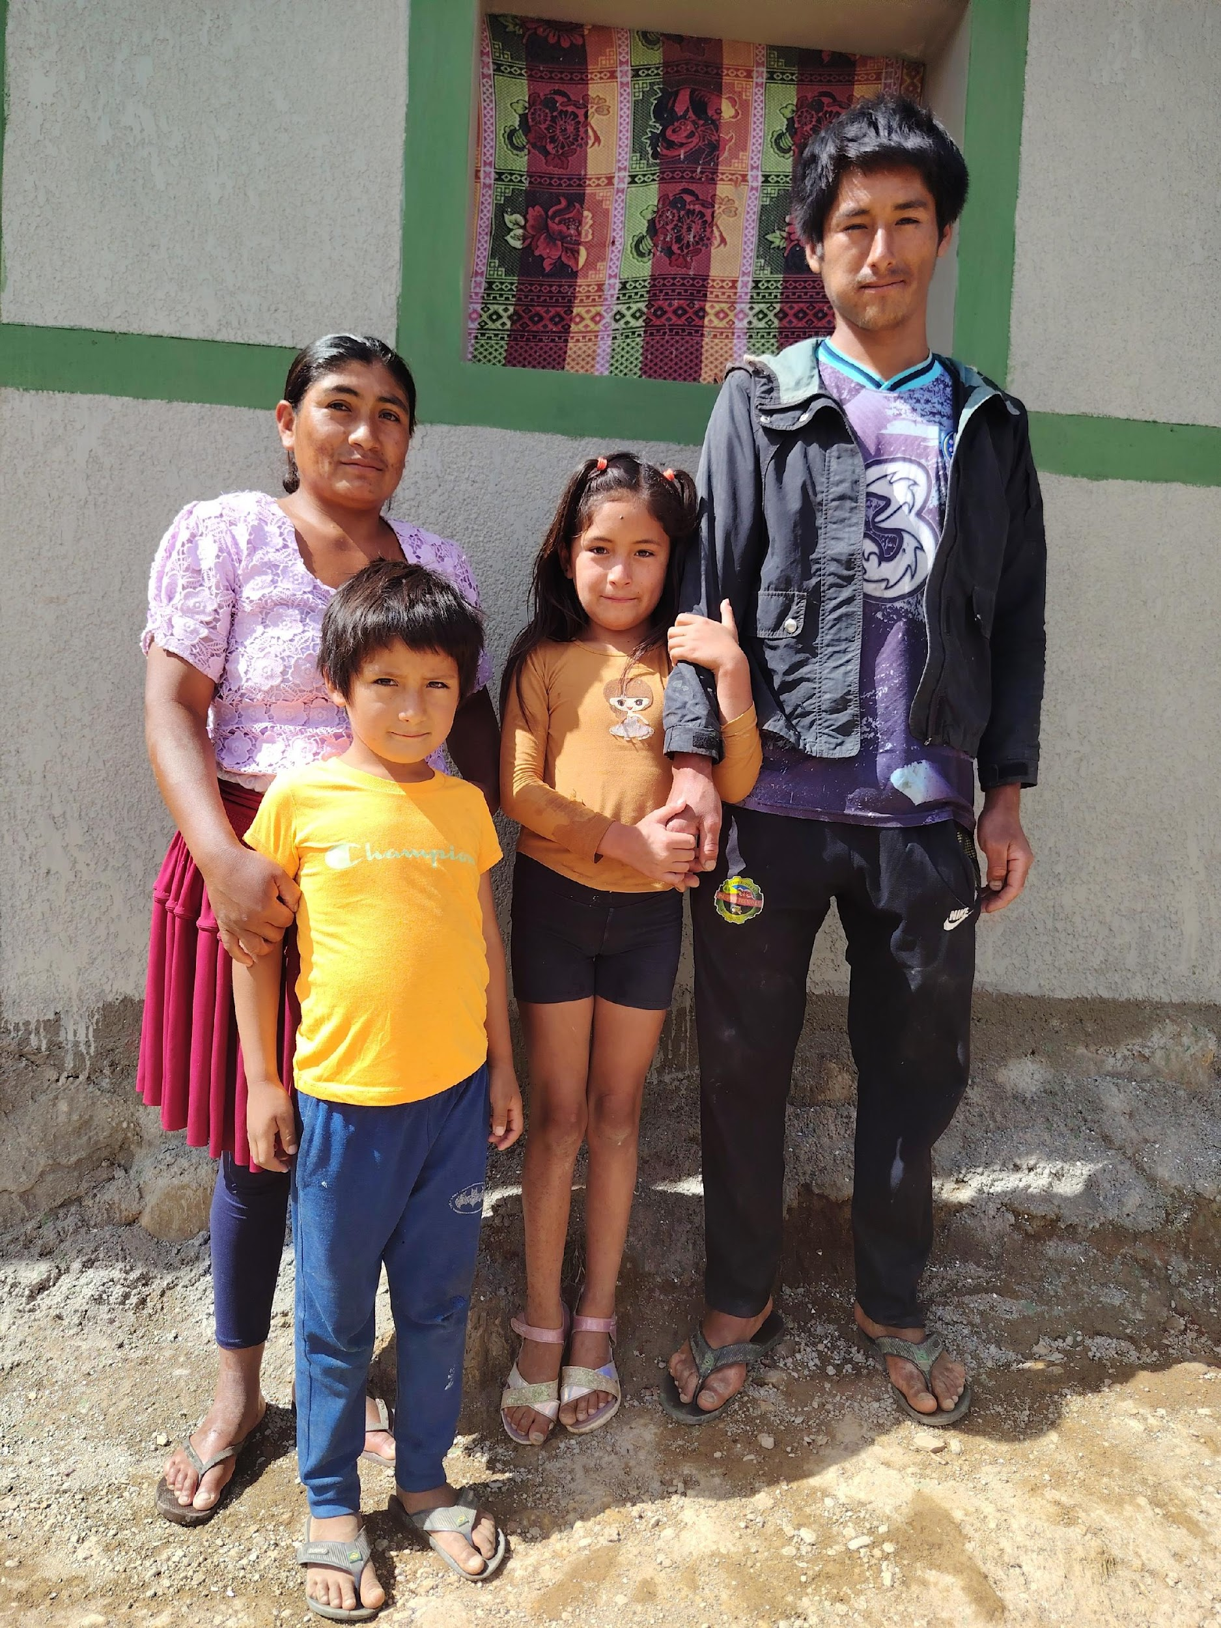 | $5,000
Bolivia | OBADES (Organización Bautista de Desarrollo Social)  181 participants in the rural communities of Mizque and Aiquile, Bolivia, benefited from a $5000 WDP grant to improve unsafe houses. Workshops and materials improved Chagas prevention through wall and roof plastering and painting , hygiene through rustic bathroom installations, and family violence. Churches engaged through prayer and volunteer mobilization. Pictures illustrate some physical changes.  The Pantoja Family:  The Pantoja family live in a rural farming household about two and a half hours from the town centre. The family depends on agriculture, but when rain fails and production drops, Benito, the father, must leave home to work as a day labourer in the mine or travel to the jungle region for coca harvest work so his family will have enough to live on. He worked for a month in the jungle region to buy paint and missing materials so he could finish the house repairs. This family’s home drew the attention of other families and inspired them to imagine similar improvements in their own homes. | Healthy Homes  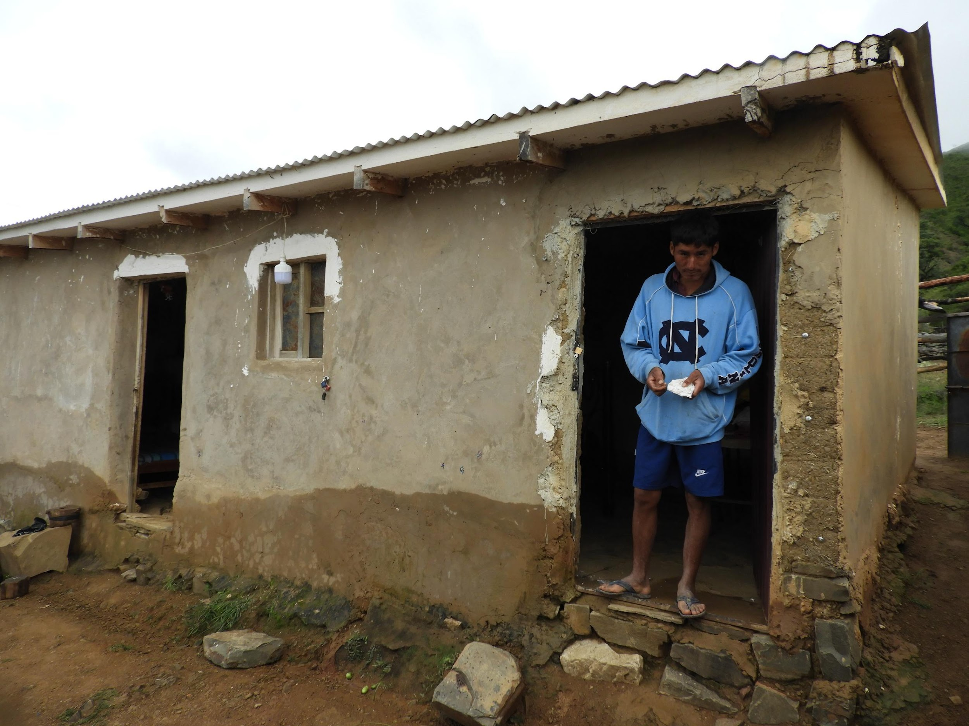  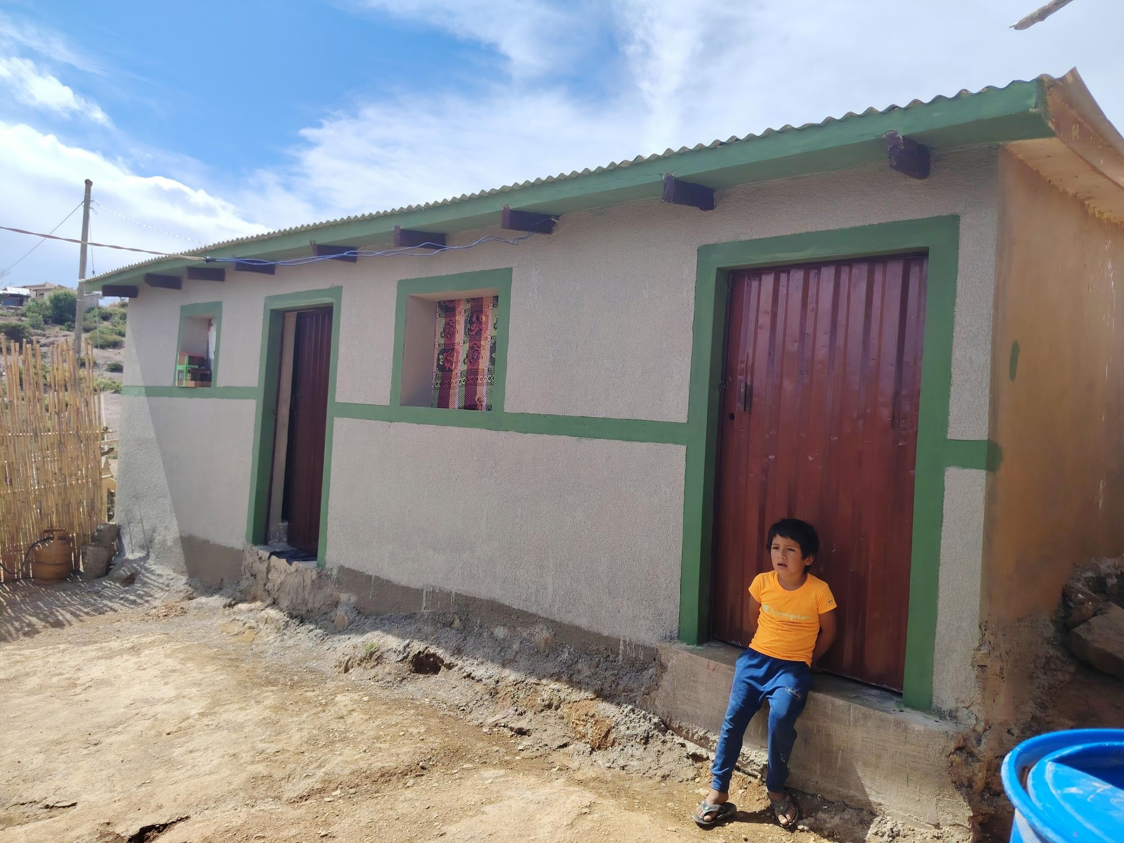 | $5,000
Ukraine | Multi-Nation Missions Foundations  Senior citizens living in Zaporizhzhia, Ukraine, are experiencing loneliness from family members moving away due to the war. The Golden Years Project received a $5,000 WDP grant to increase the number of participants who build friendships and feel emotional support through group activities, including Nordic skiing, candle-making, crafts, and knitting. Seventeen churches offered related Bible studies and prayer sessions for the 25 participants.  Tamara’s Story:  Tamara Semyonovna, raised in an orphanage, spent her life caring for her disabled brother until his passing six months ago, leaving her alone. While visiting a veterans' center, an elderly woman who had been attending Golden Years programs invited Tamara to a Nordic walking group. There, Tamara found community, felt truly seen, joined the church, and dedicated her life to God. | Golden Years: Supporting Elderly Women Affected by War in Ukraine  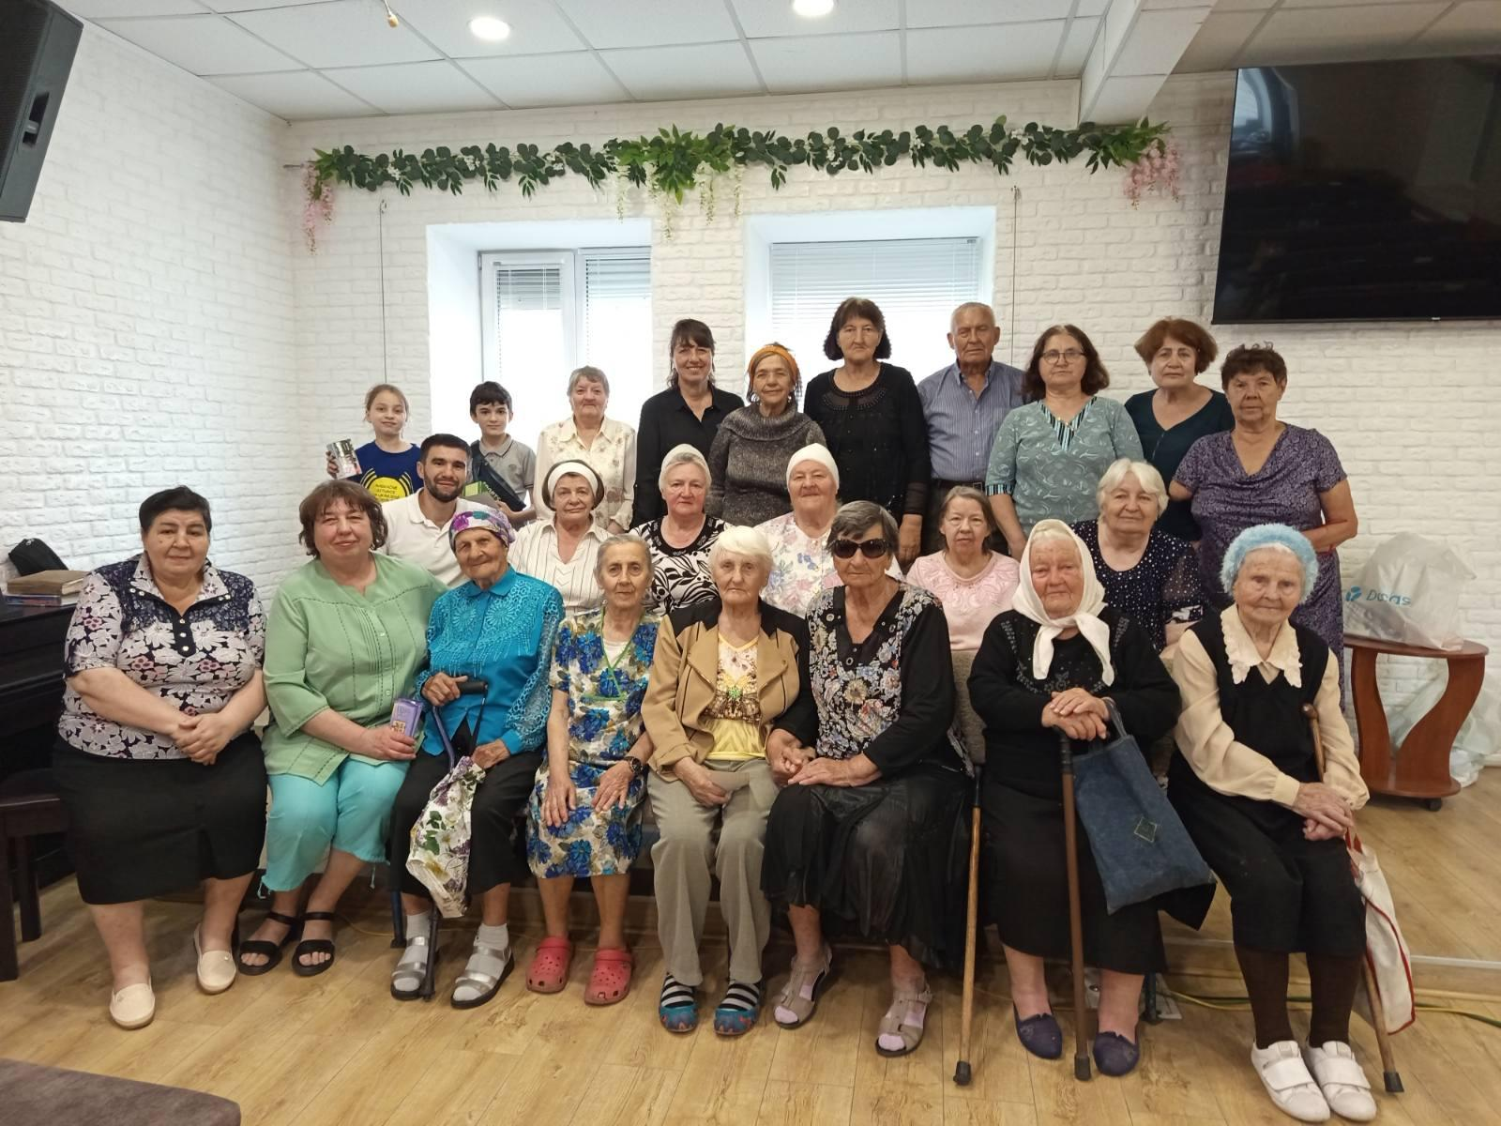 | $5,000
Int Total |  |  | $51, 500
Total |  |  | $100, 000

